**WAPT Week 3.2 OWASP Top 10 Assignment**

Contents

Horizontal privilege escalation 2

1. User ID controlled by request parameter 2

2. User ID controlled by request parameter, with unpredictable user IDs 5

3. User ID controlled by request parameter with data leakage in redirect 9

Insecure Direct Object References (IDOR) 12

Access control vulnerabilities in multi-step processes 18

Referer-based access control 24

Directory traversal 29

1. File path traversal, simple case 29

2. File path traversal, traversal sequences blocked with absolute path bypass 33

3. File path traversal, traversal sequences stripped non-recursively 37

4. File path traversal, traversal sequences stripped with superfluous URL-decode 41

5. File path traversal, validation of start of path 45

6. File path traversal, validation of file extension with null byte bypass 46

# Horizontal privilege escalation

## User ID controlled by request parameter

1. Open the lab and Login to the account with the credentials

Username: wiener

Password: Peter

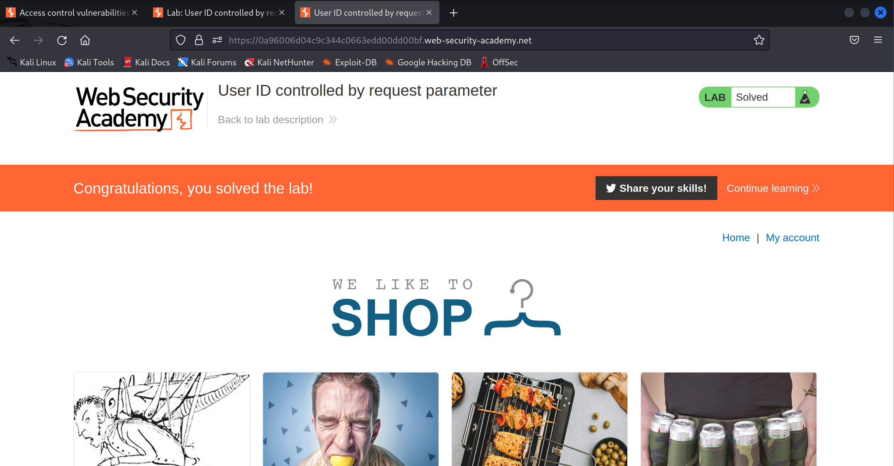

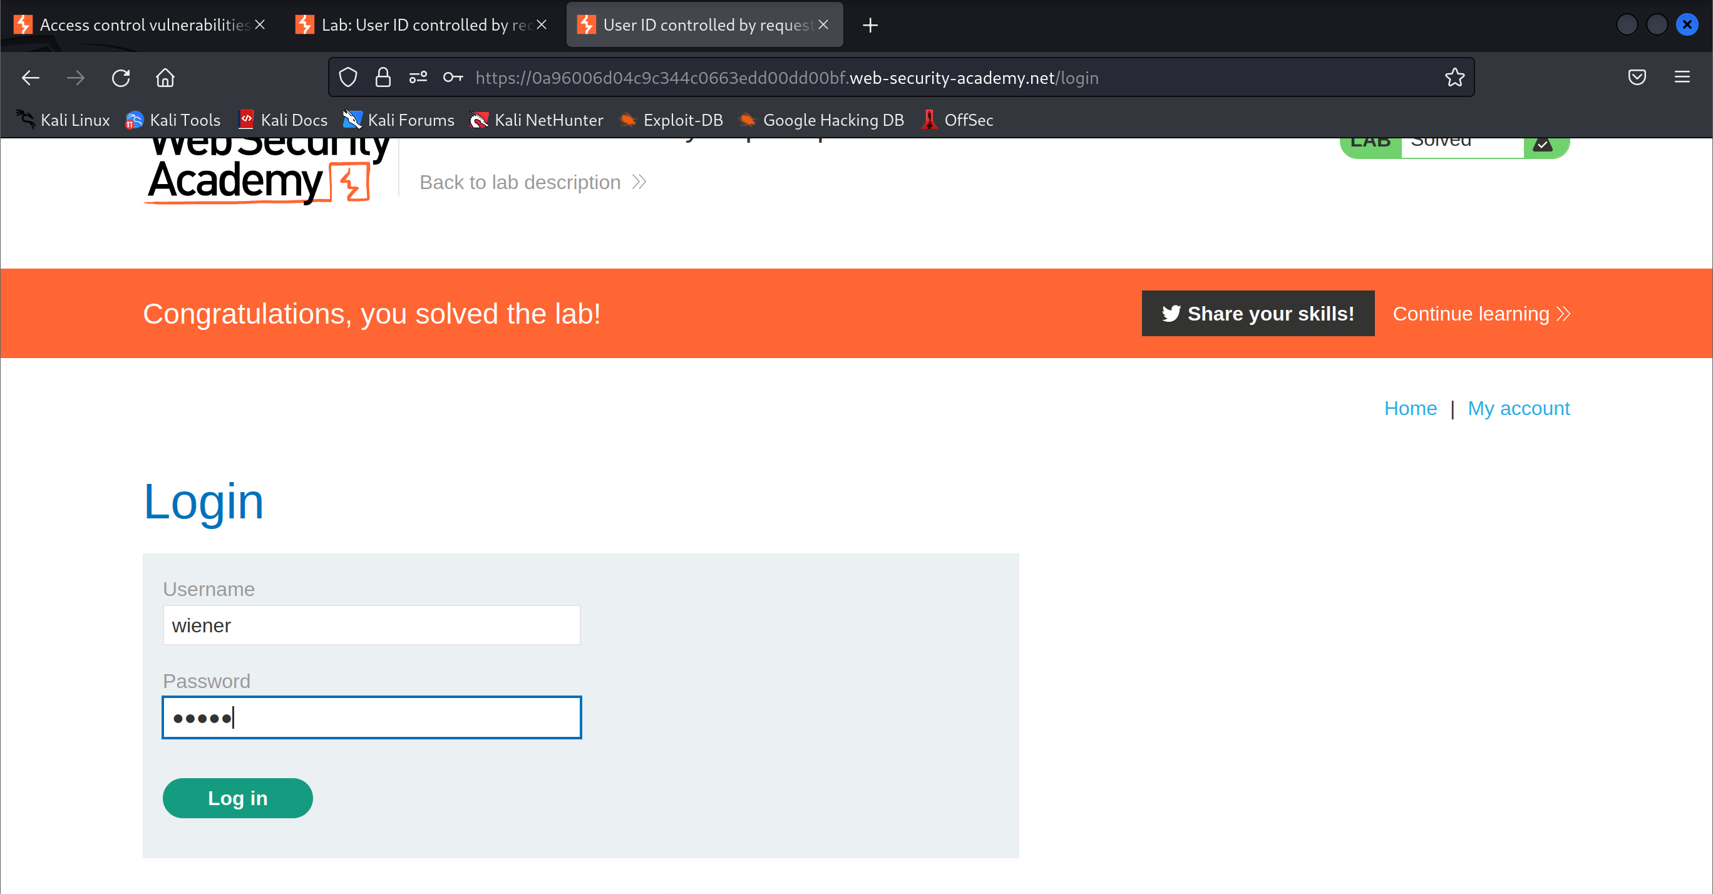

1. Notice that the API key in shown on successful login to the account

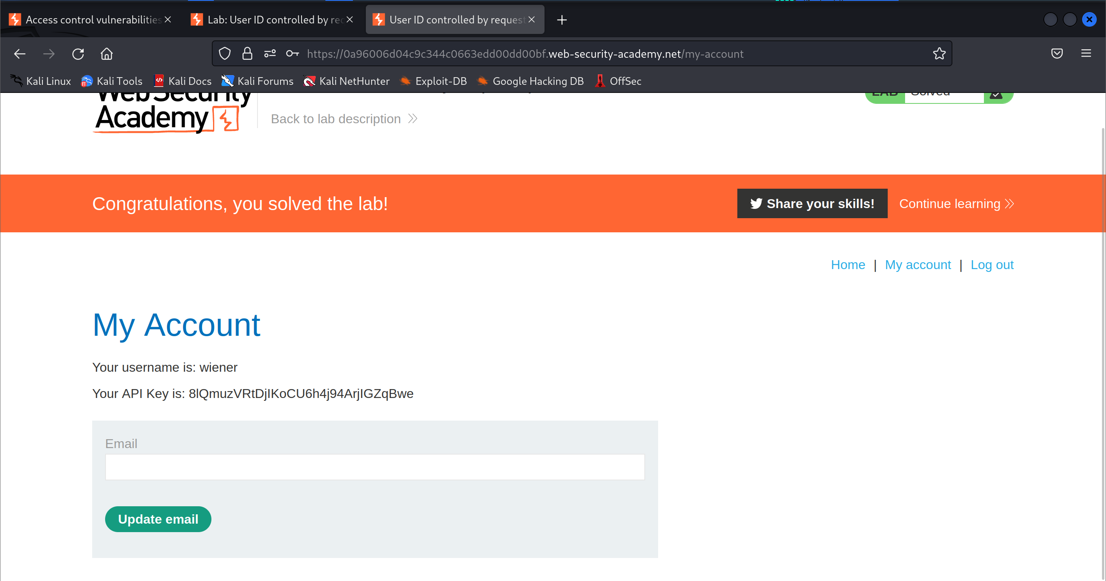

1. Modify the web url to reflect the id as carlos (user that you want to login as)

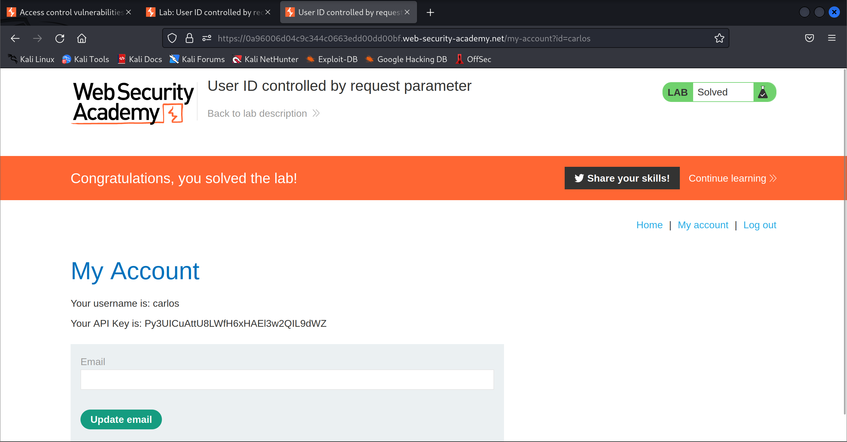

1. Get the API key and submit it

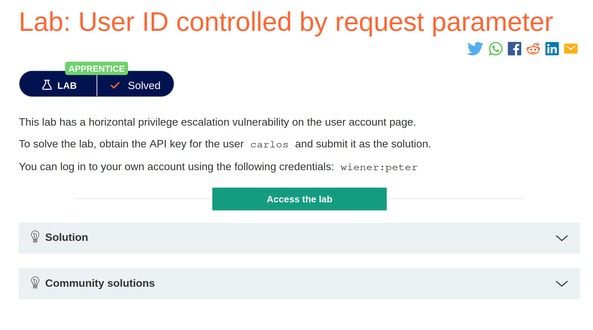

## User ID controlled by request parameter, with unpredictable user IDs

1. Open the lab and Login to the account with the credentials

Username: wiener

Password: Peter

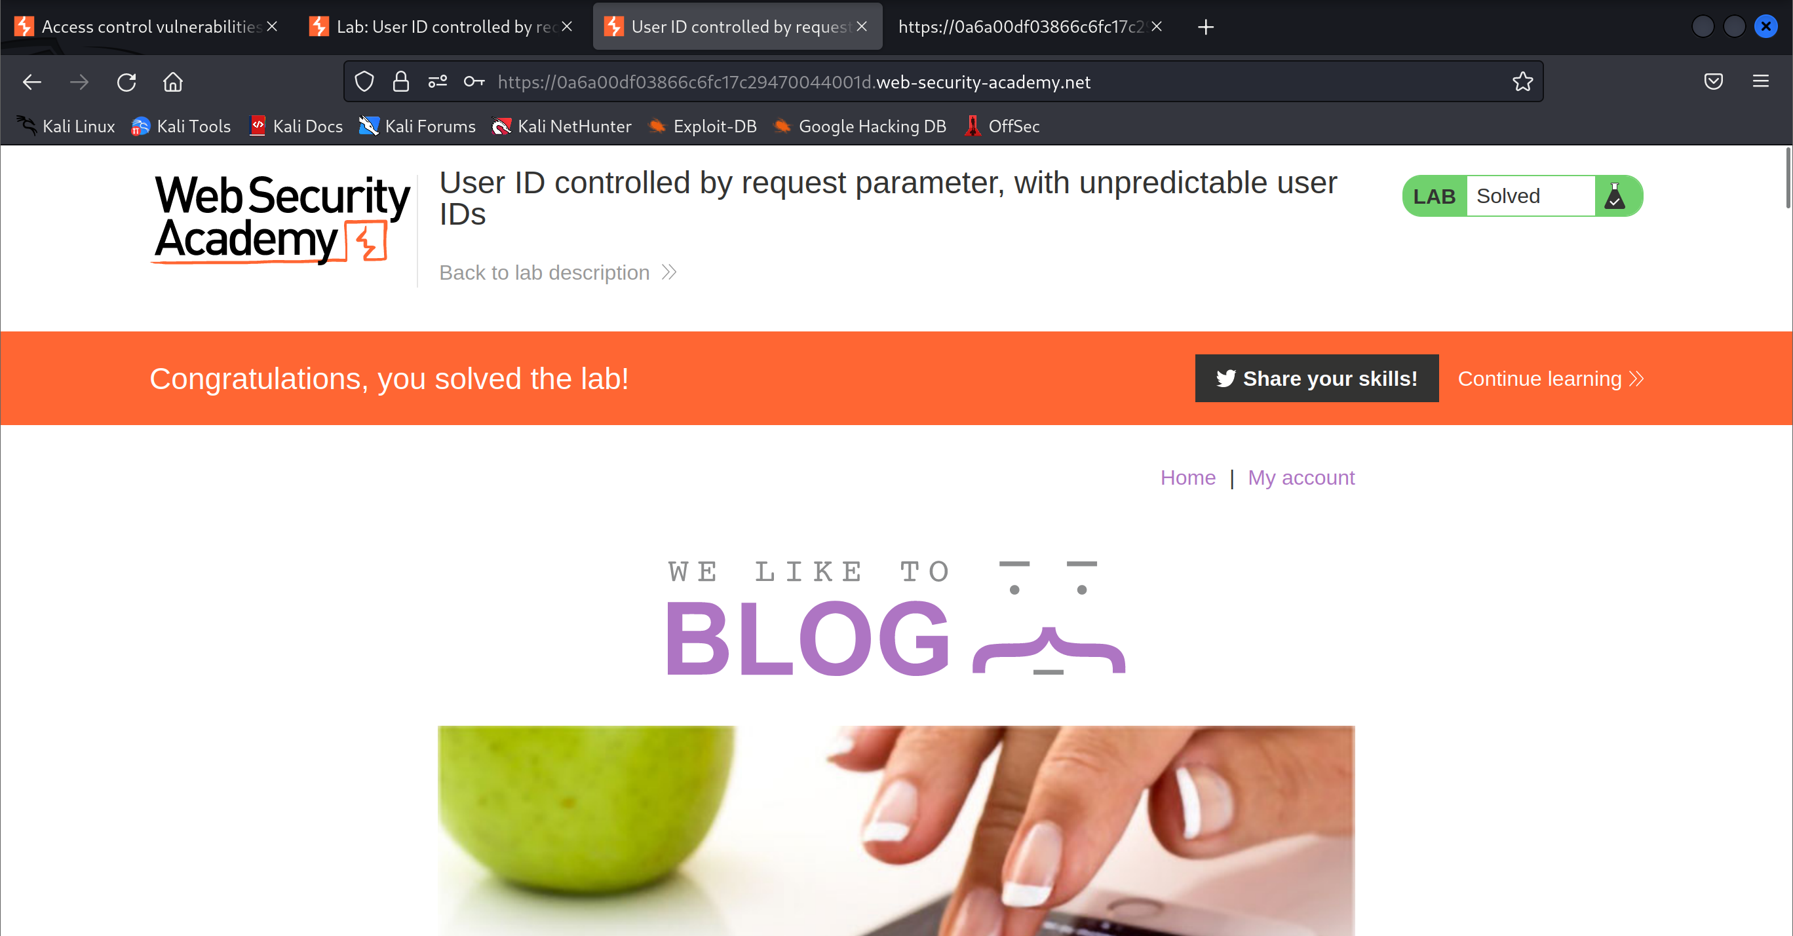

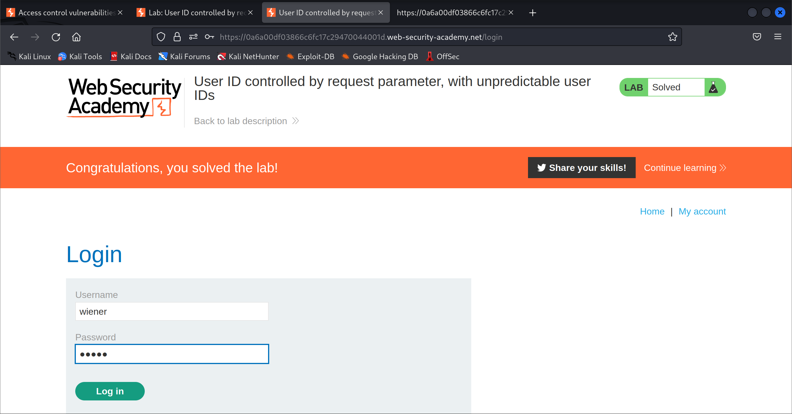

1. Notice the user id of the account from the url

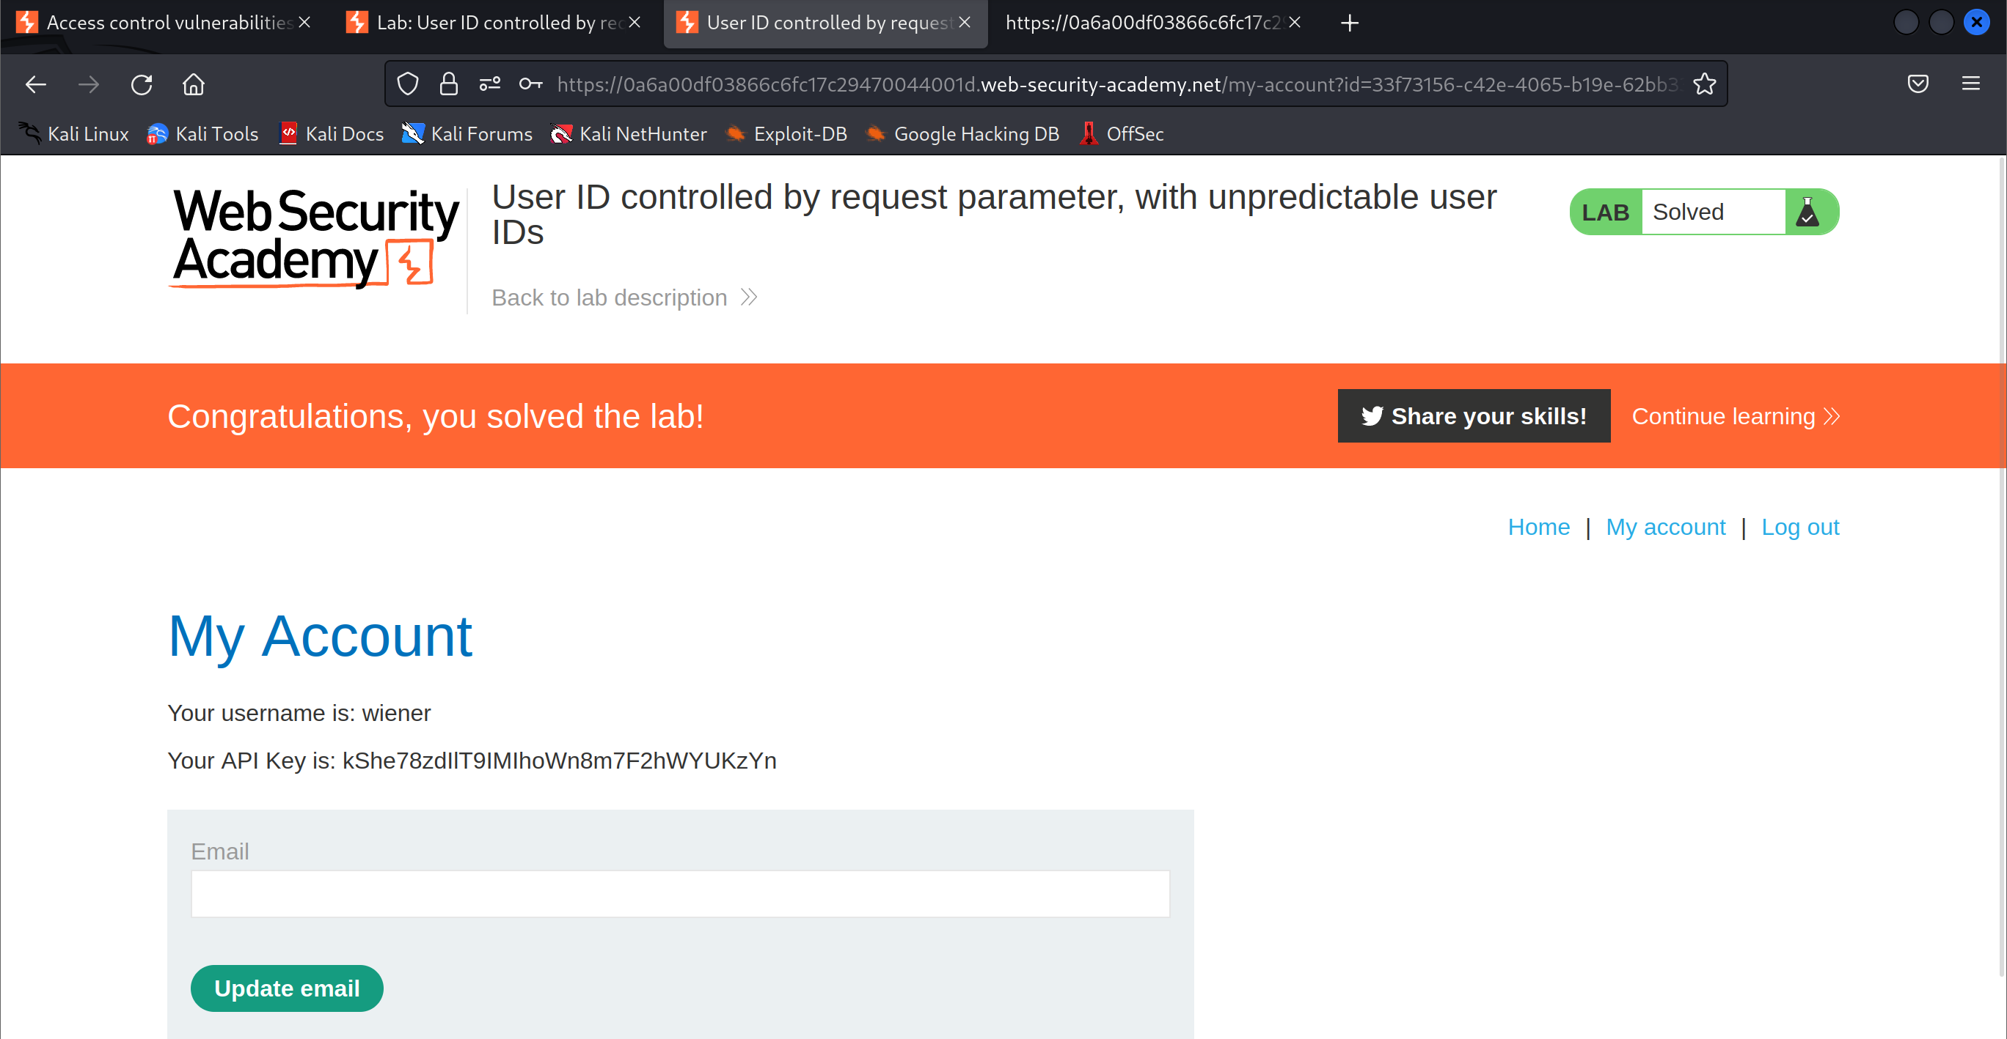

1. View one of the post in the home page that is posted by the user you want to login as

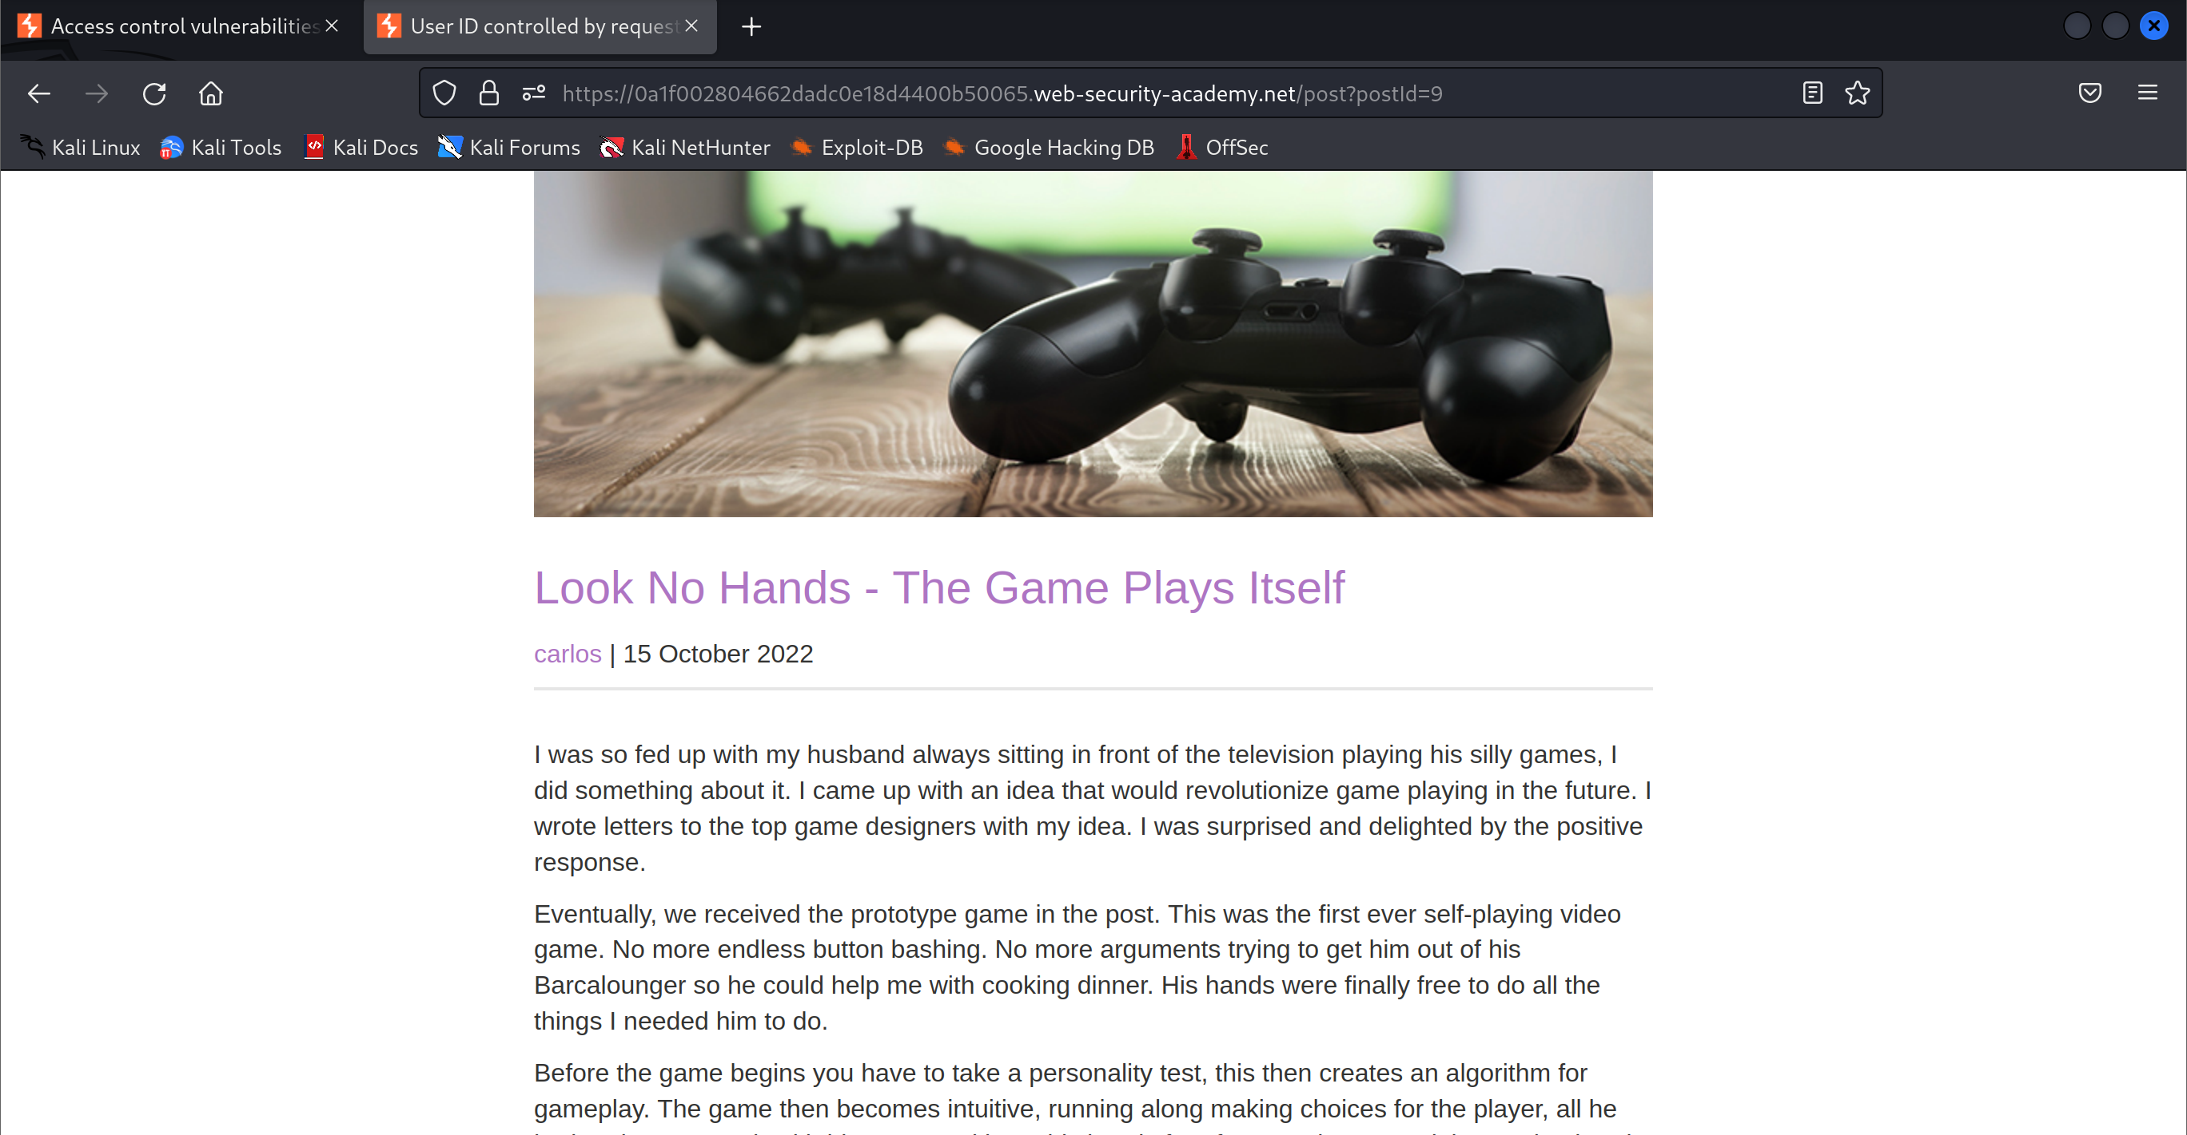

1. Click on the username of the user and notice the userid in the url

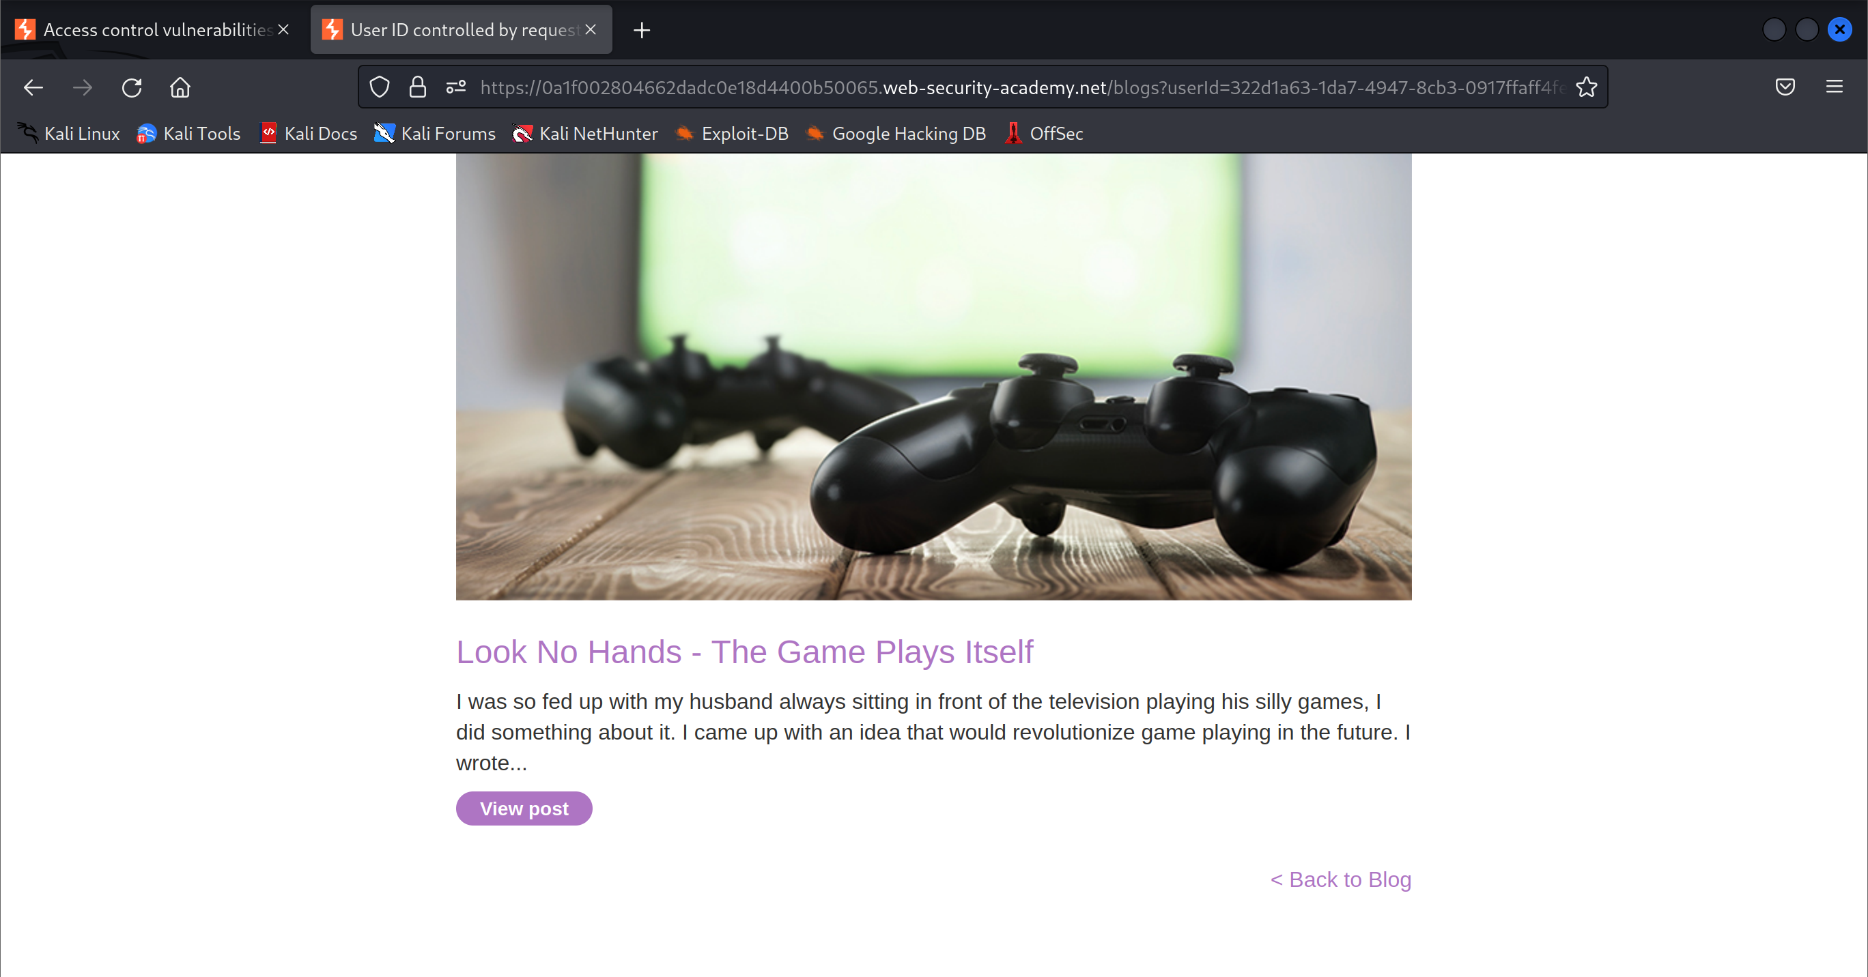

1. Go to the My Account page and modify the url userid to the one found in the post

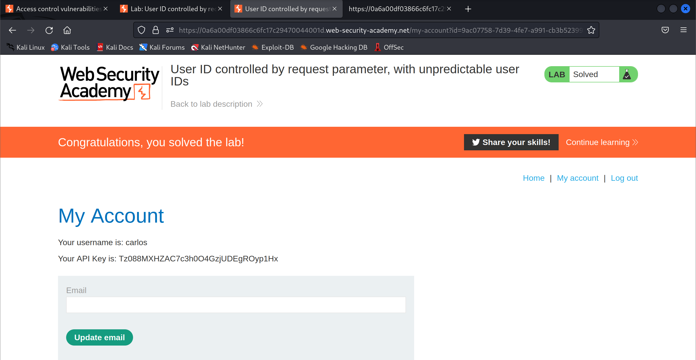

1. Get the API key and submit it

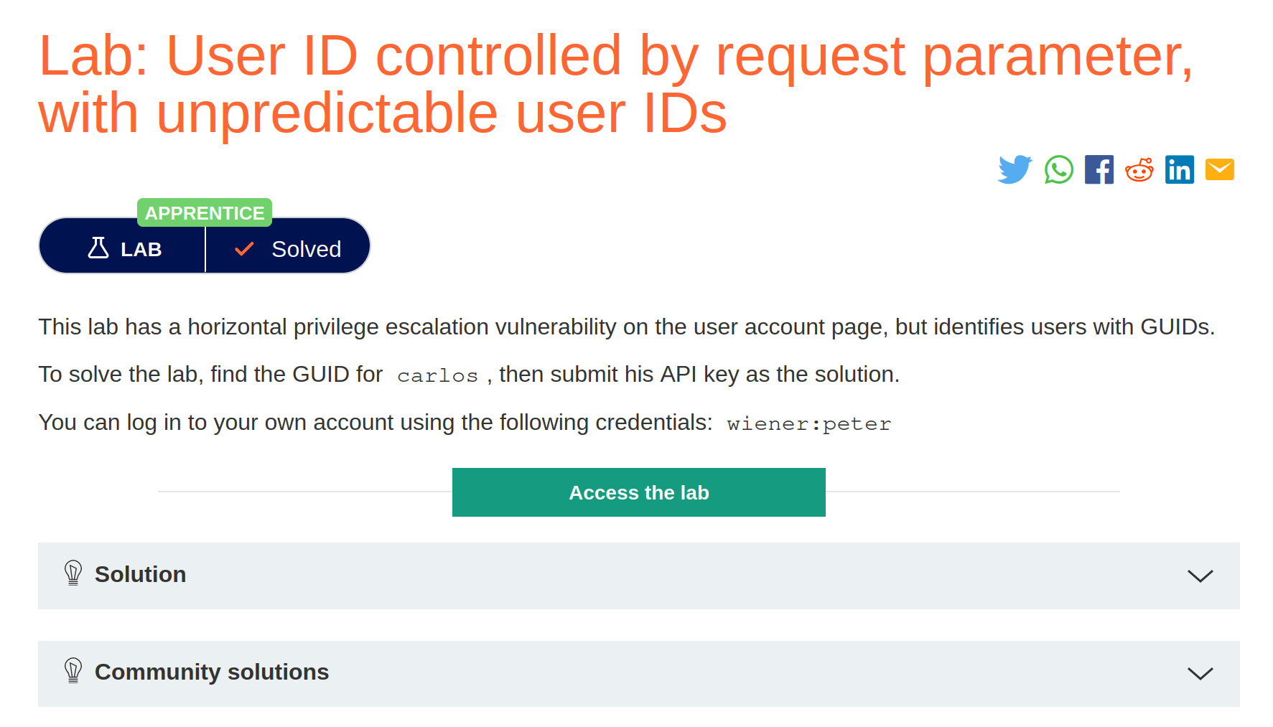

## User ID controlled by request parameter with data leakage in redirect

1. Configure Burp Suite Community Edition to intercept server response

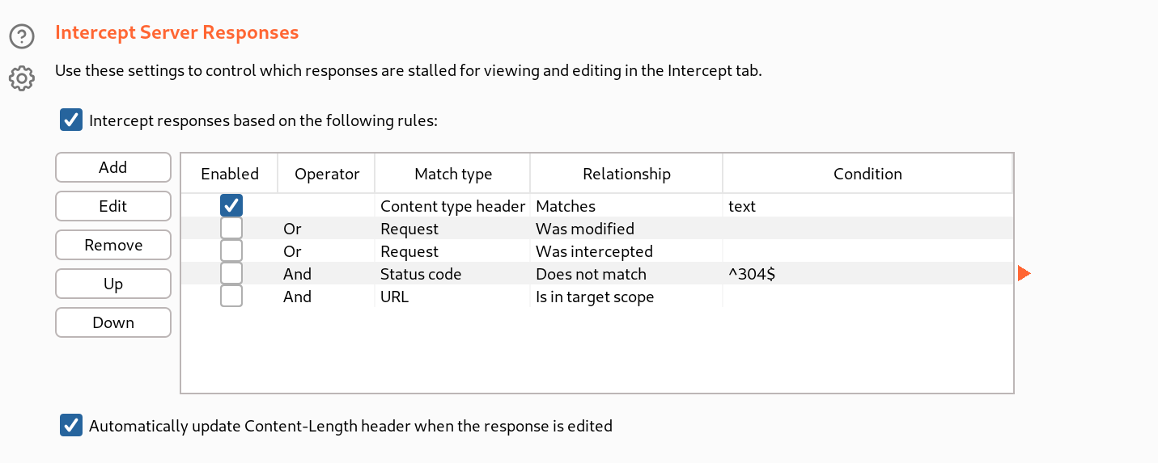

1. Launch the lab and start intercepting traffic

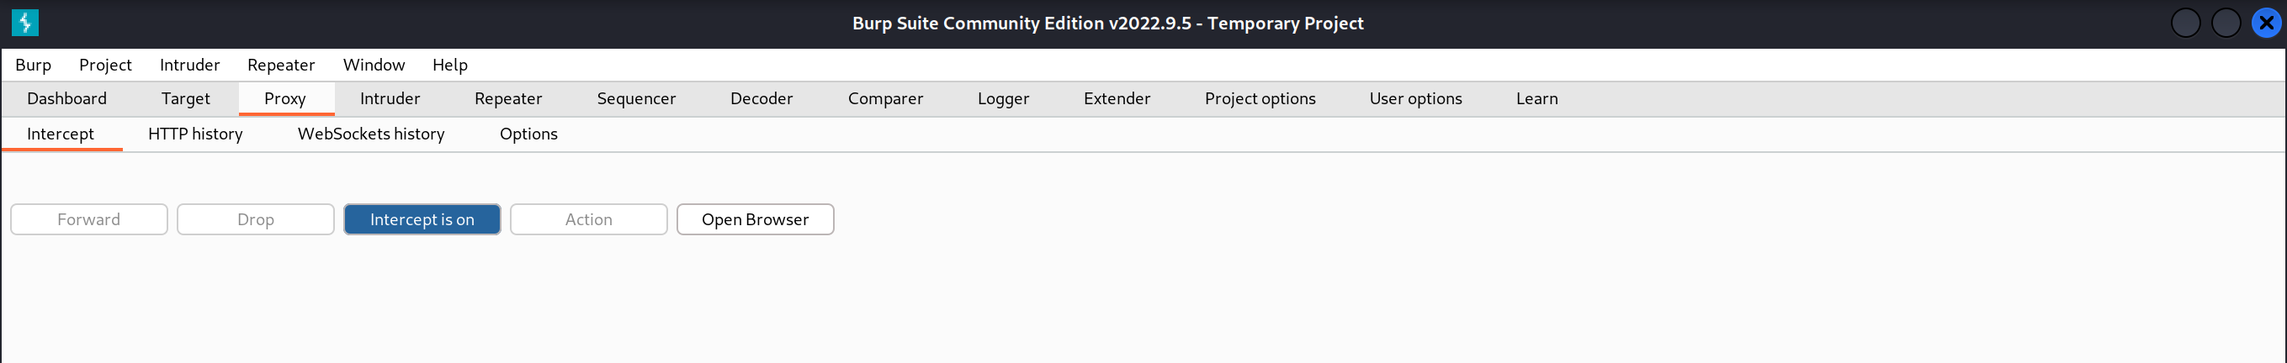

1. Login to the account with the credentials

Username: wiener

Password: Peter

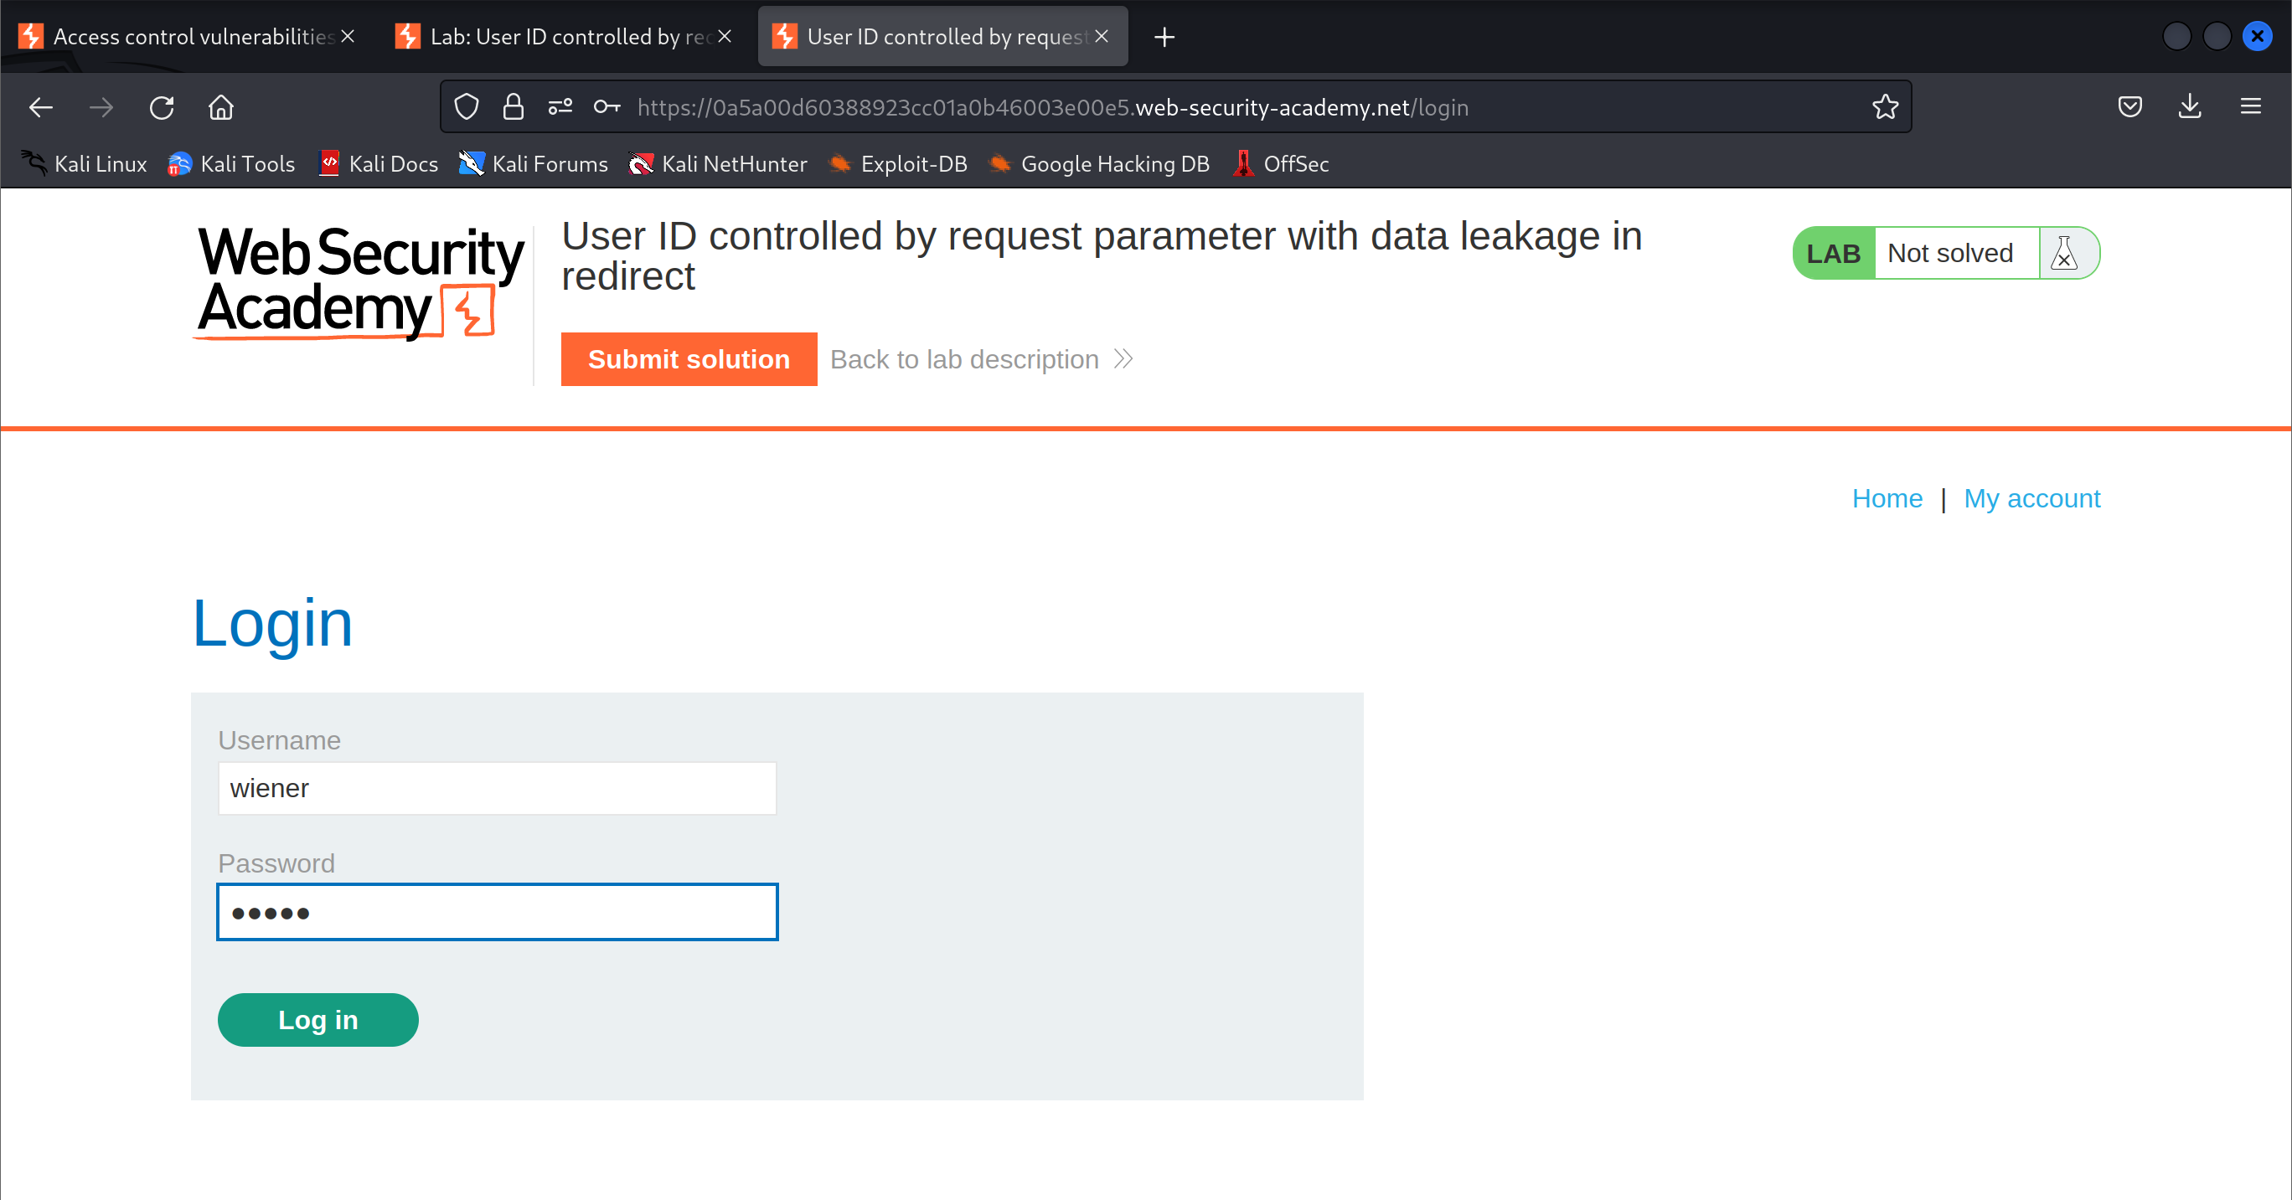

1. Notice the userid in the url

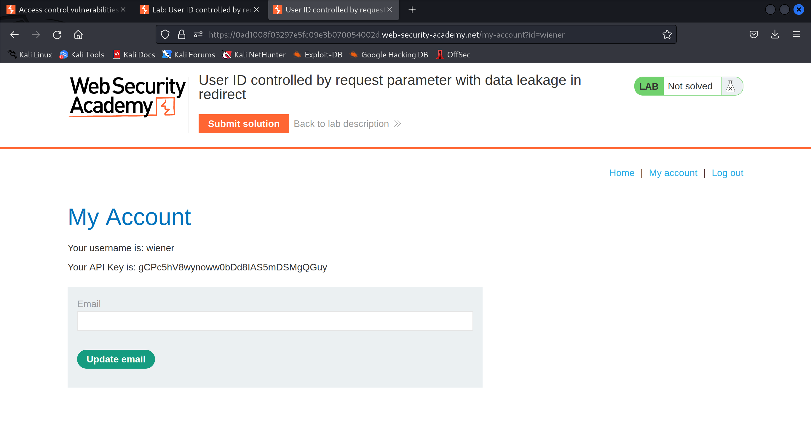

1. Start intercepting the traffic

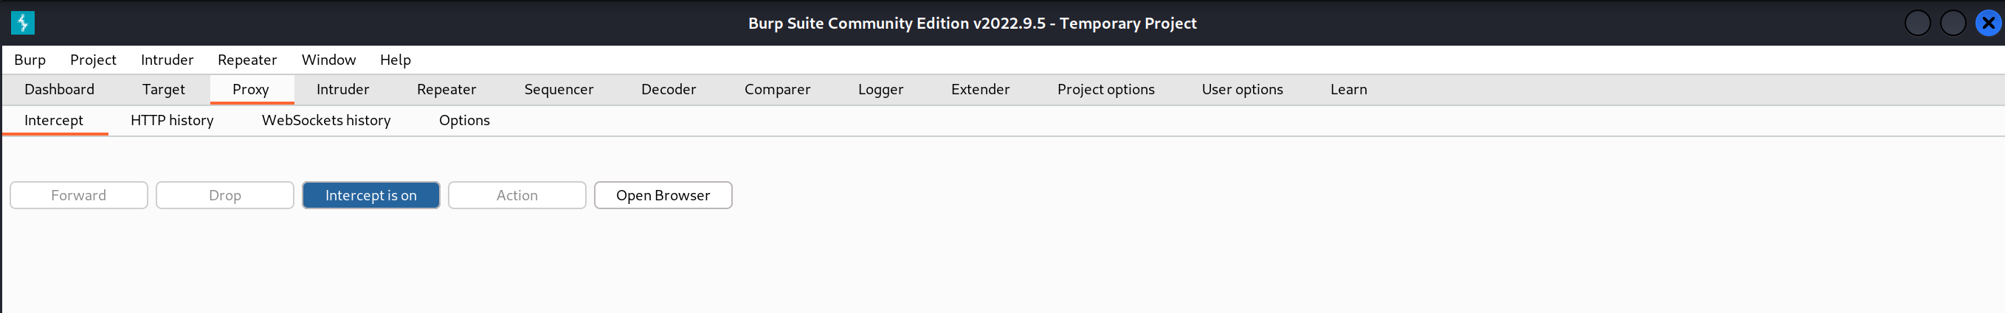

1. Modify the userid in the url to reflect carlos

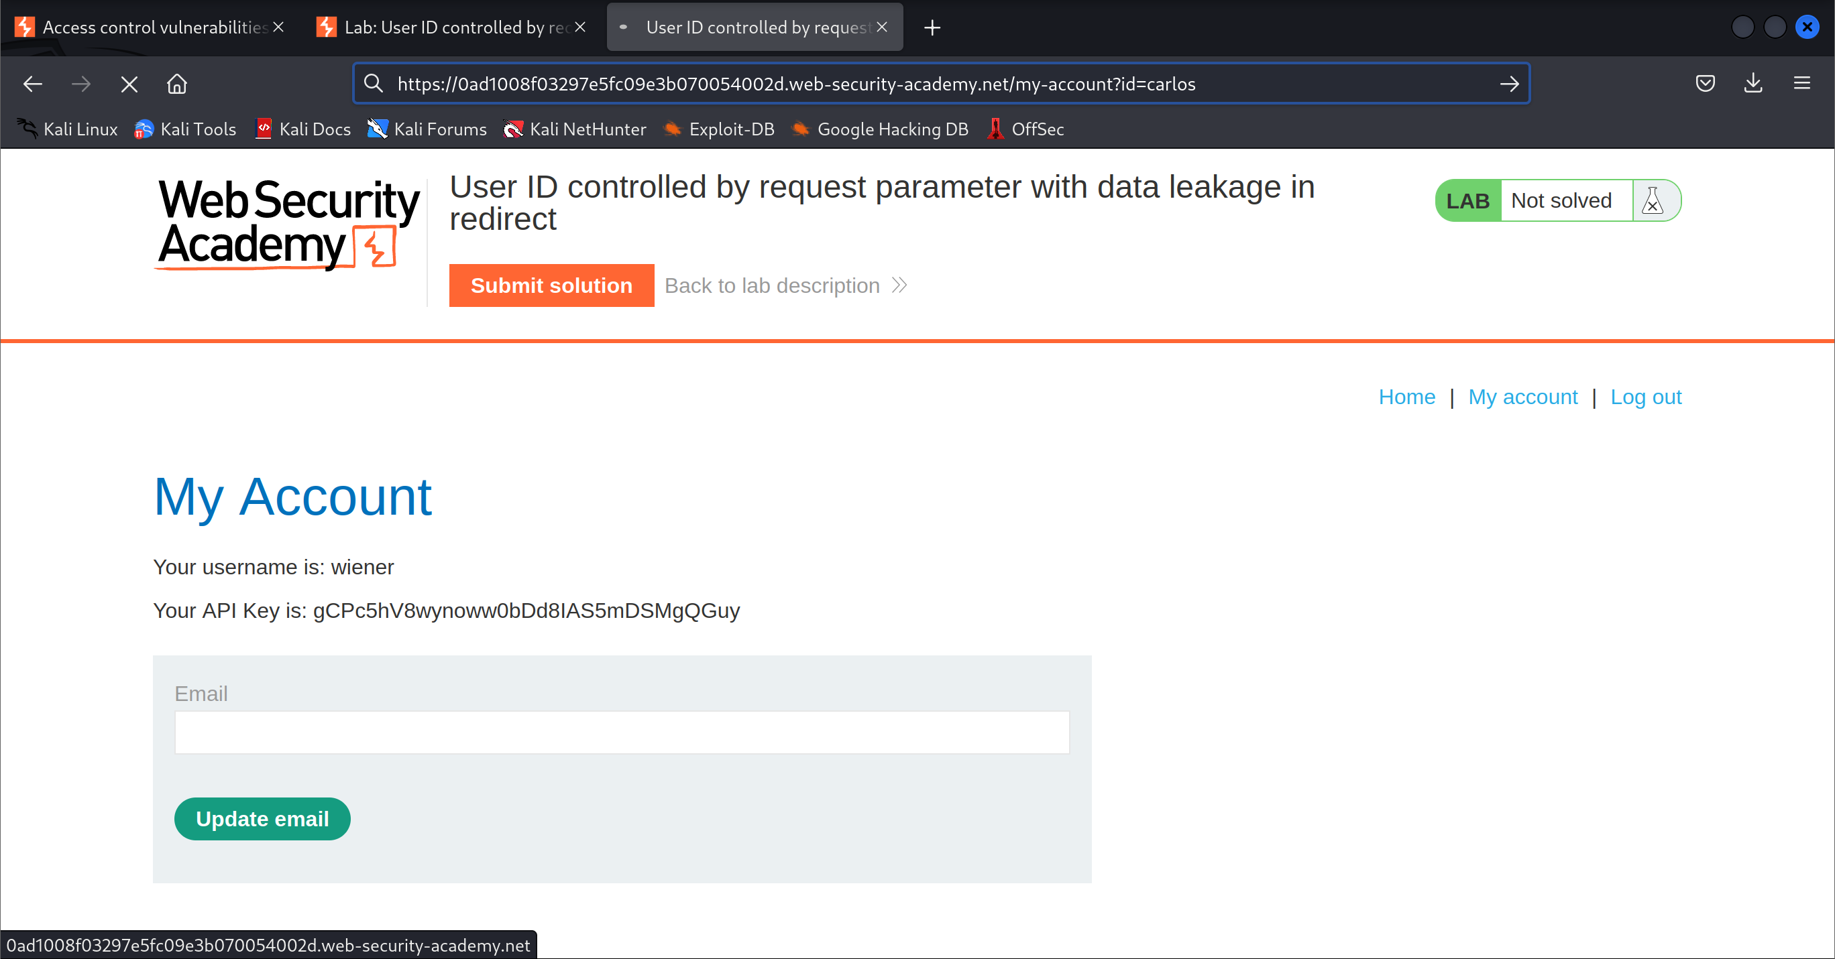

1. Read and forward the packets

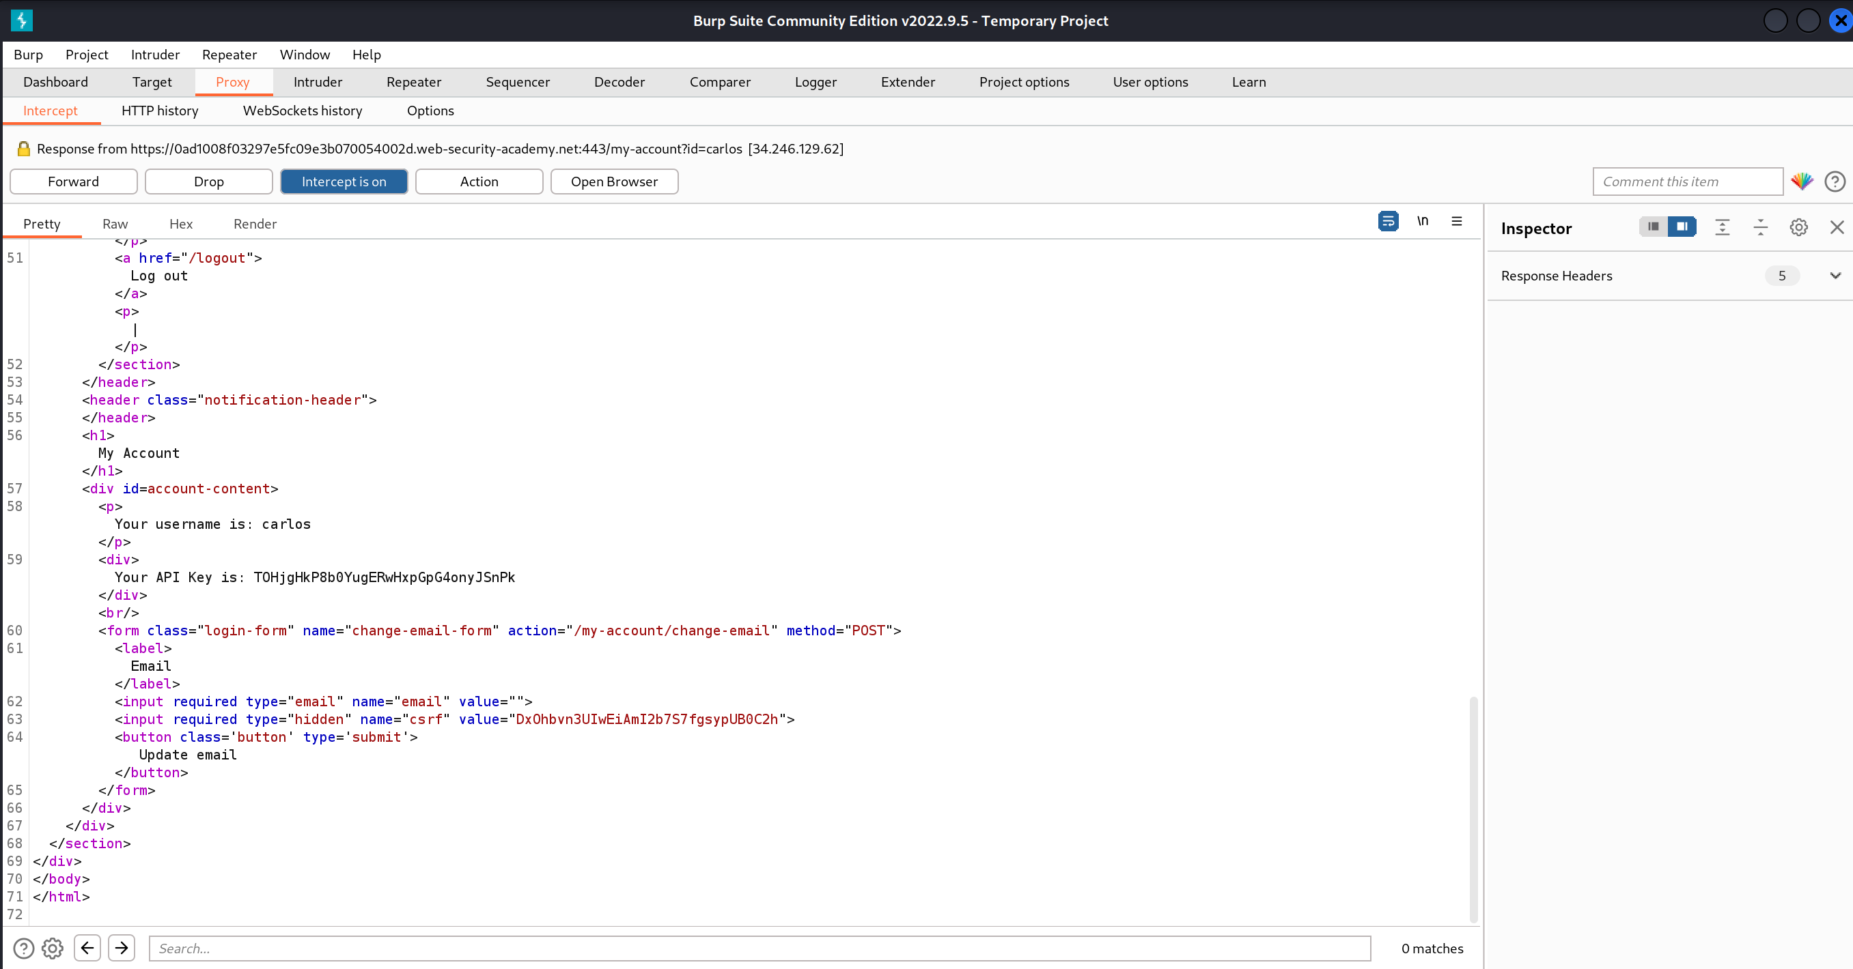

1. Get the API key and submit it

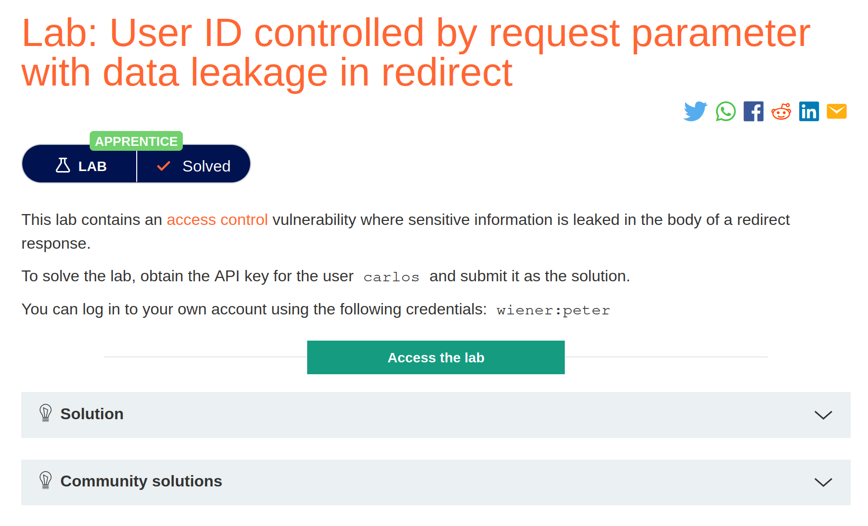

# Insecure Direct Object References (IDOR)

1. Open the lab and go to the live chat page

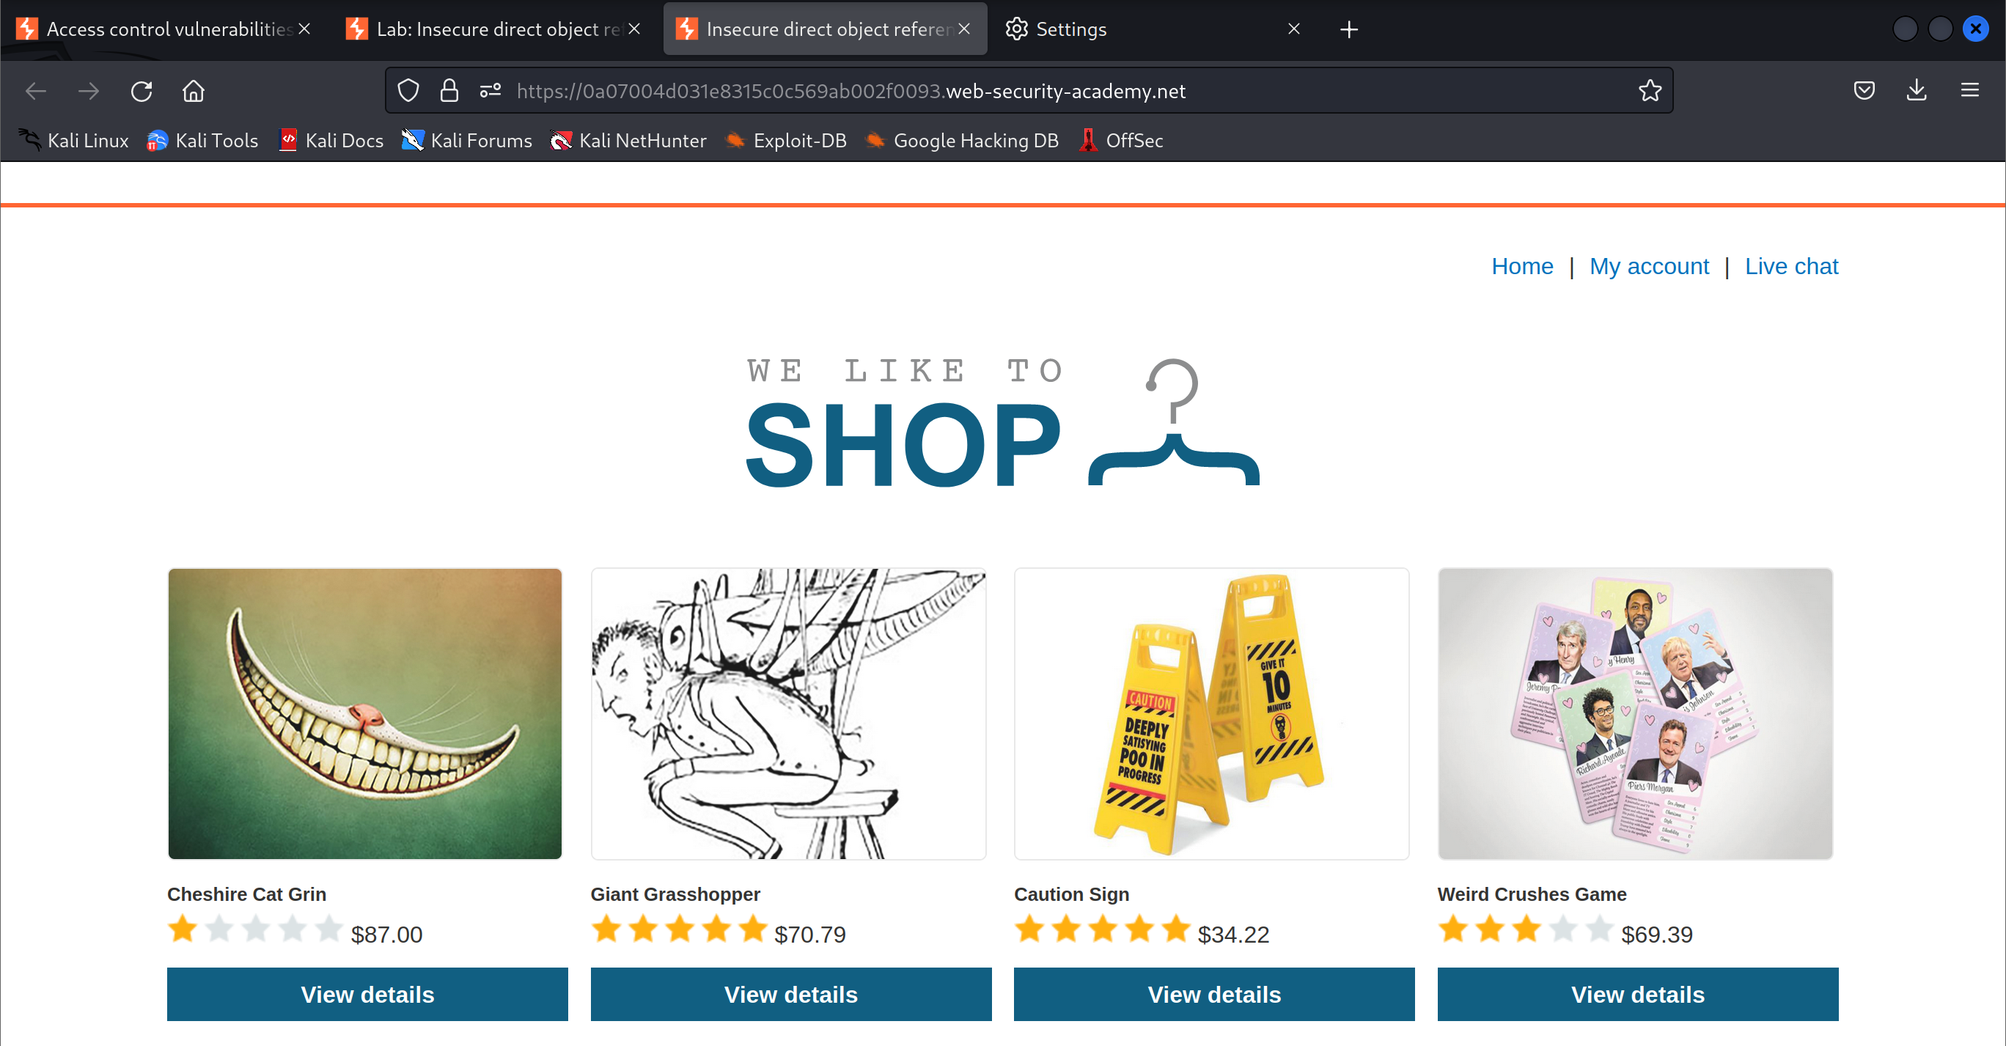

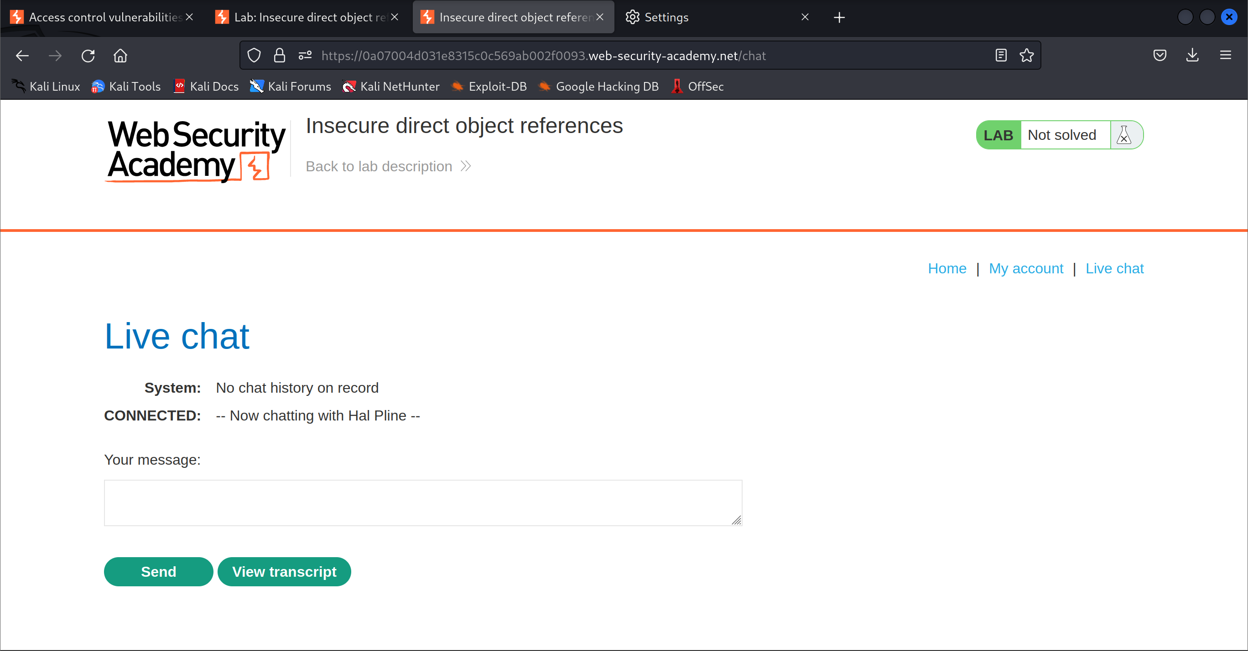

1. Send a message into the live chat page and click view transcript

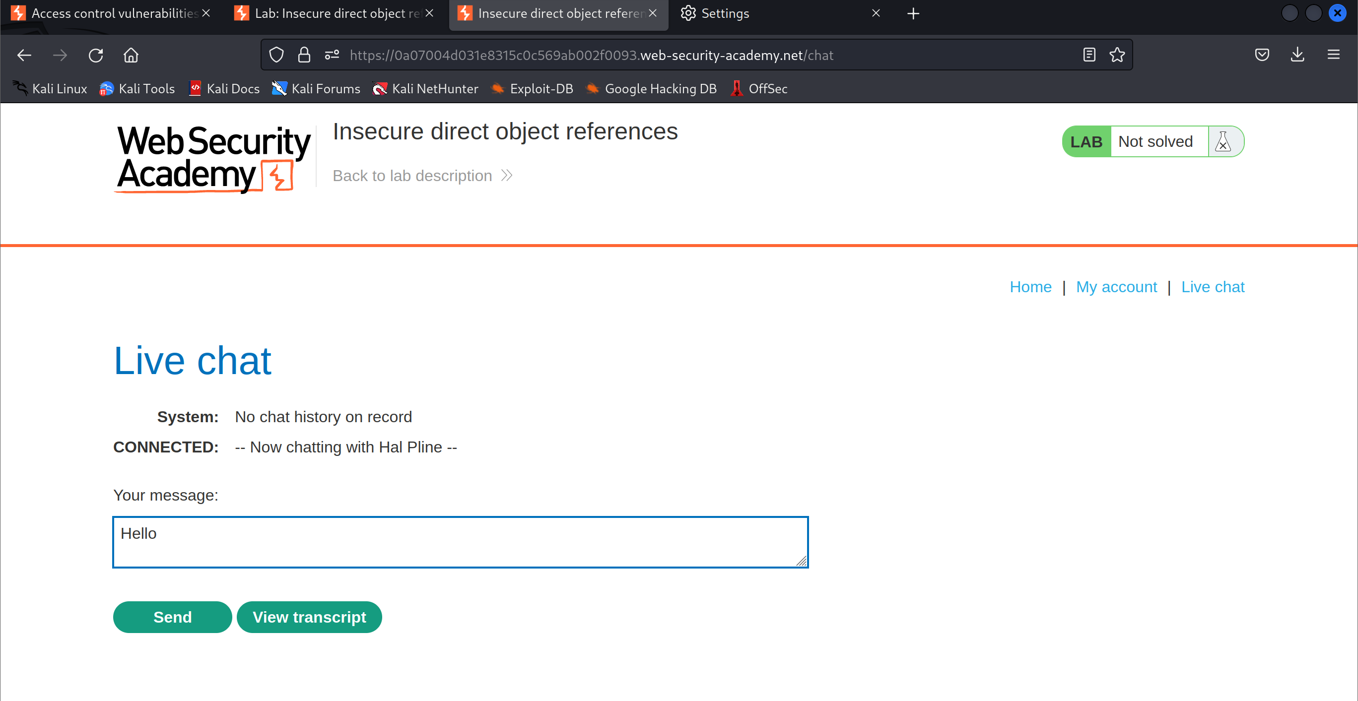

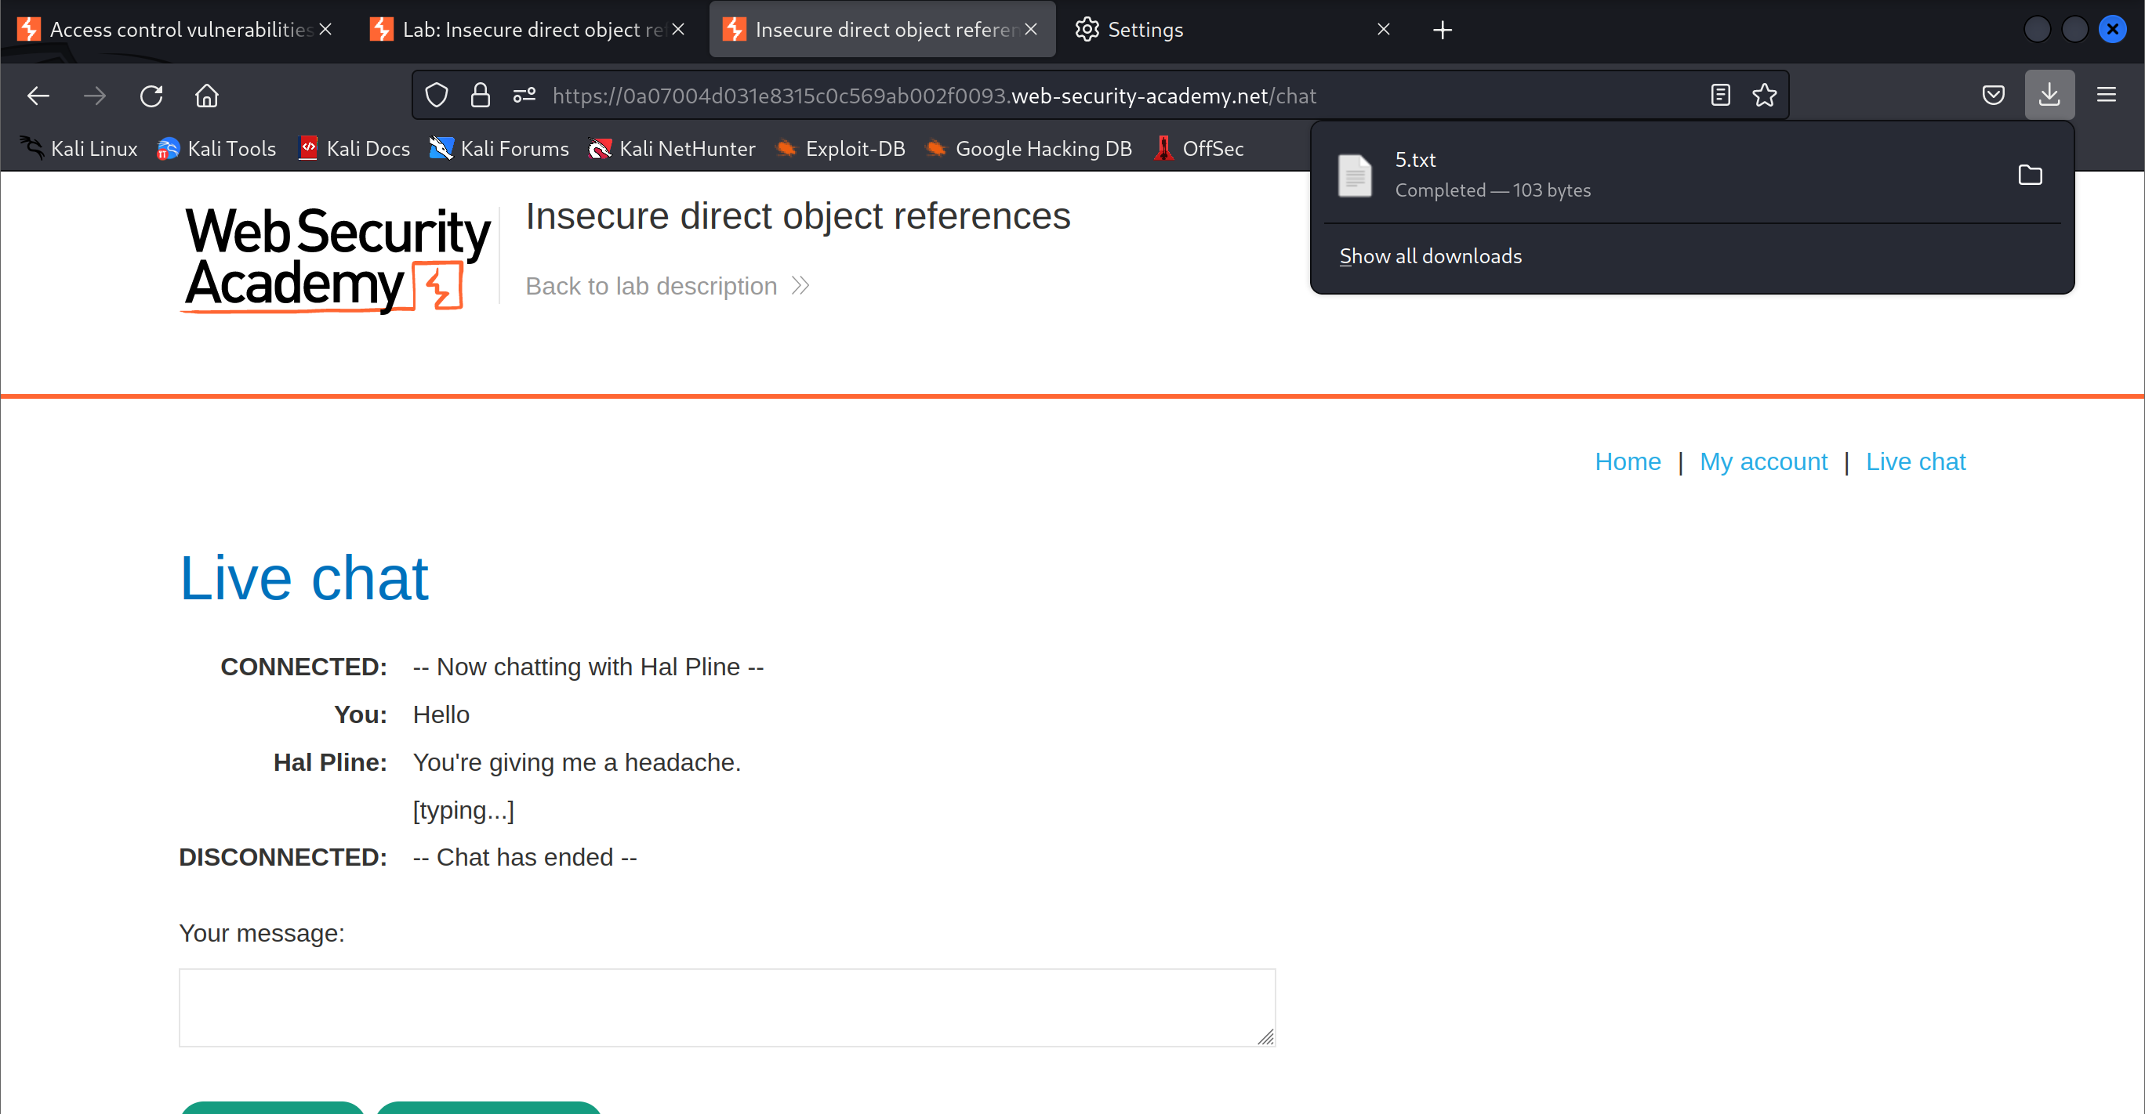

1. Refresh the page and send another message in the live chat and view transcript

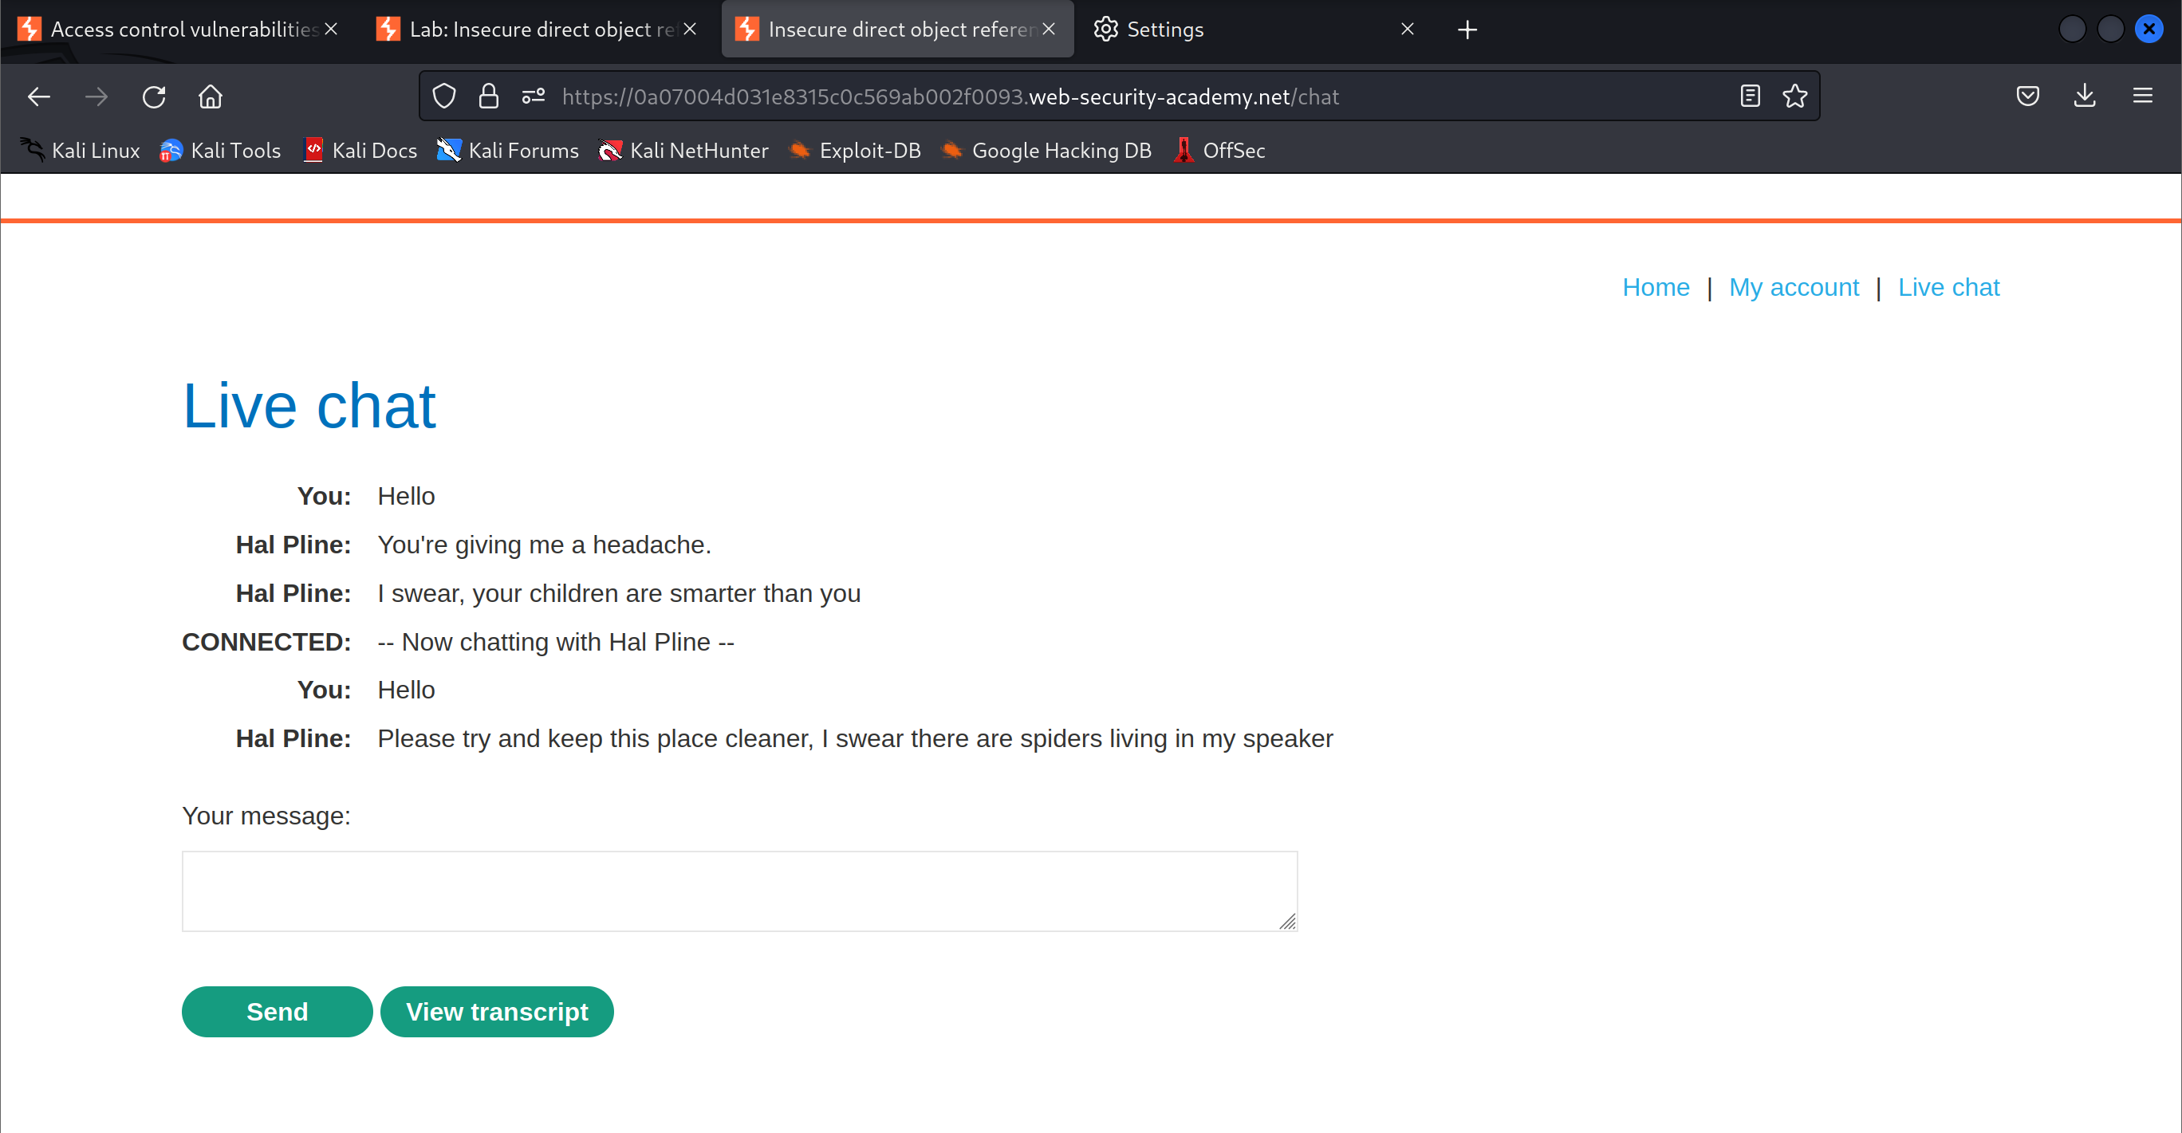

1. Notice that the file’s downloaded numbers are incrementing

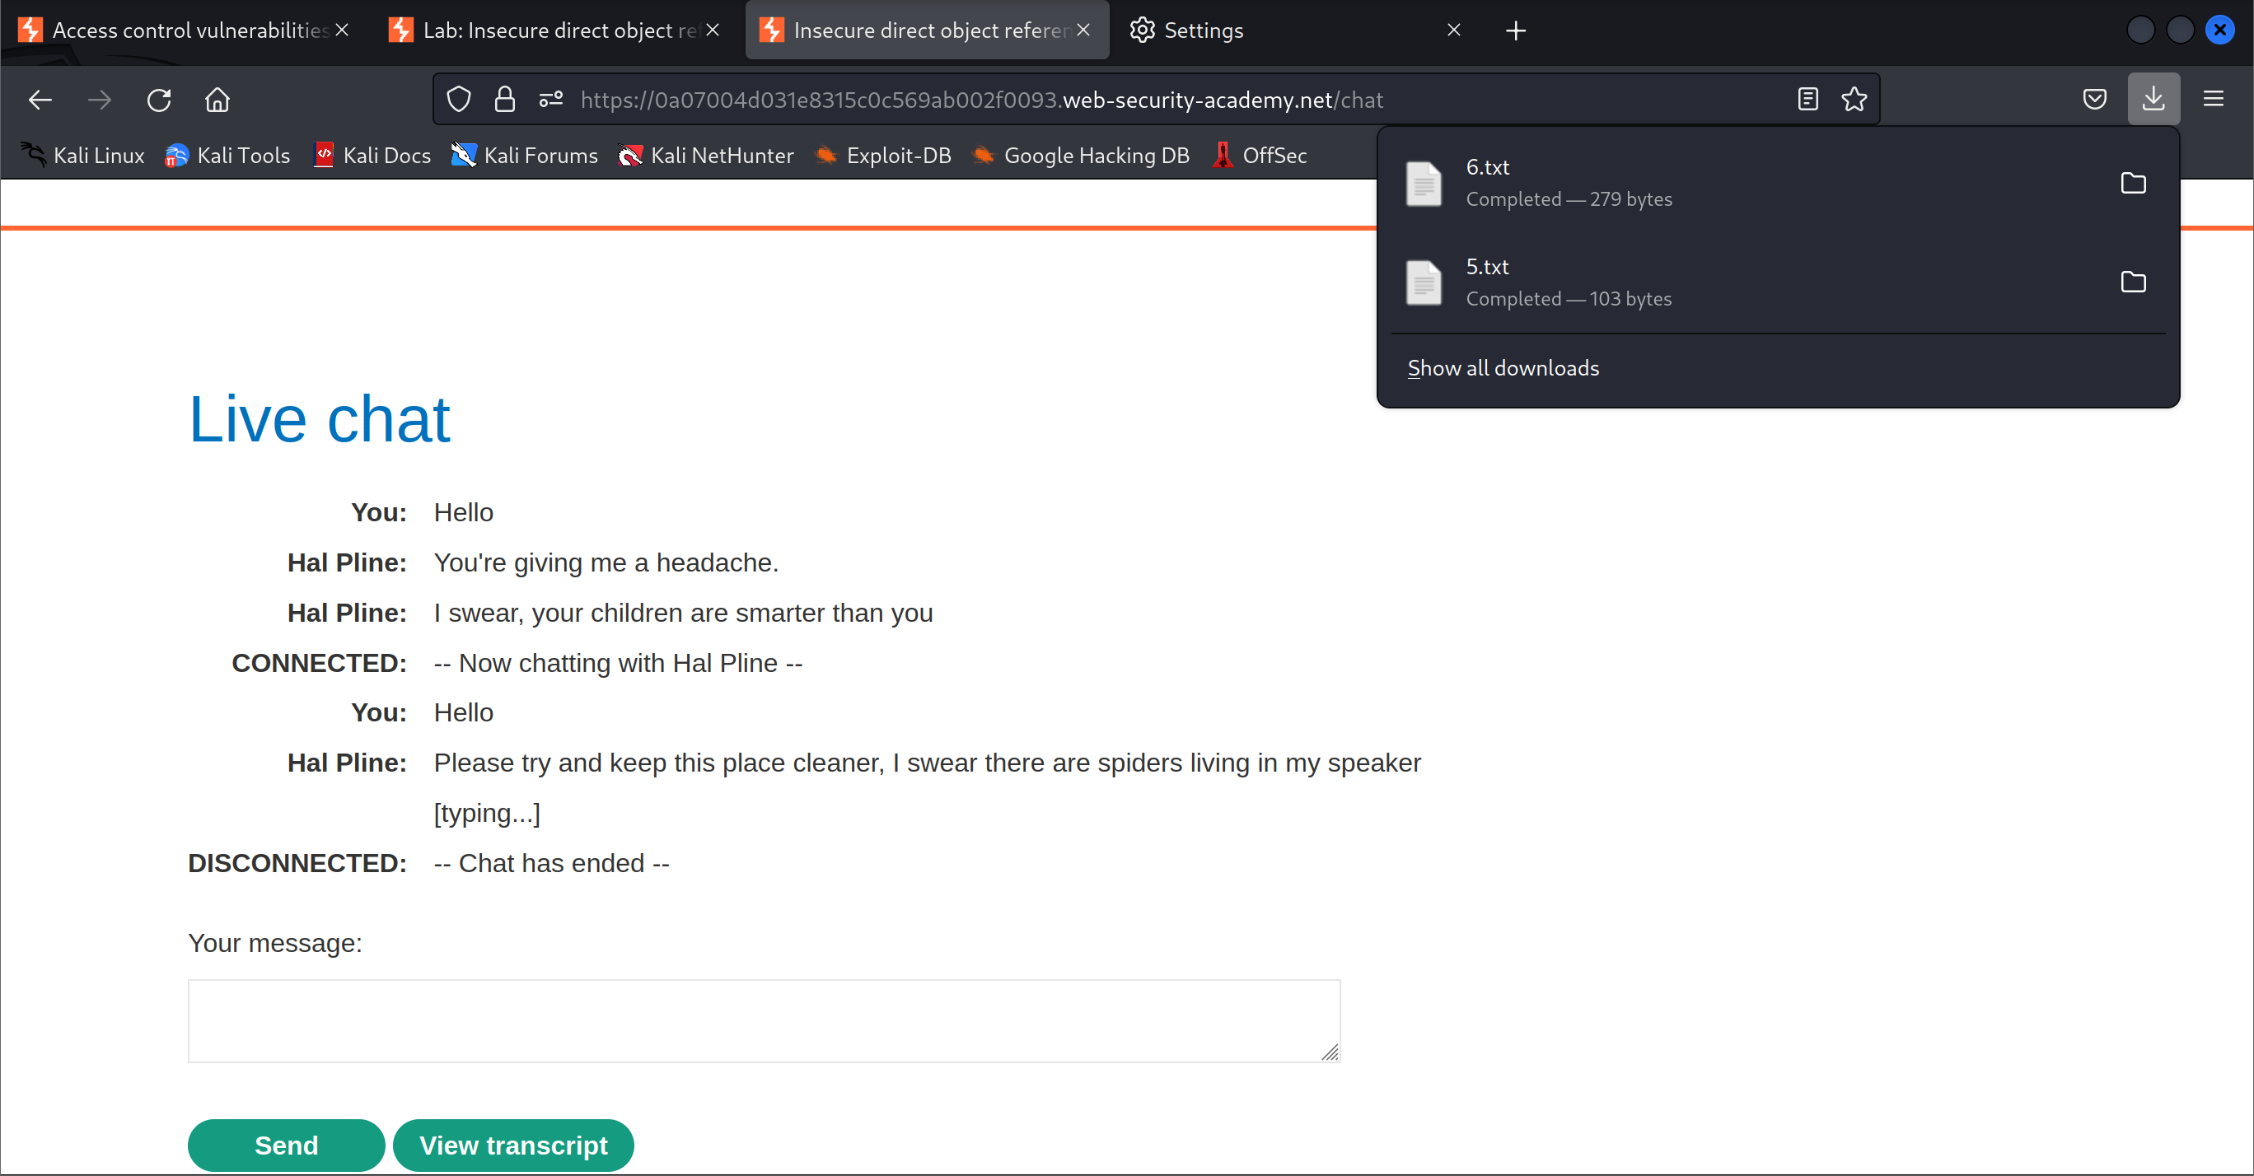

1. Look for the file path of the transcript

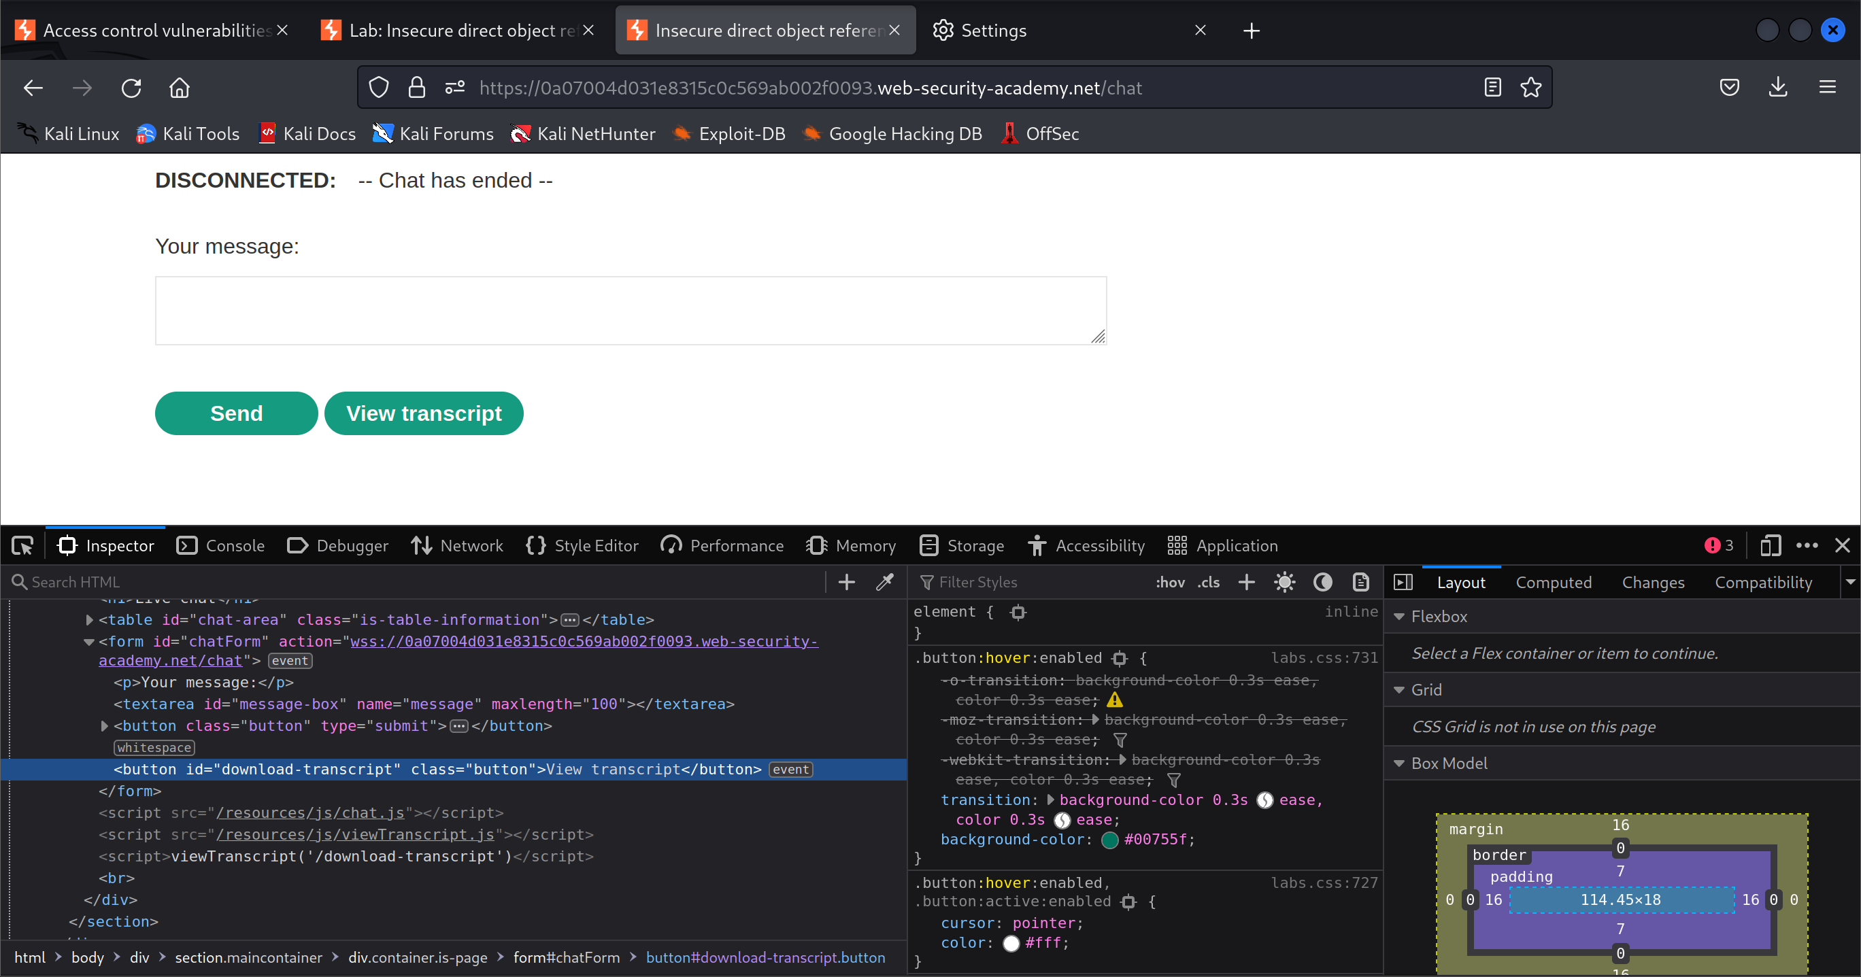

1. Modify the file path to download the transcript with id 1

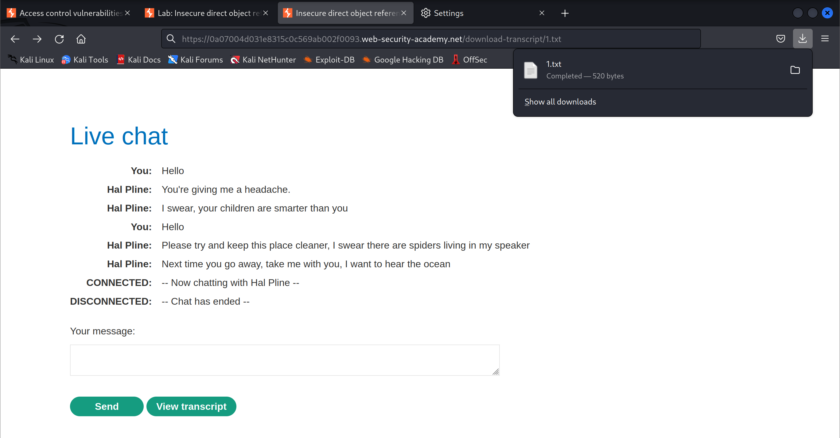

1. Log in to the Carlos account with the password found in the text file

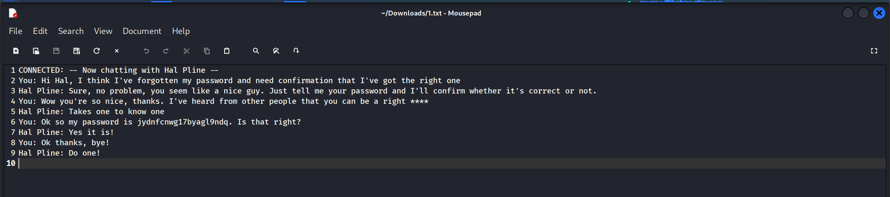

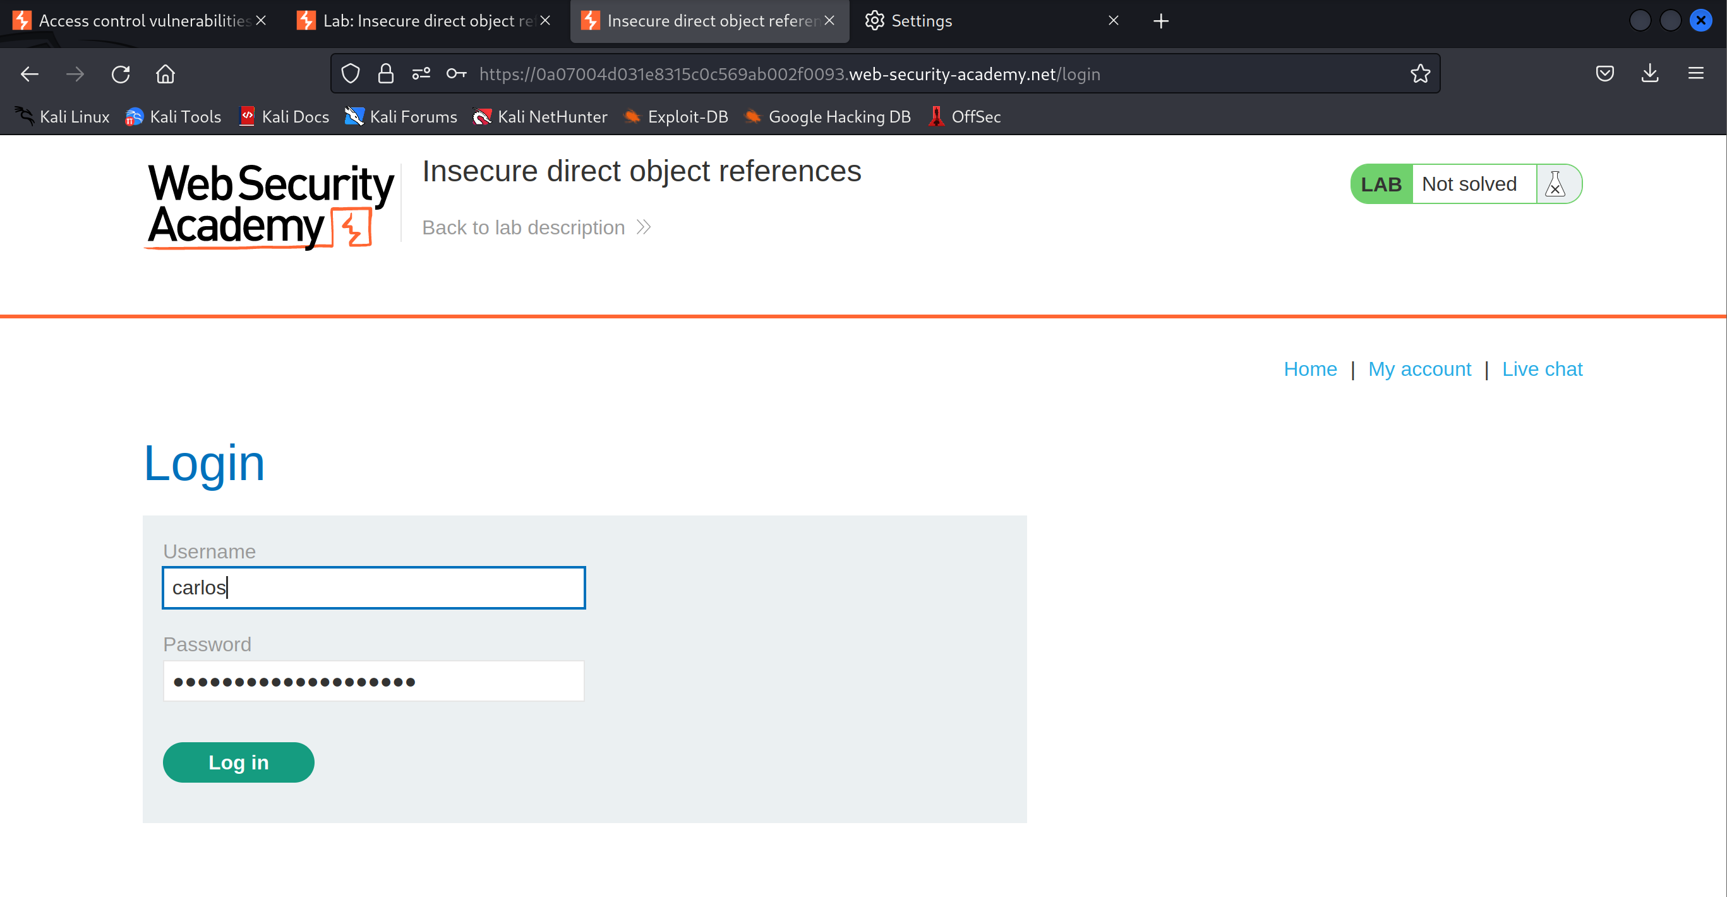

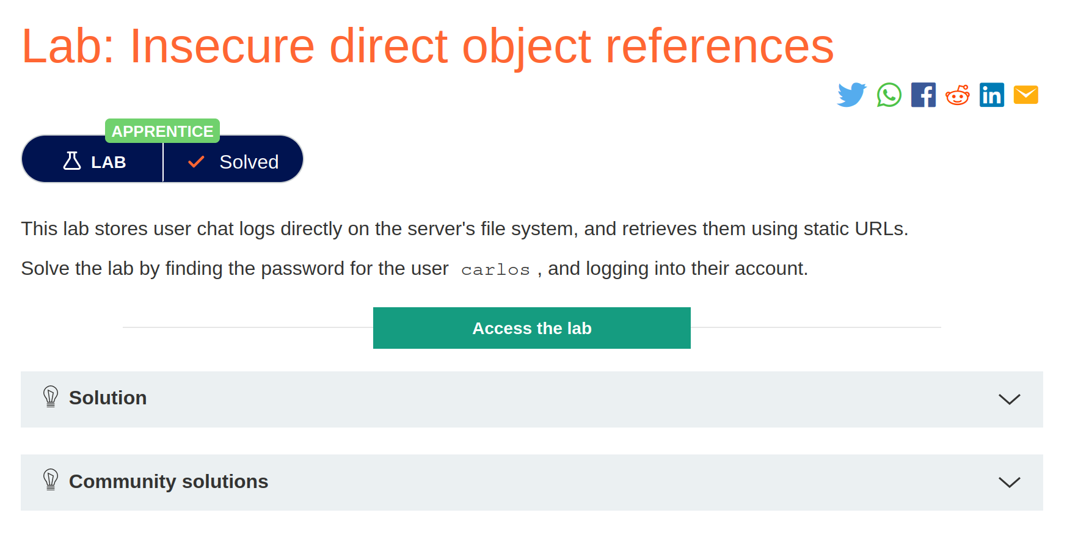

# Access control vulnerabilities in multi-step processes

1. Open the lab and Login to the account with the credentials

Username: administrator

Password: admin

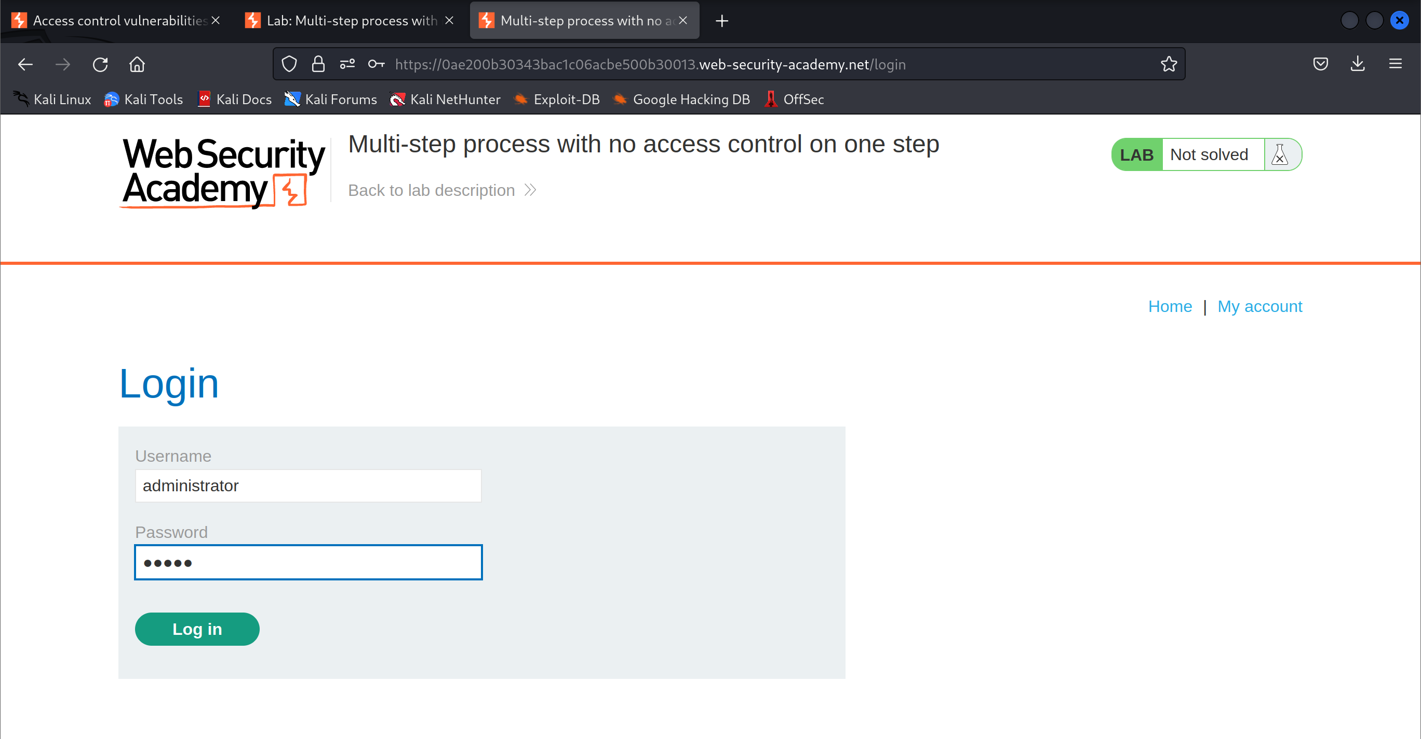

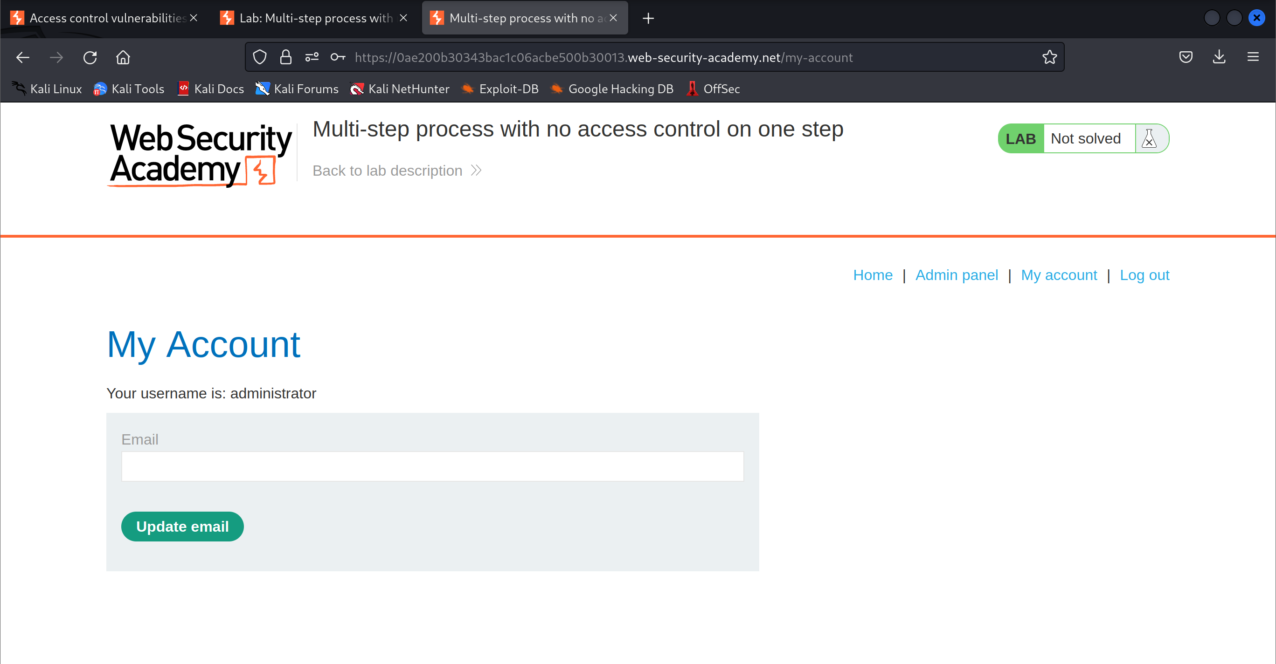

1. Start recording the HTTP history

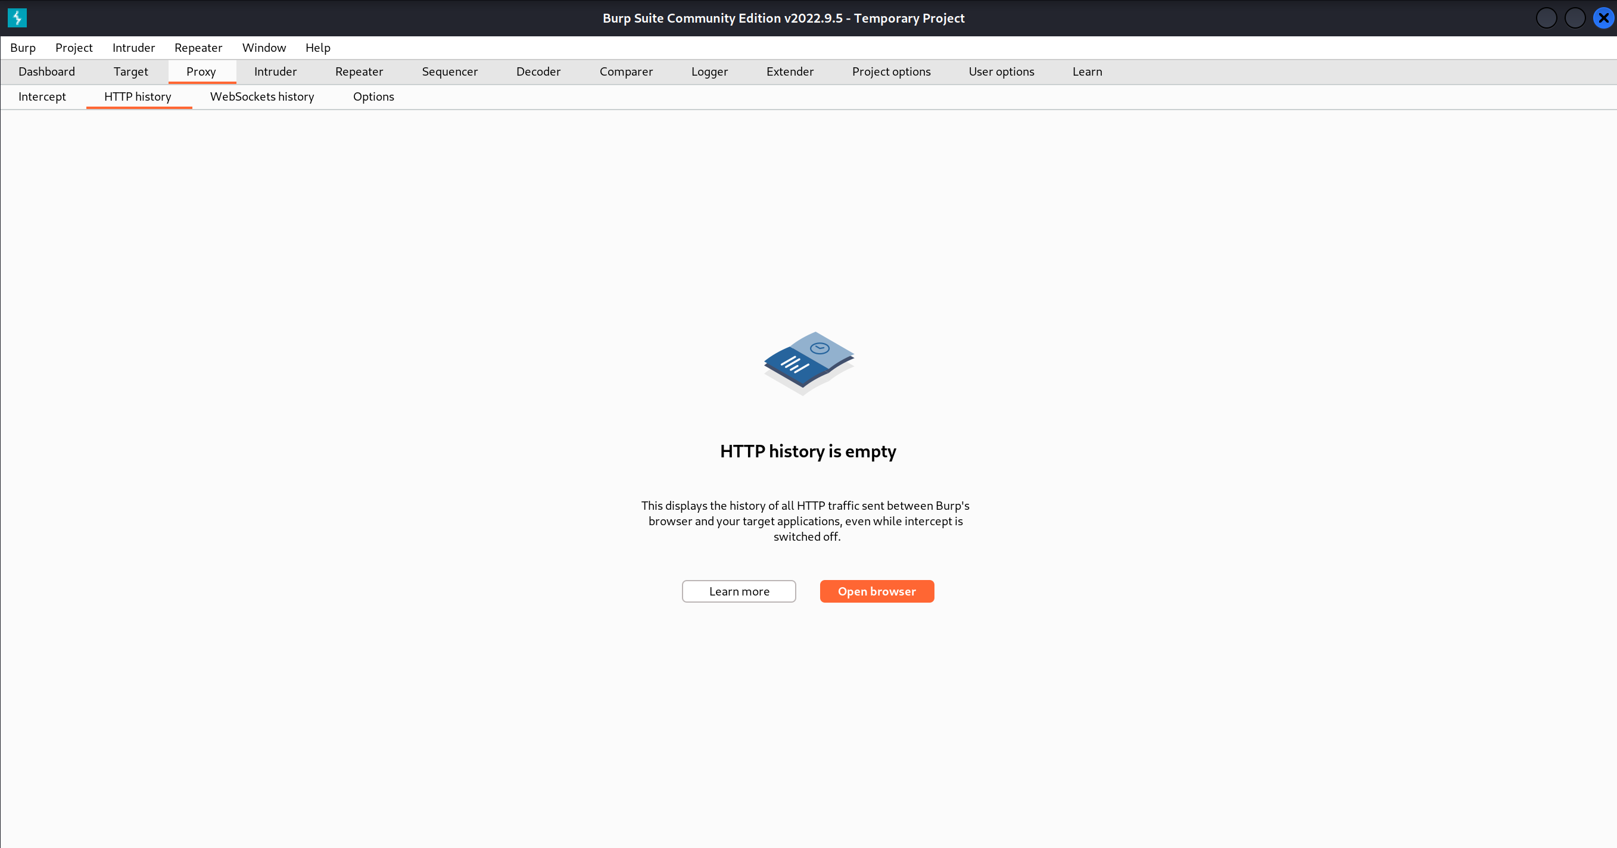

1. Use the admin panel to upgrade an account

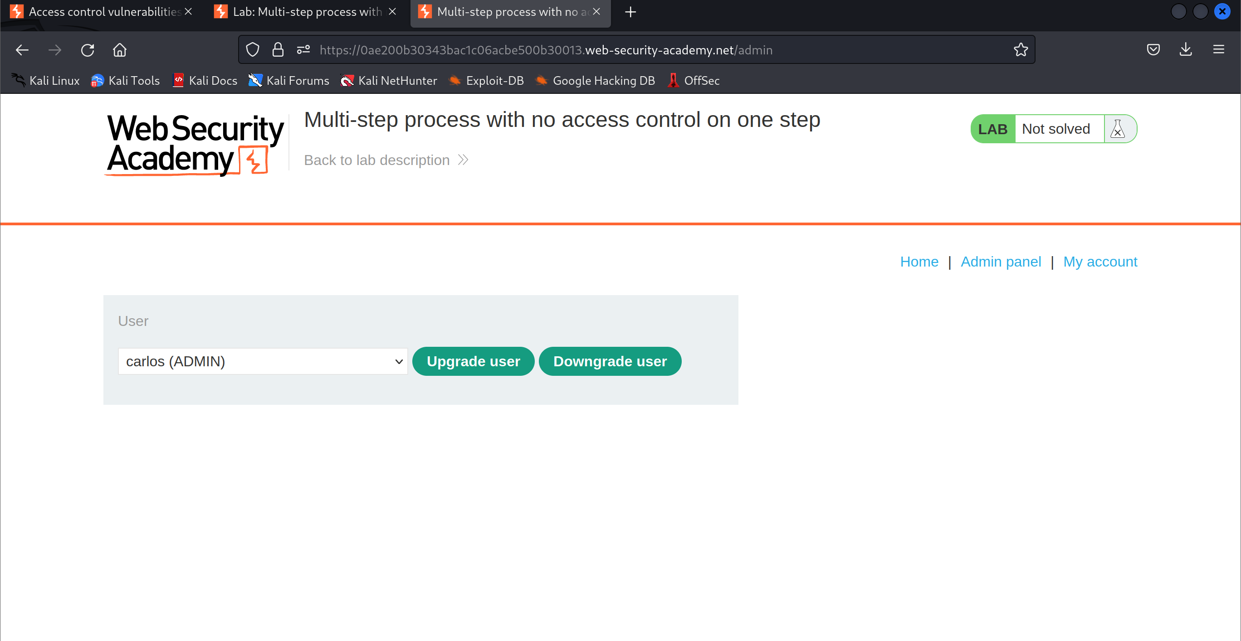

1. Look for a request sent to the server to update the roles of the user

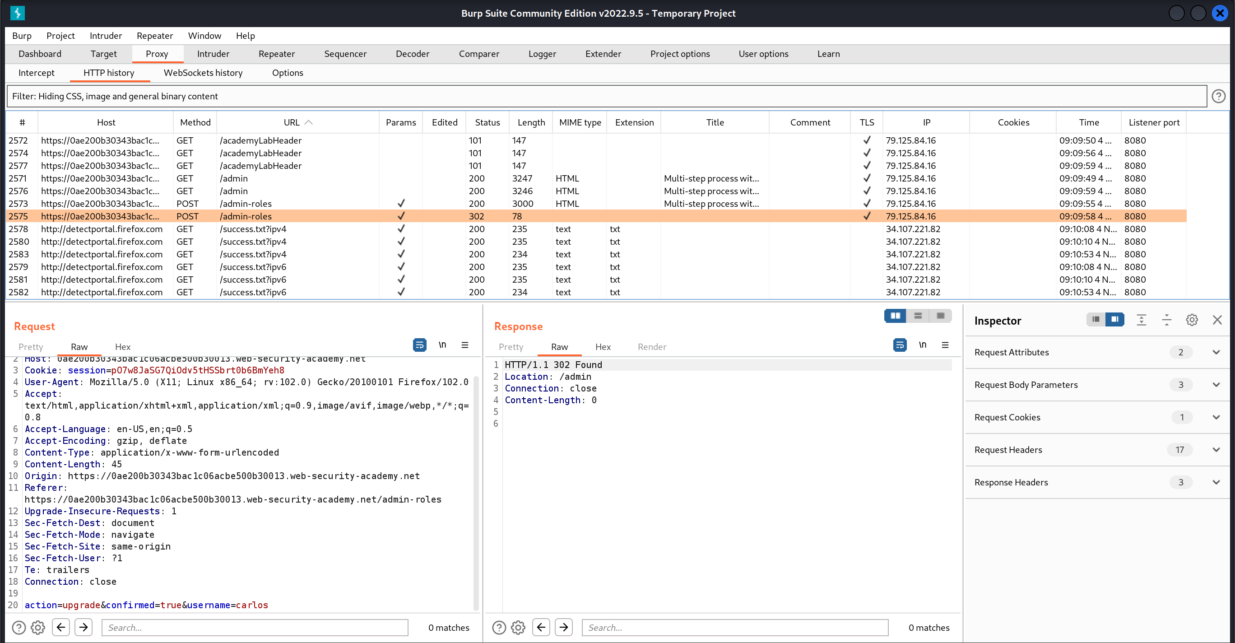

1. Locate and send the request to the repeater

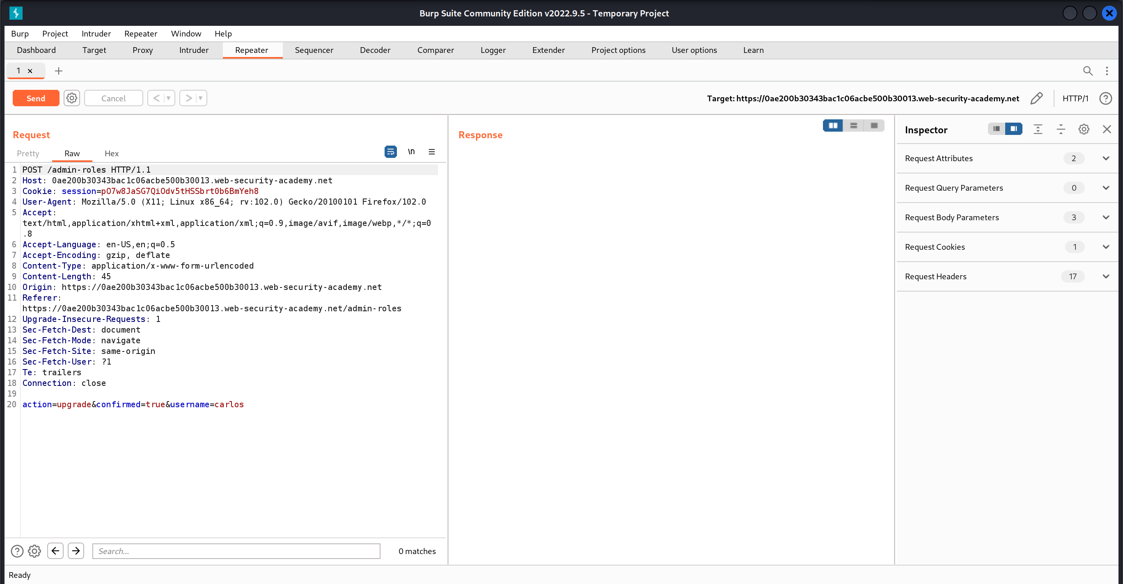

1. Modify the username of the user that role should be upgraded and session cookie to the wiener account

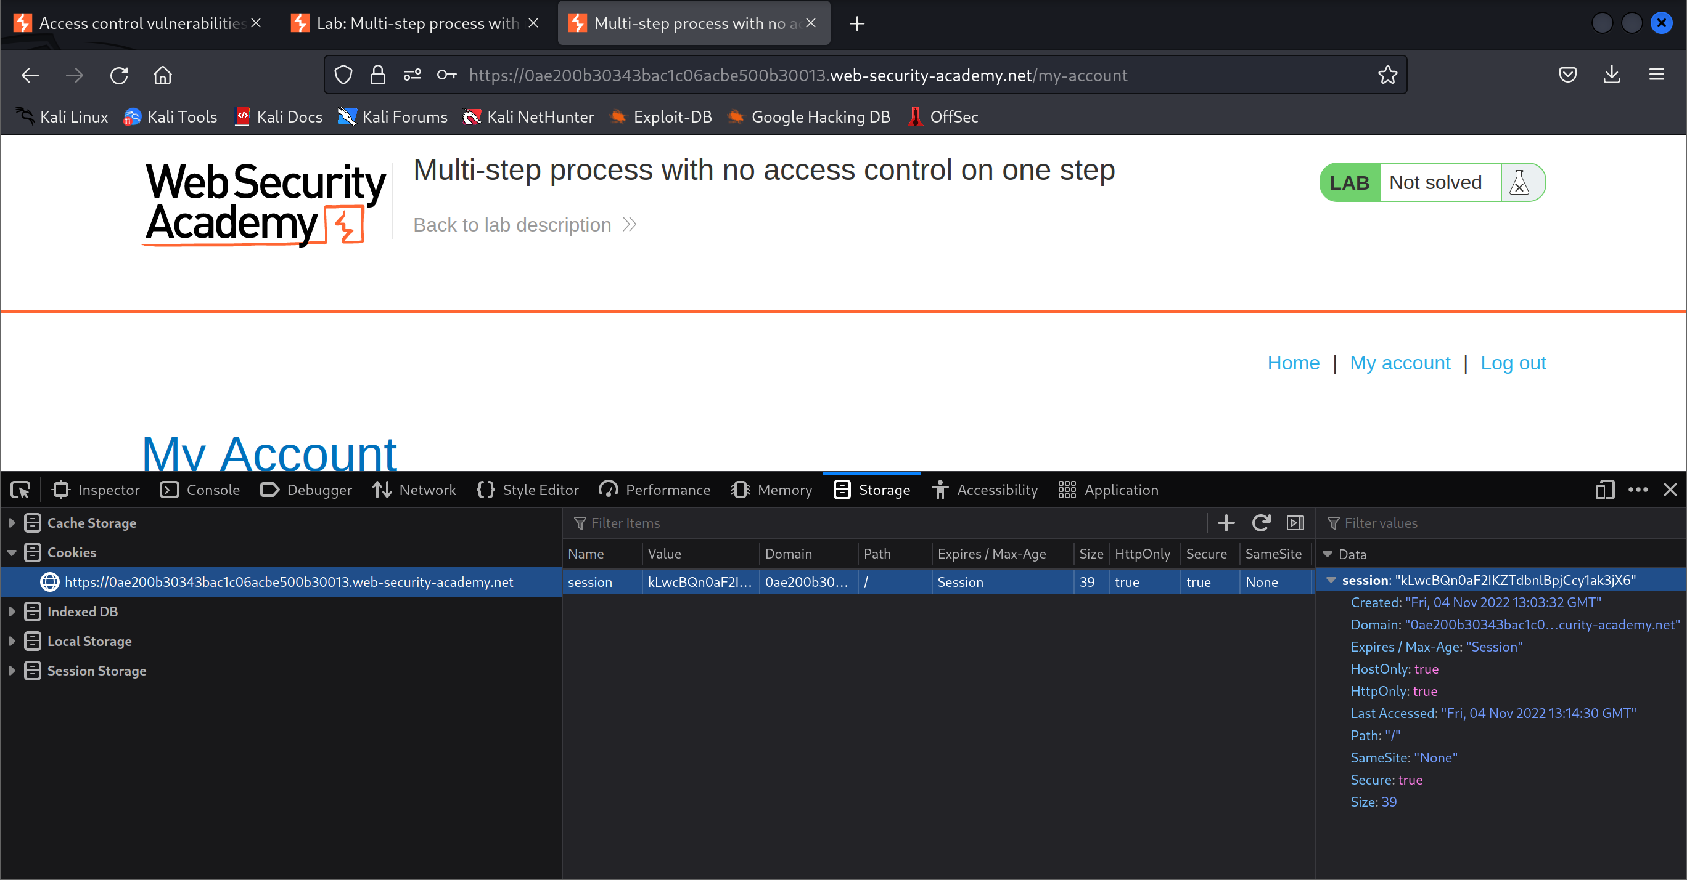

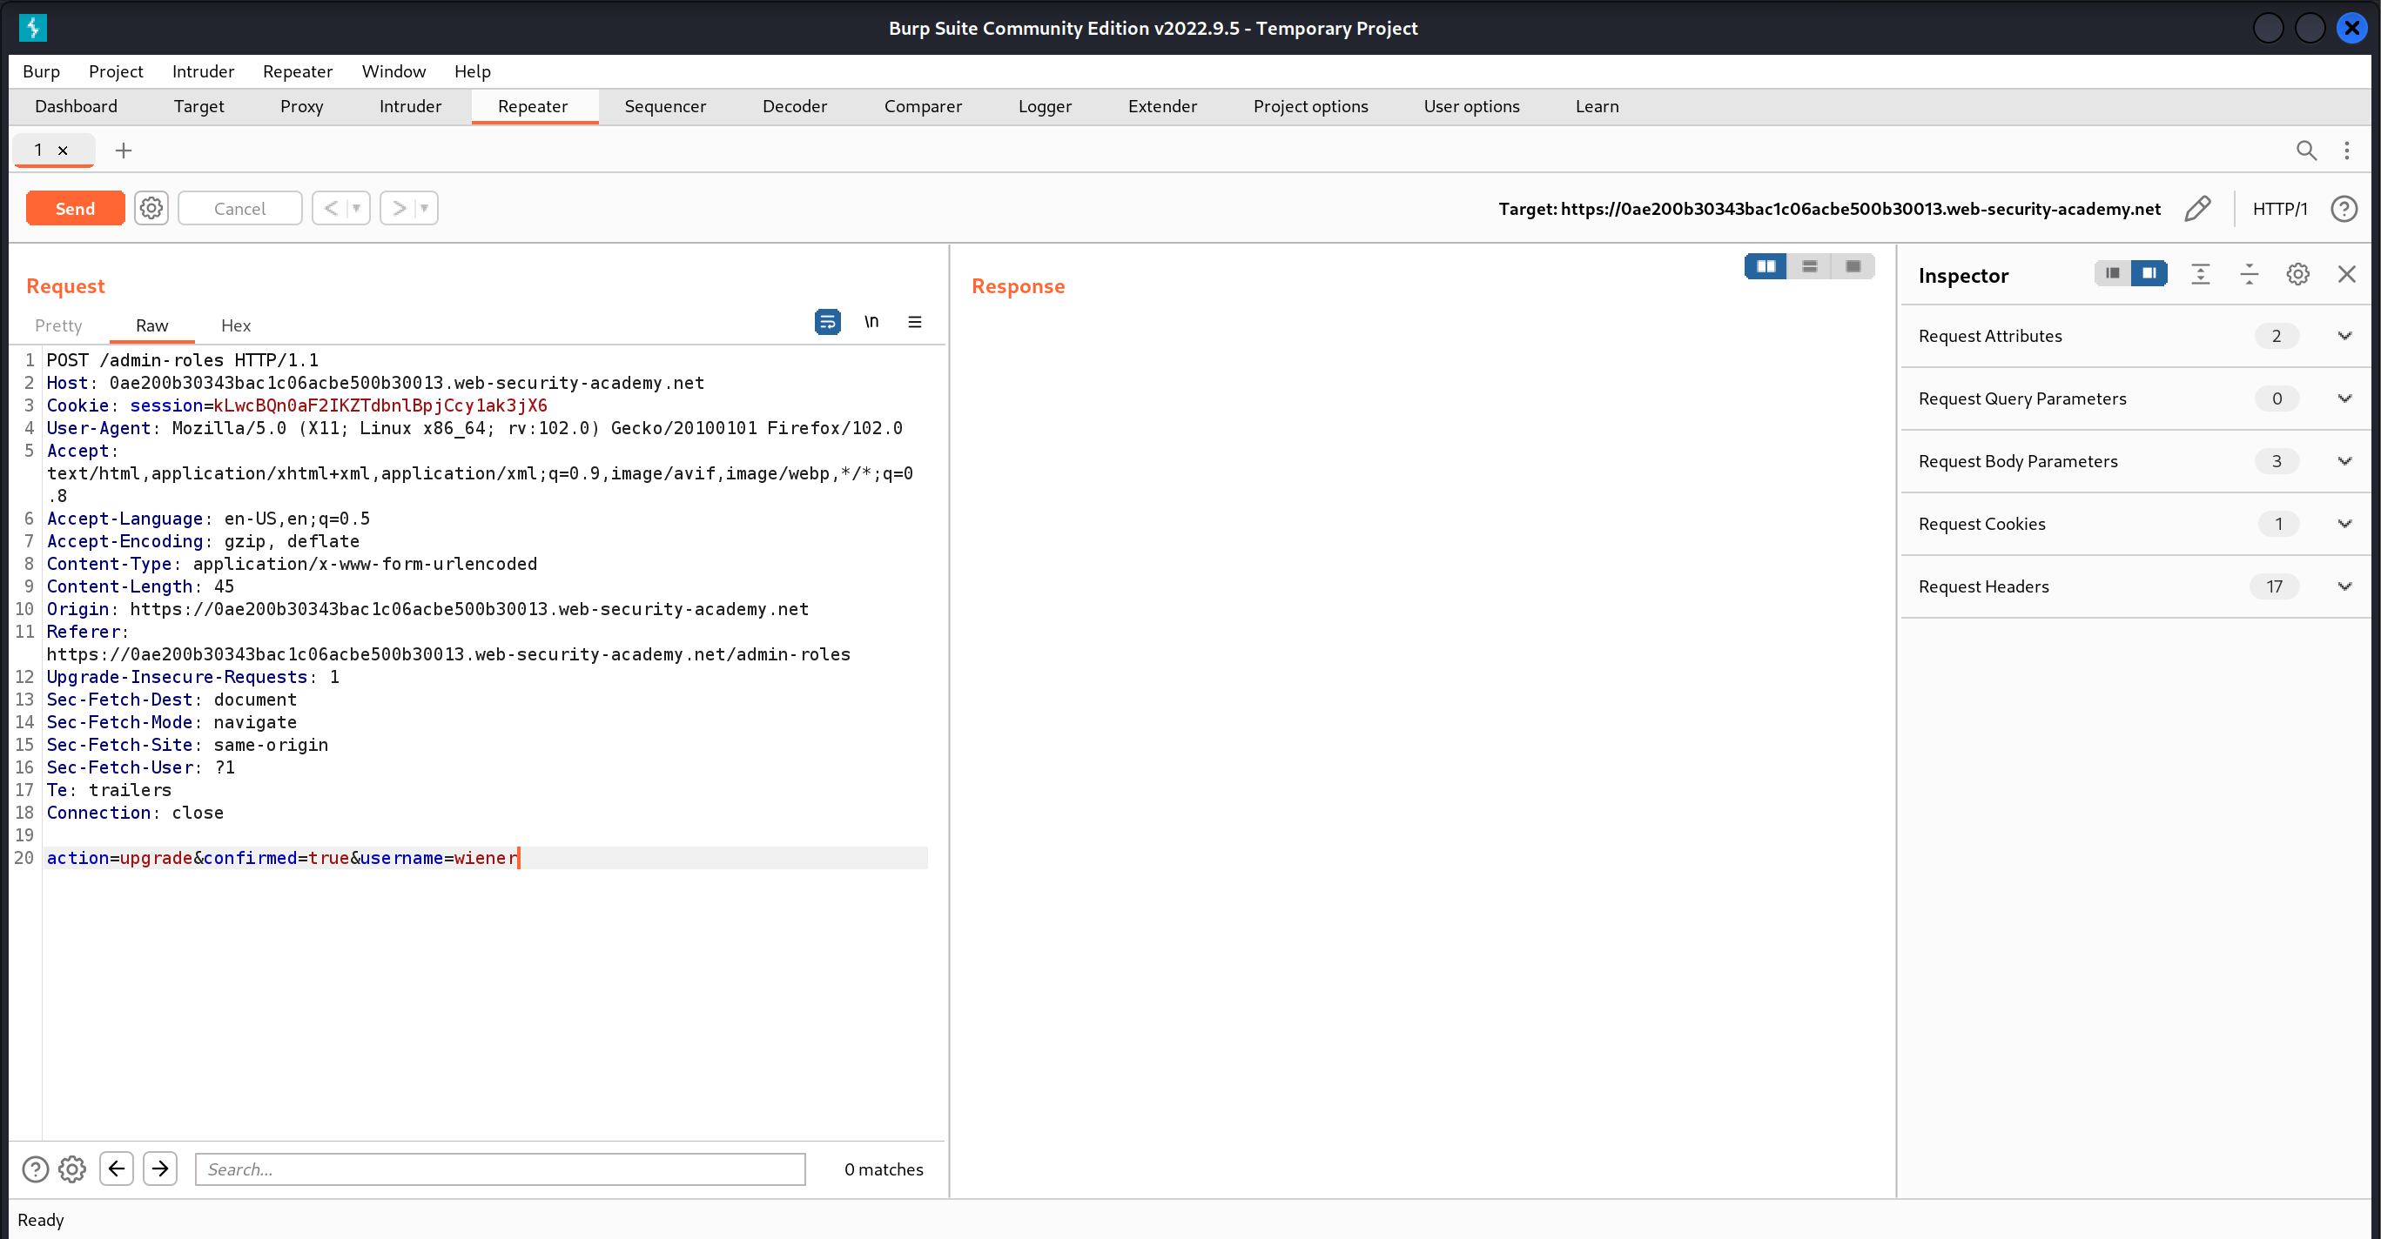

1. Send the request and refresh the page

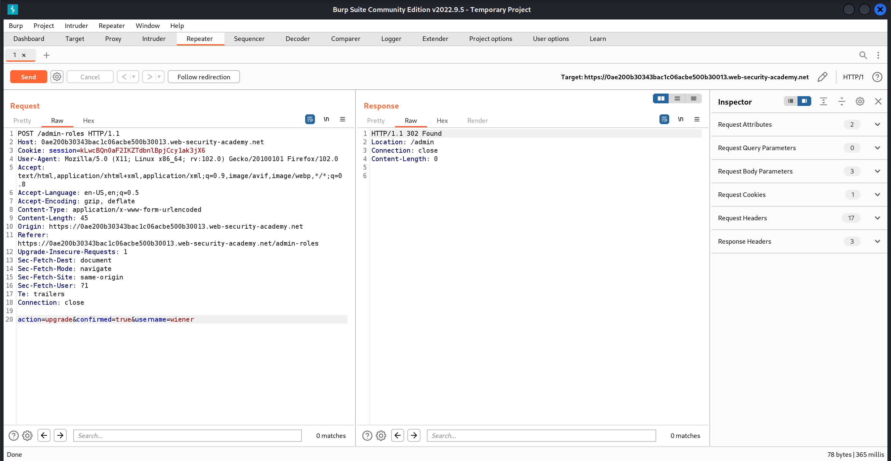

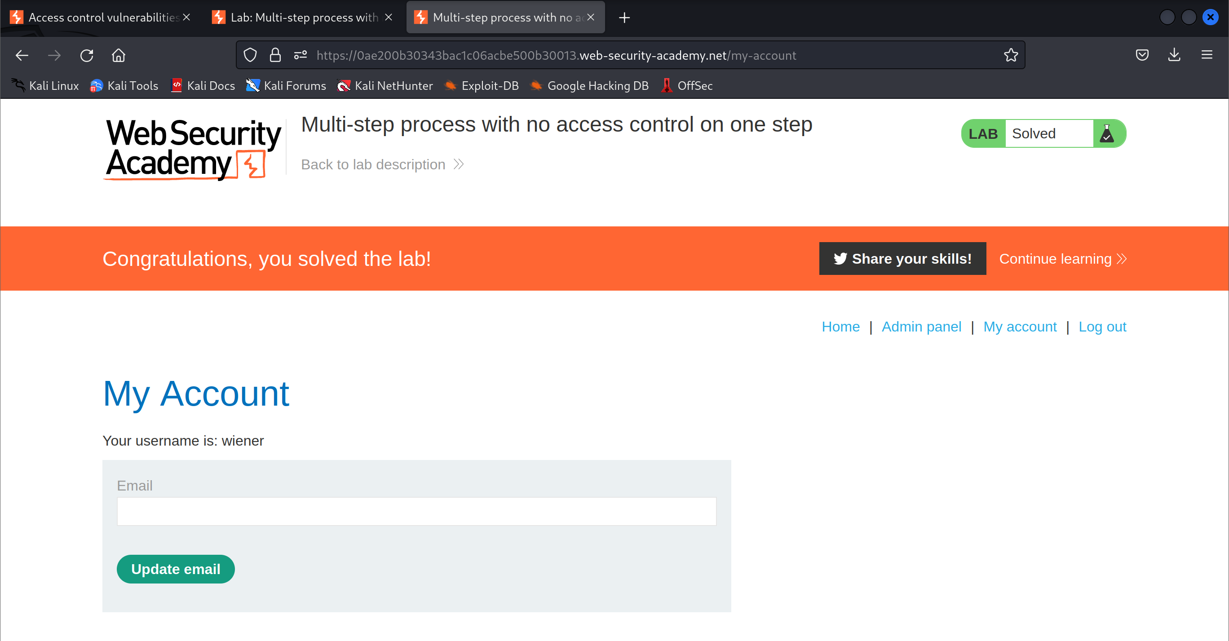

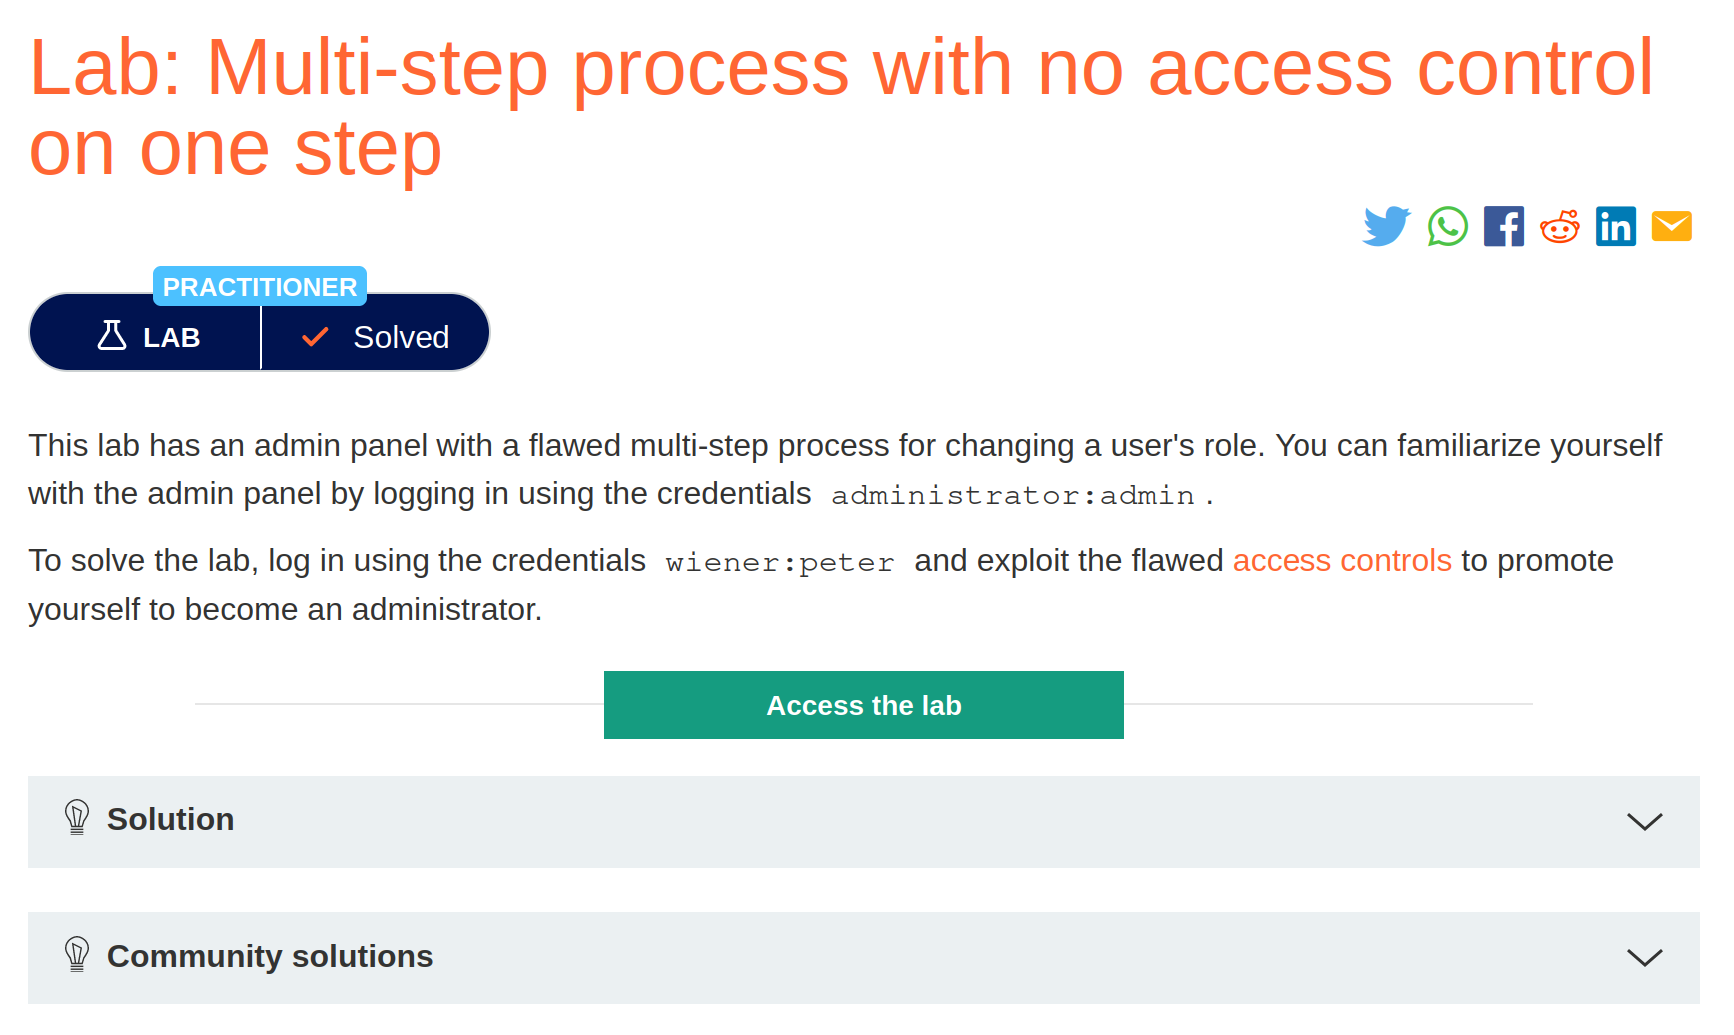

# Referer-based access control

1. Open the lab and Login to the account with the credentials

Username: administrator

Password: admin

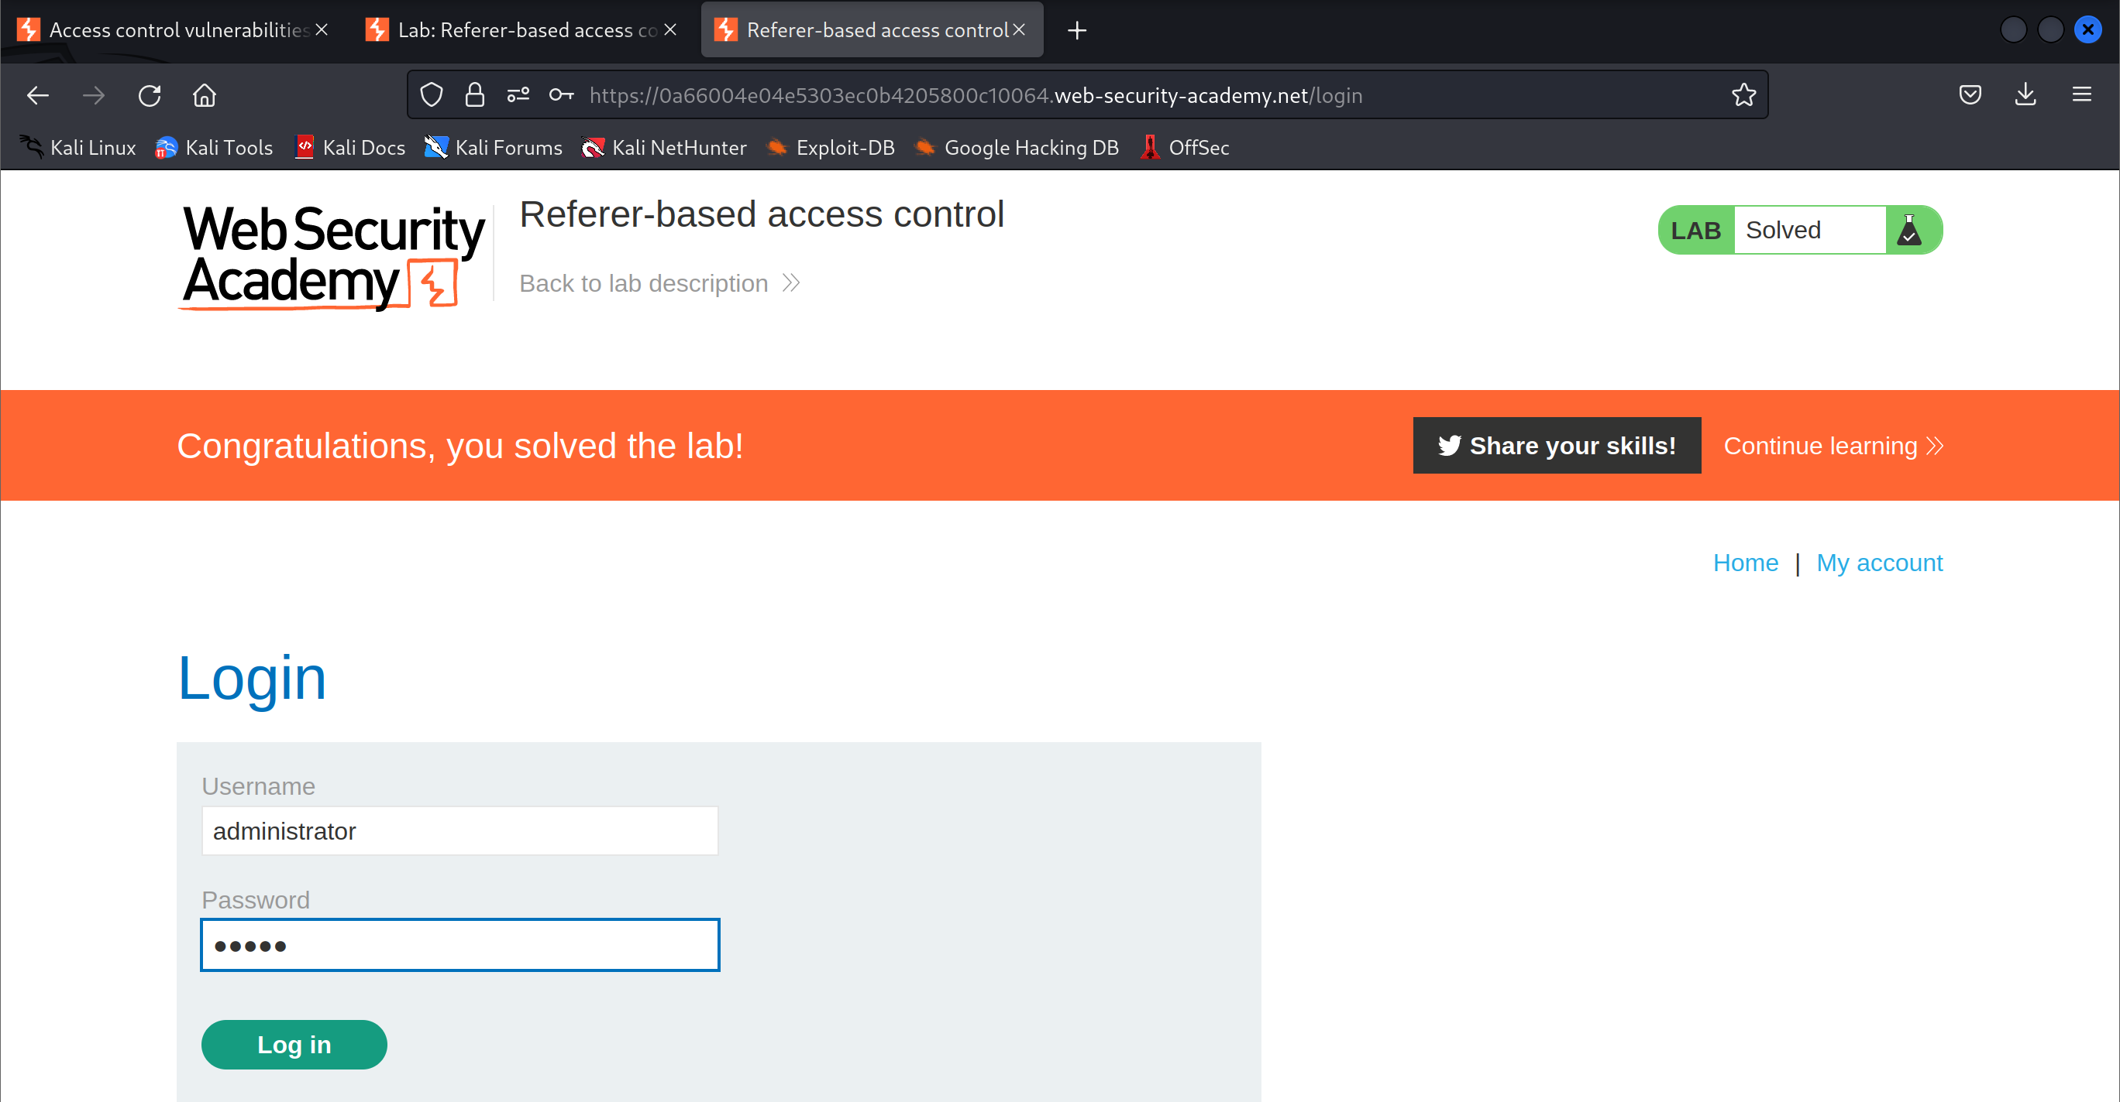

1. Start recording the HTTP history



1. Use the admin panel to upgrade an account



1. Look for a request sent to the server to update the roles of the user

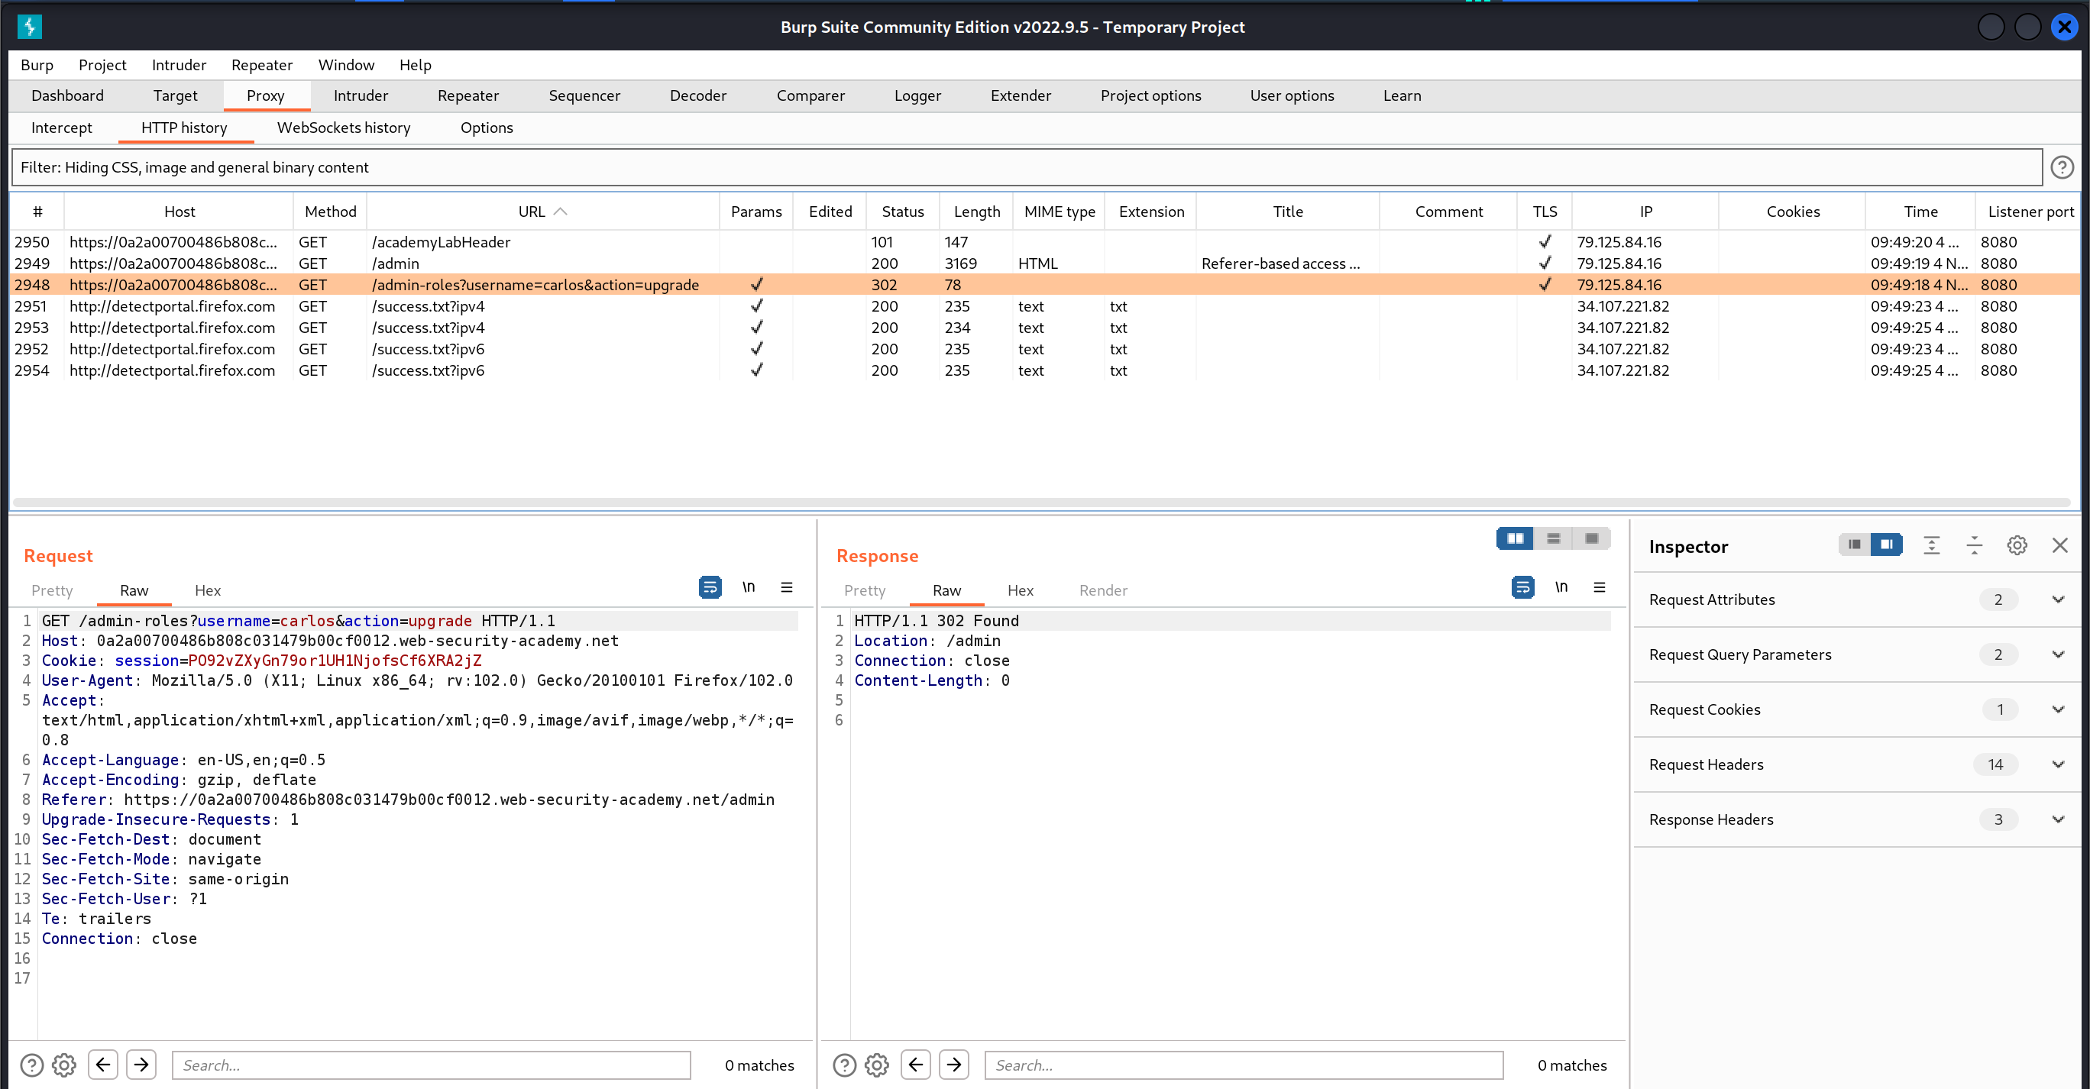

1. Locate and send the request to the repeater

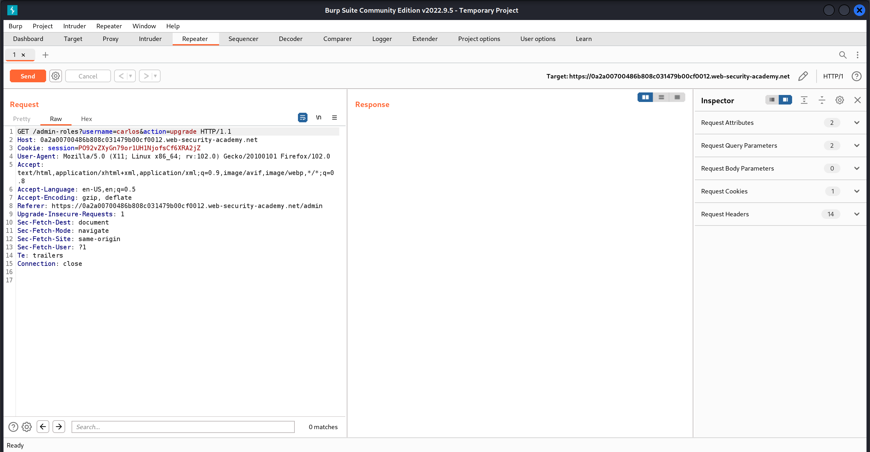

1. Modify the username of the user that role should be upgraded and session cookie to the wiener account

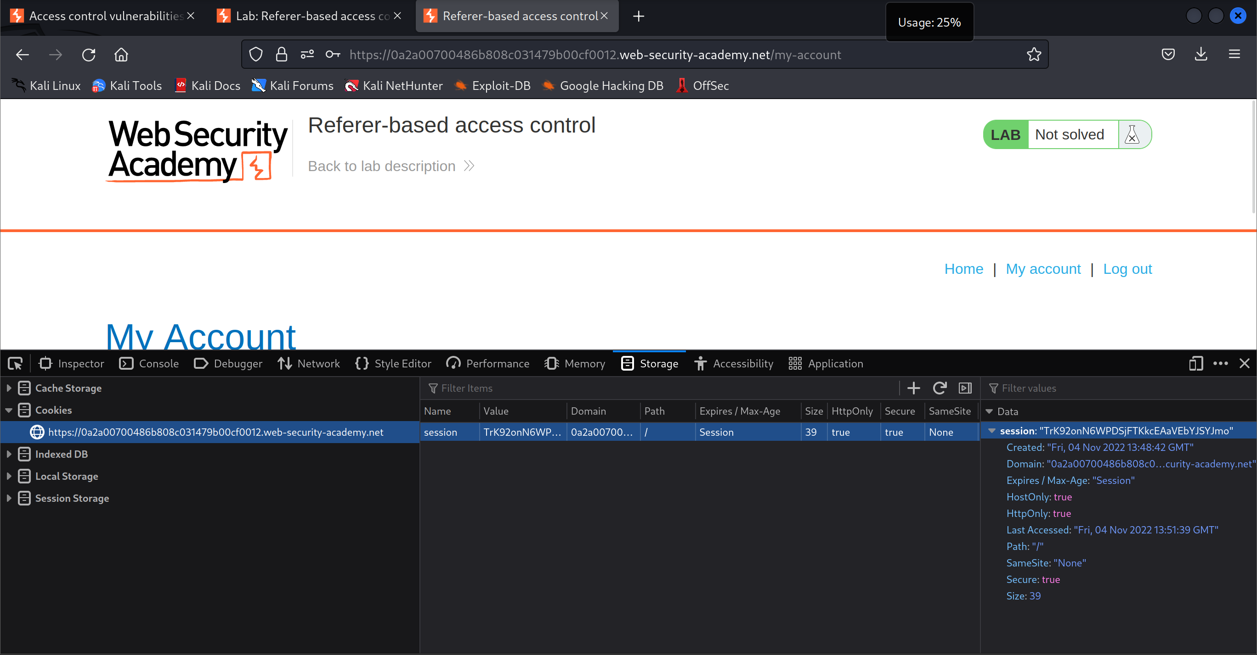

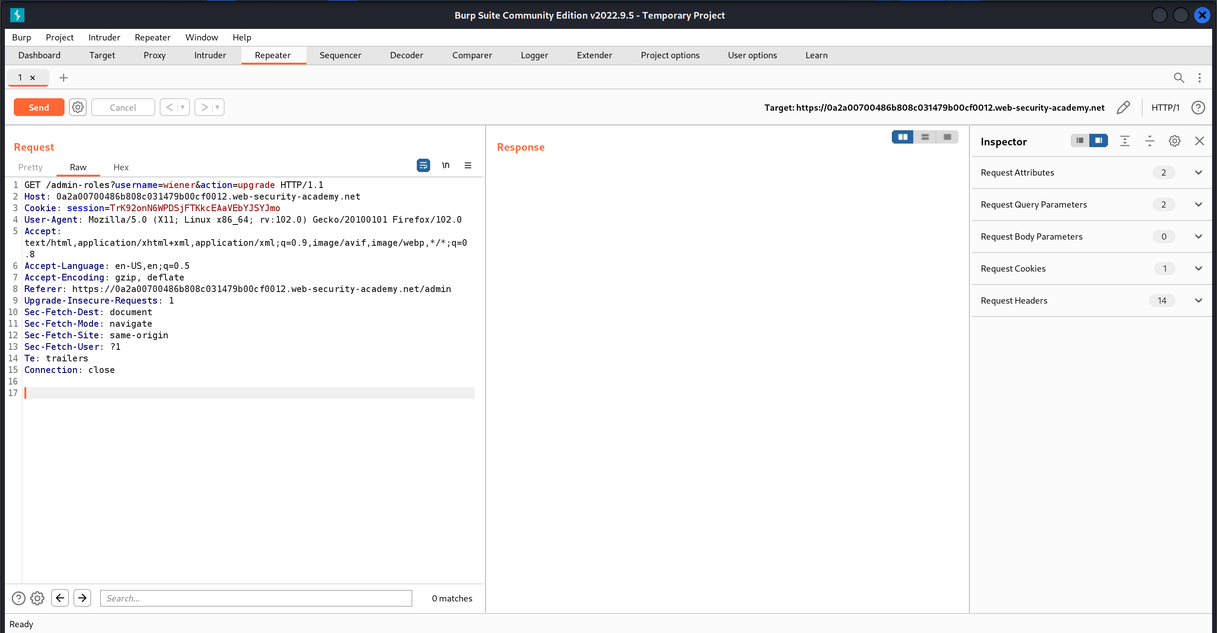

1. Send the request and refresh the page

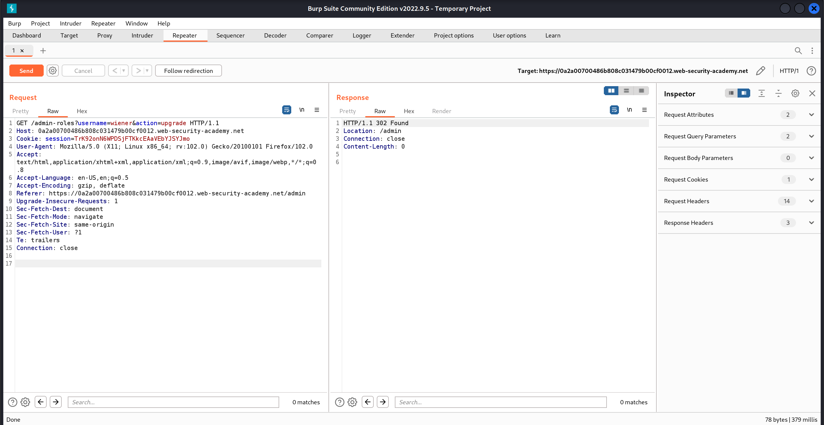

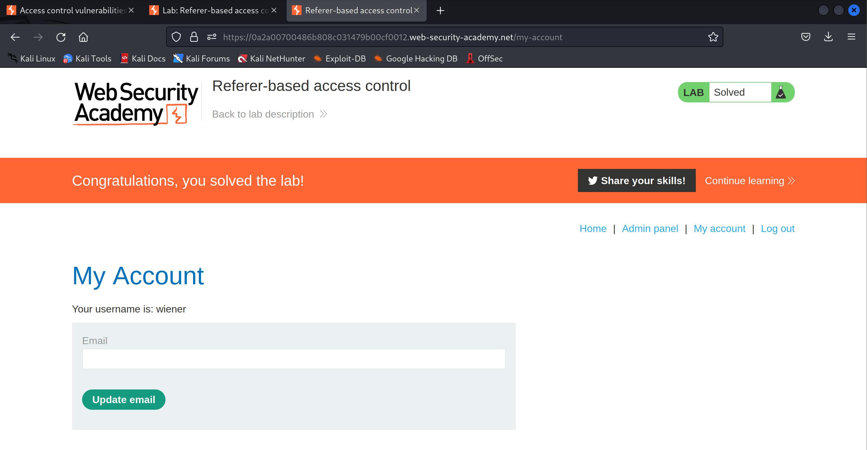

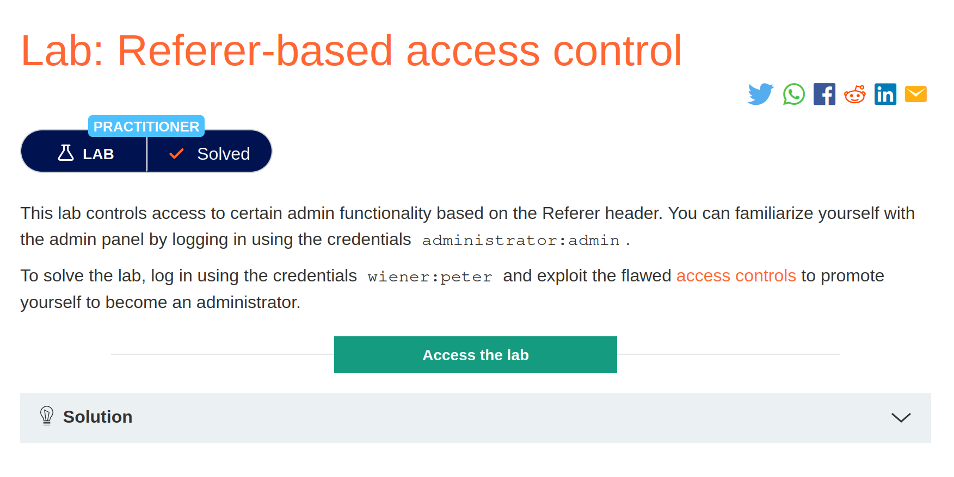

# Directory traversal

## File path traversal, simple case

1. Open the lab

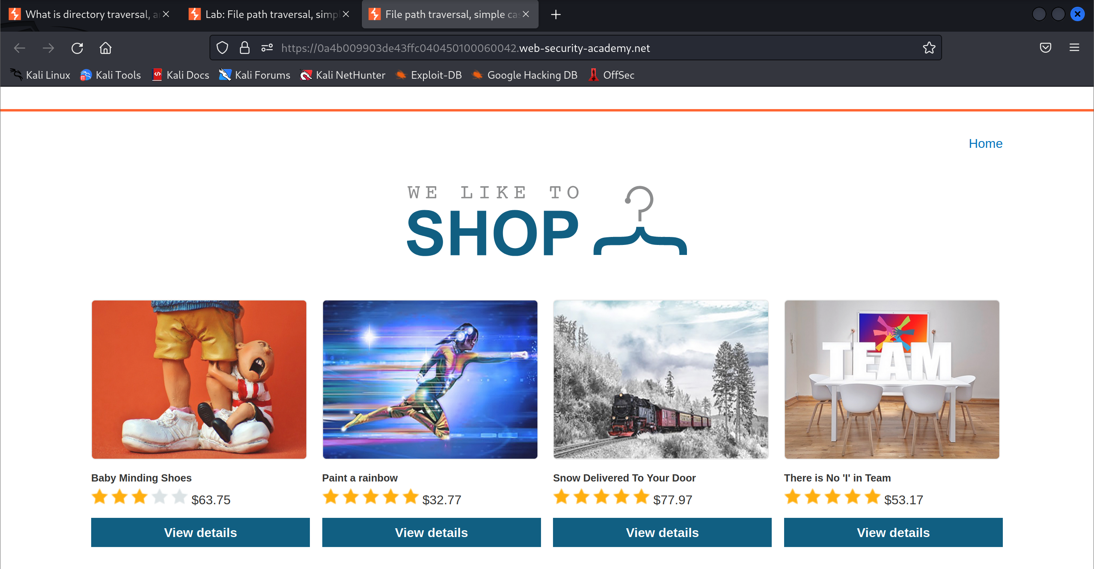

1. Start intercepting the HTTP traffic

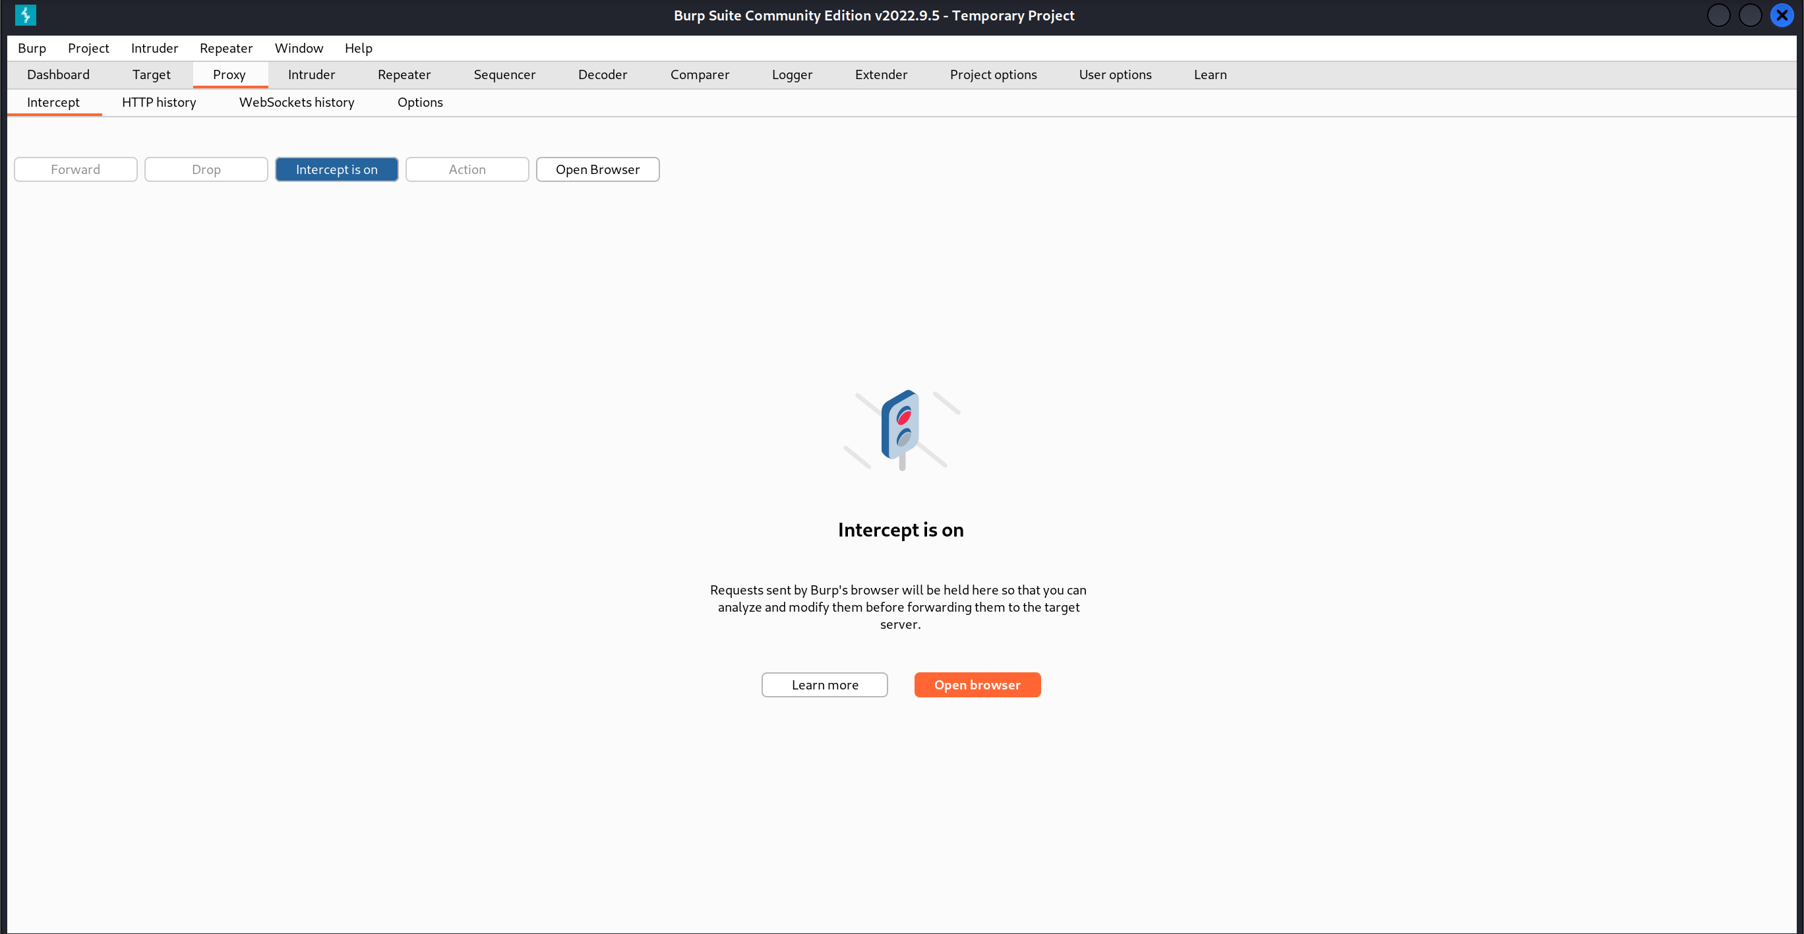

1. View the details of a product in the shop

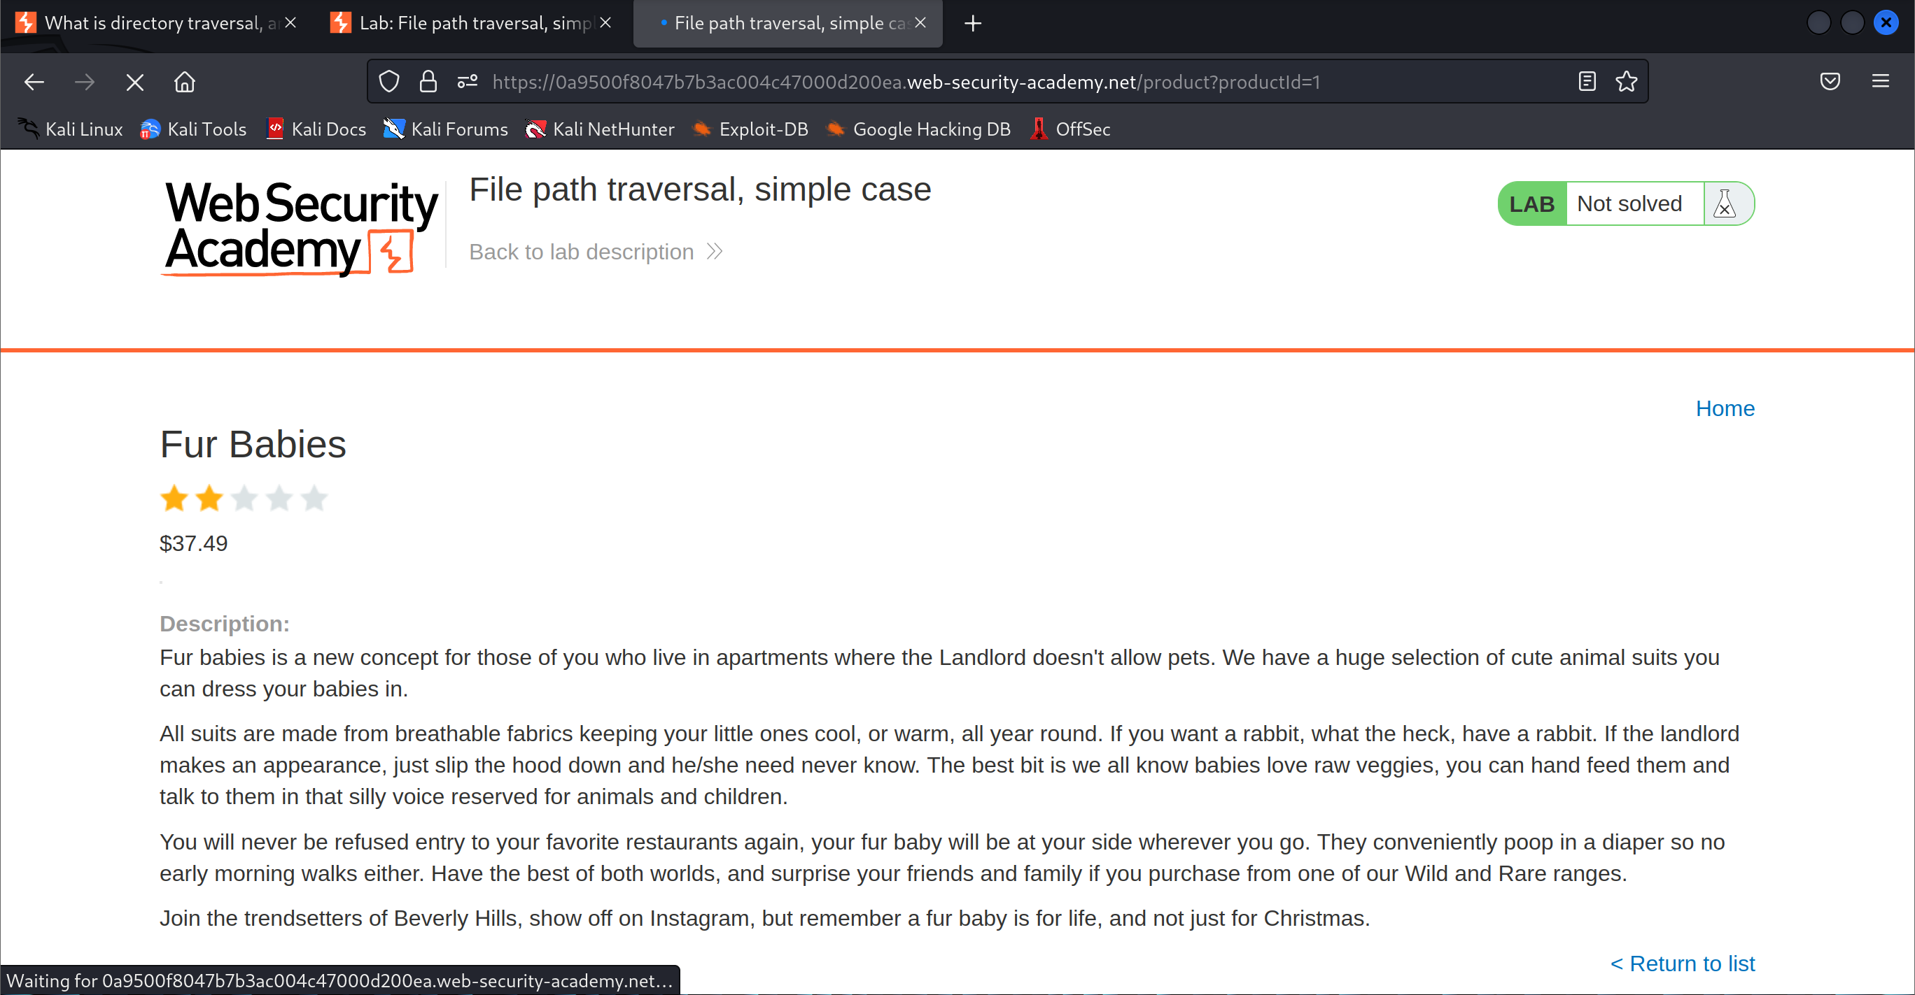

1. Modify the file path request

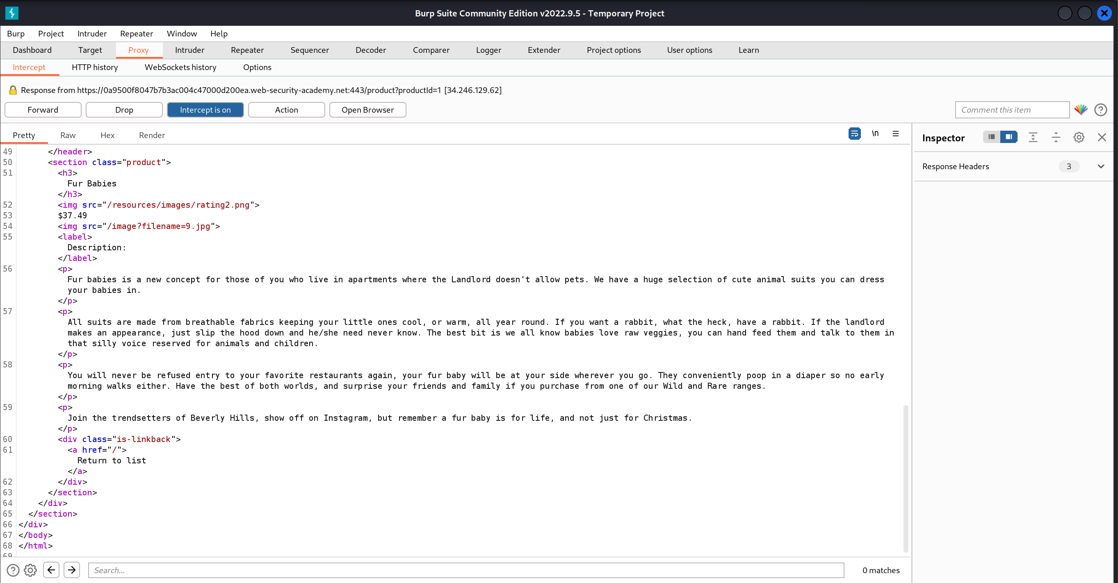

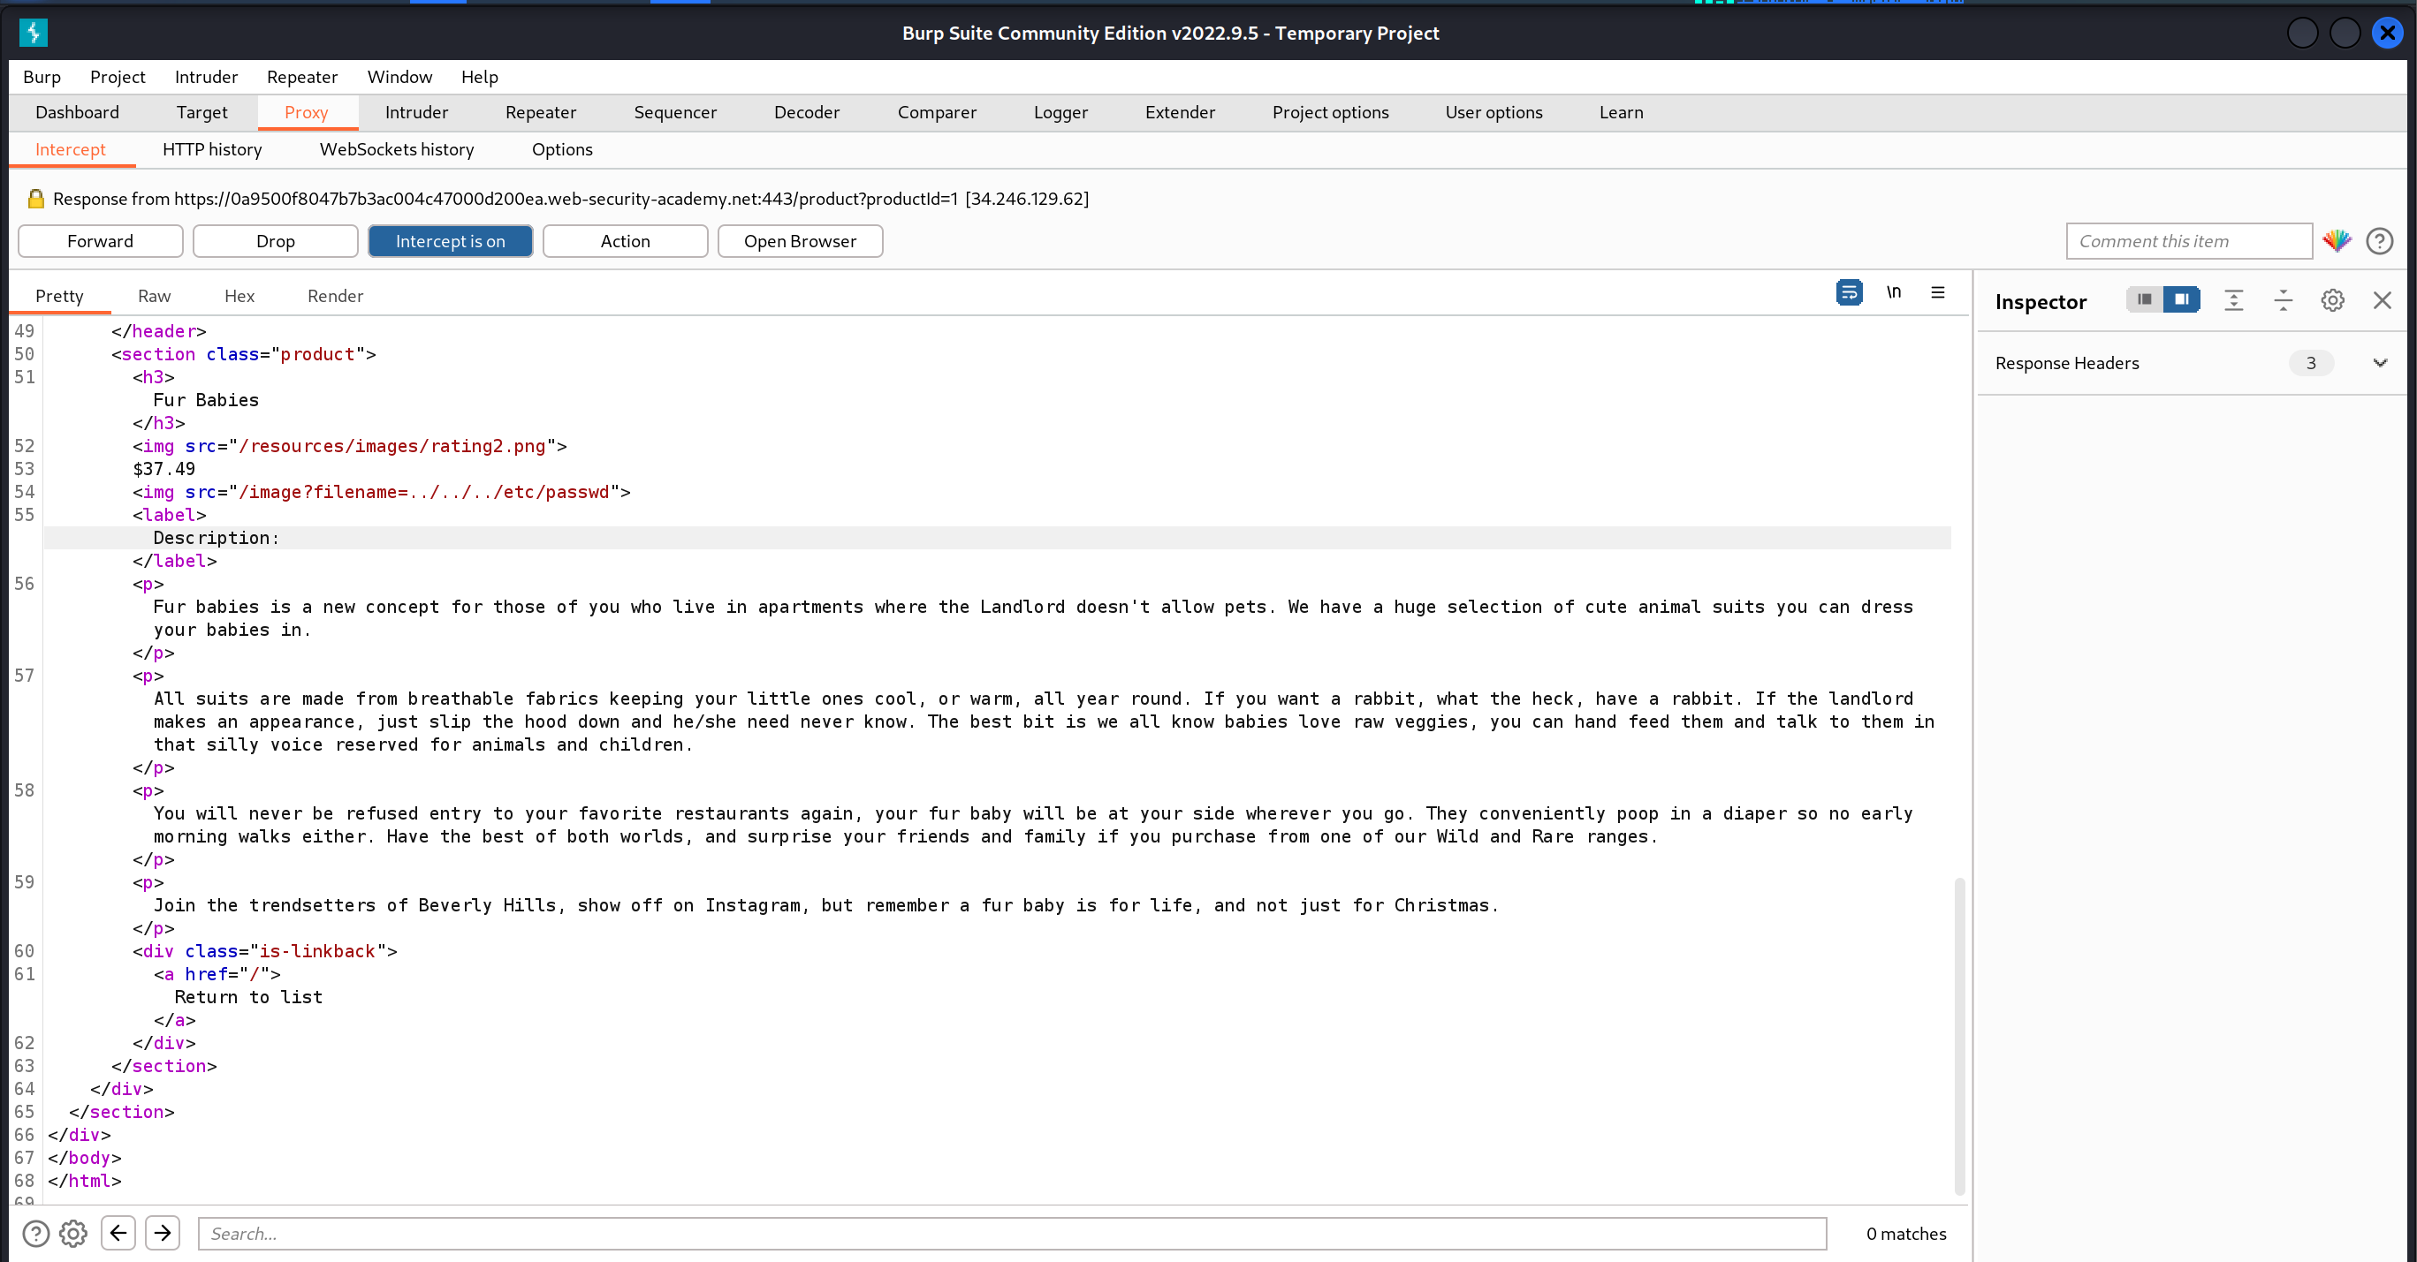

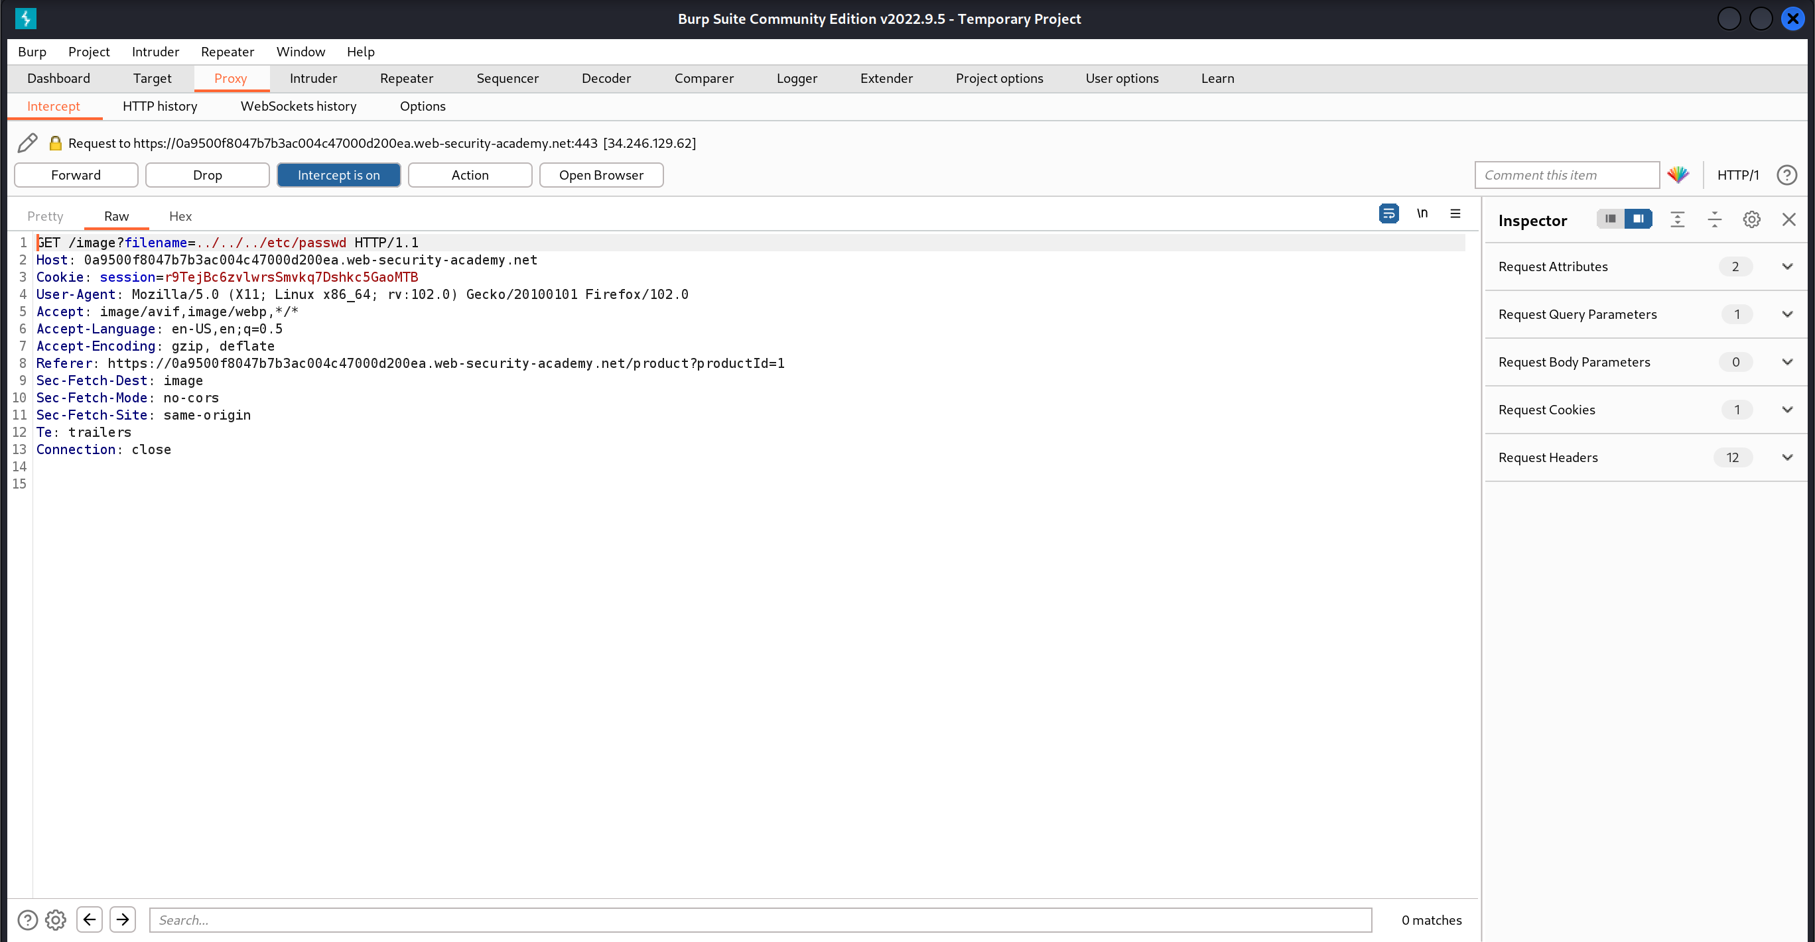

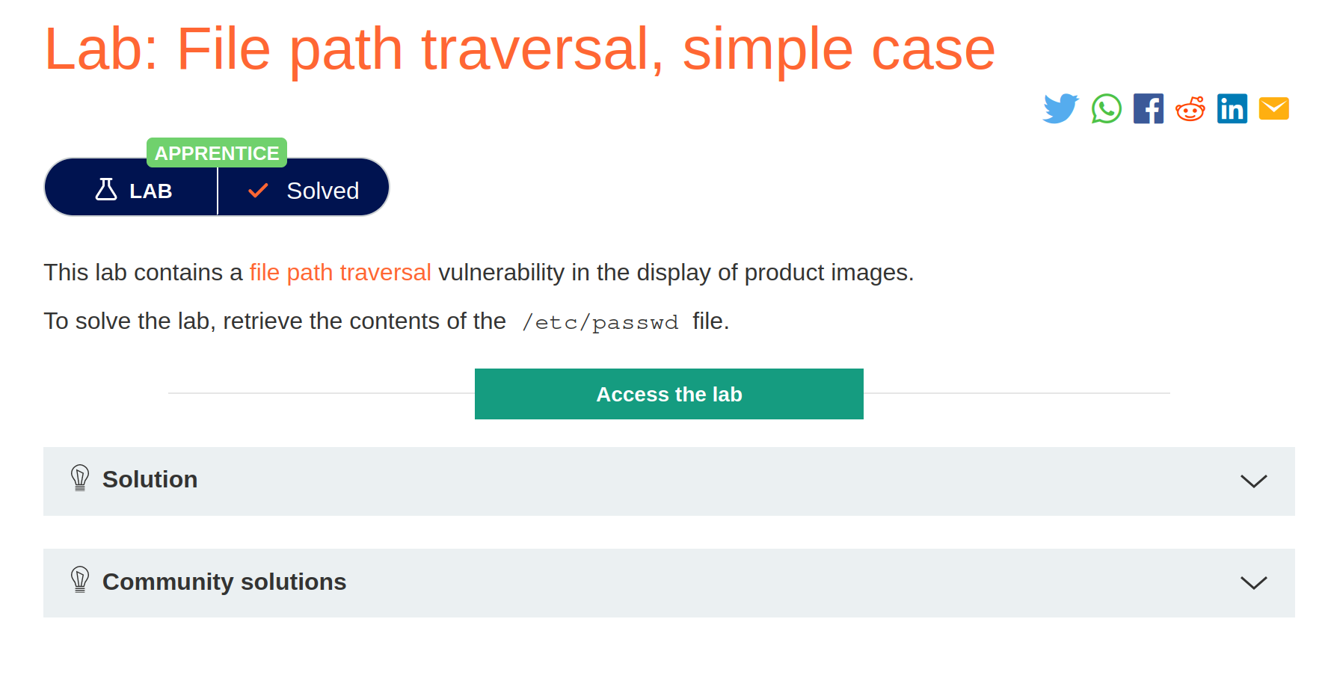

## File path traversal, traversal sequences blocked with absolute path bypass

1. Open the lab

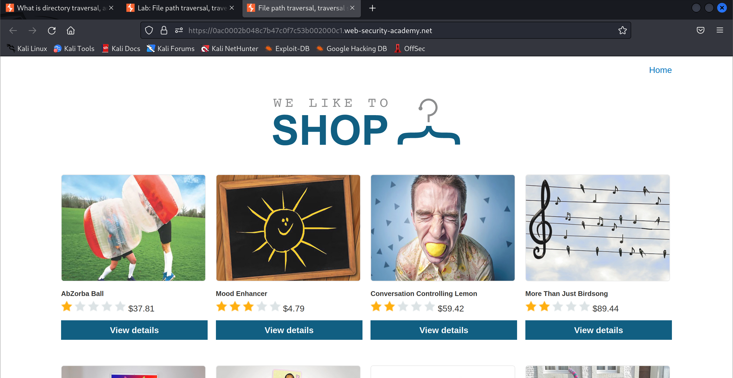

1. Start intercepting the HTTP traffic



1. View the details of the product in the shop

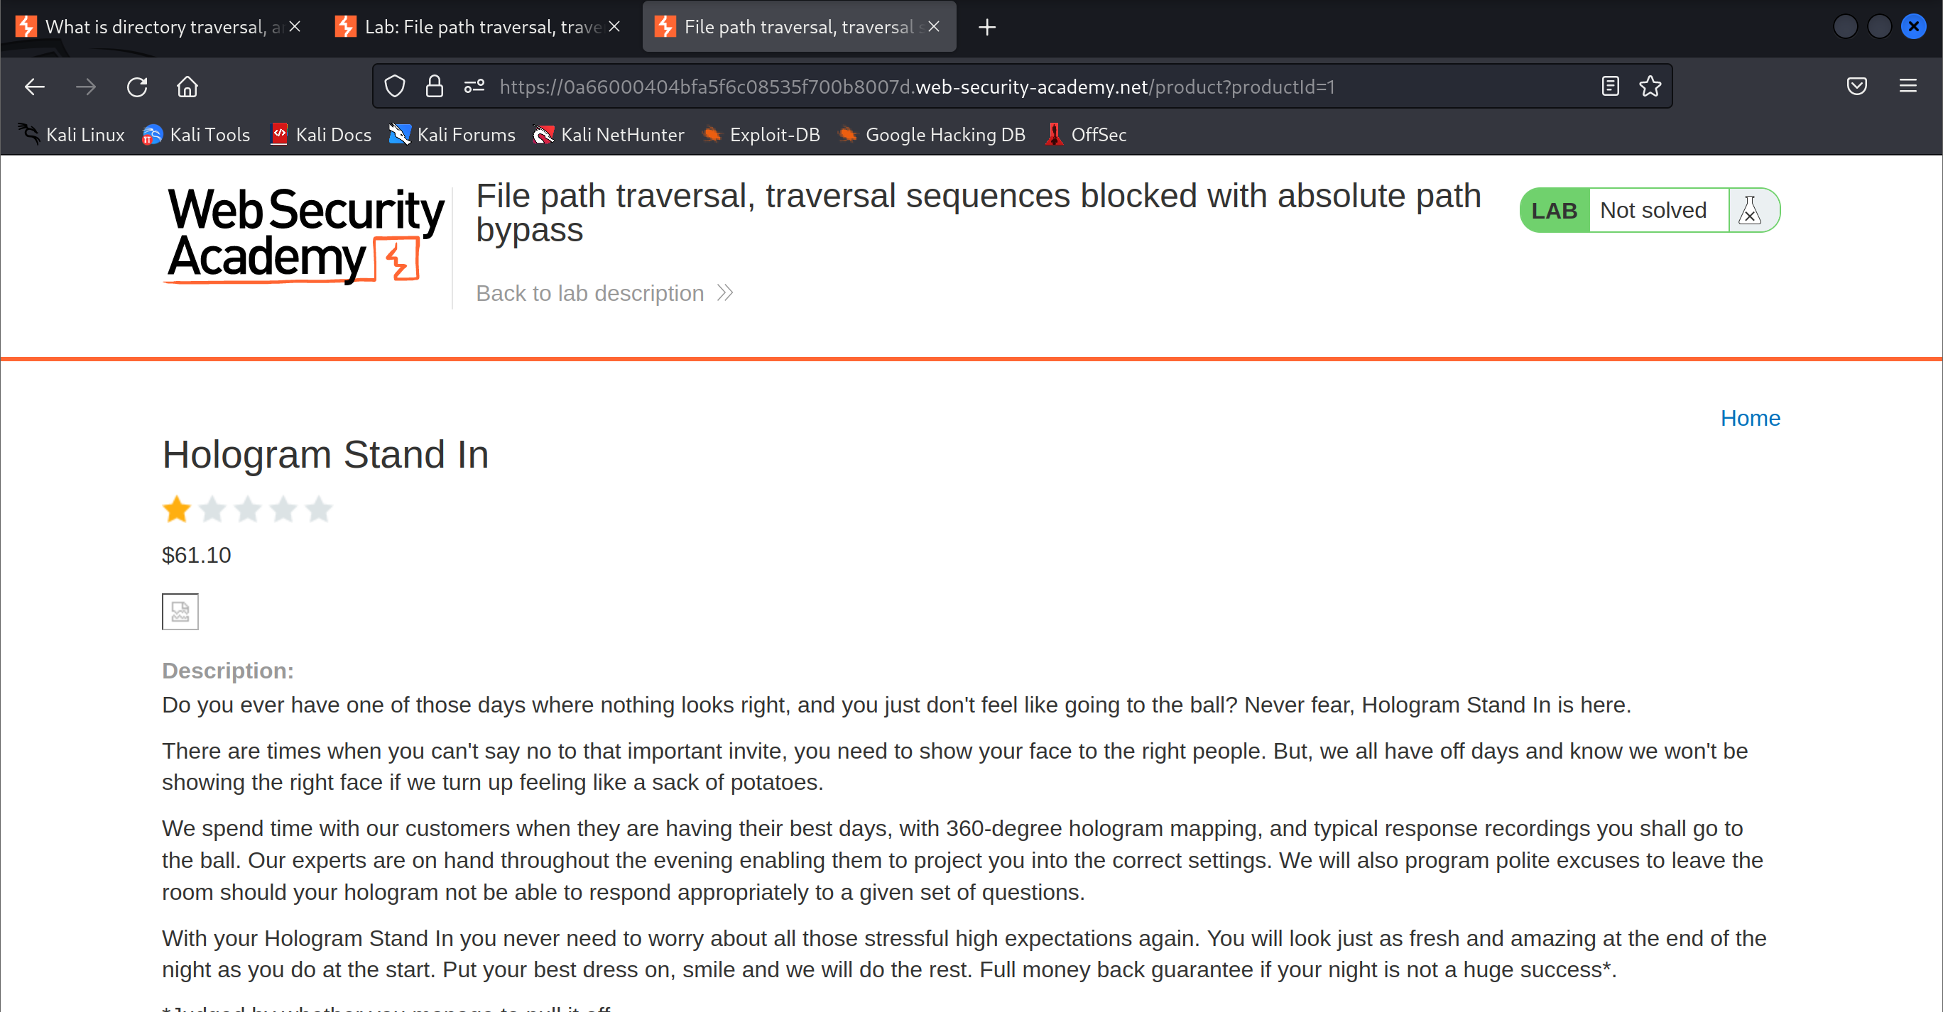

1. Modify the file path request

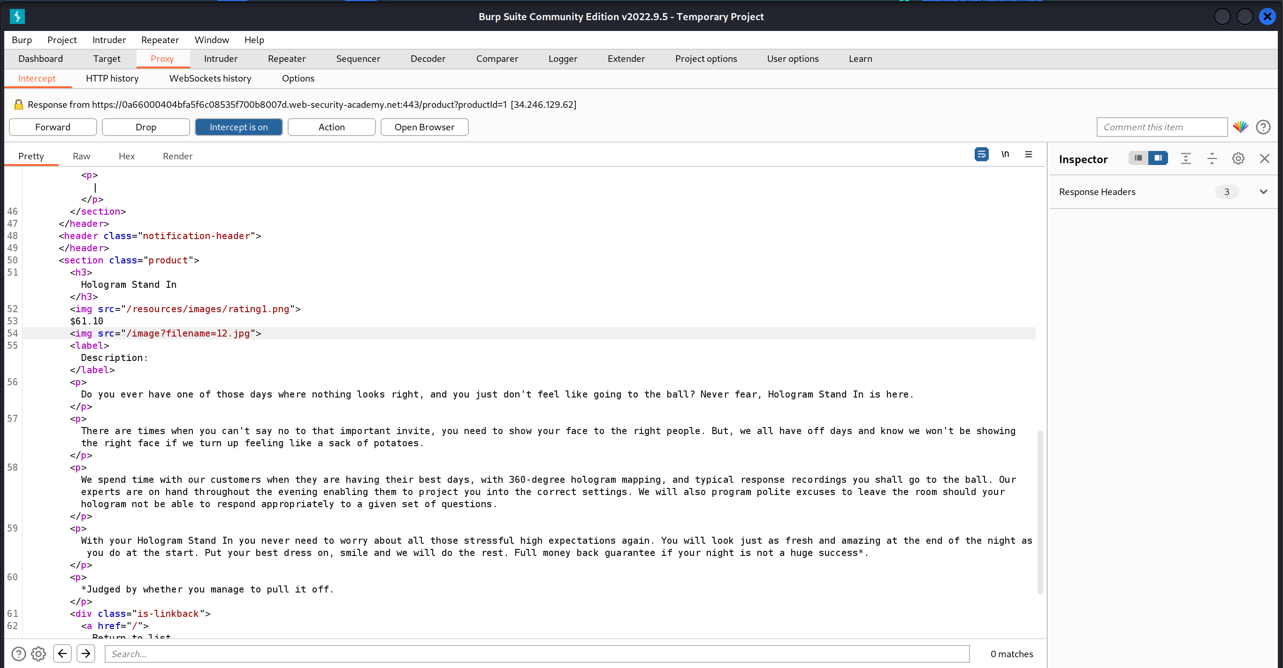

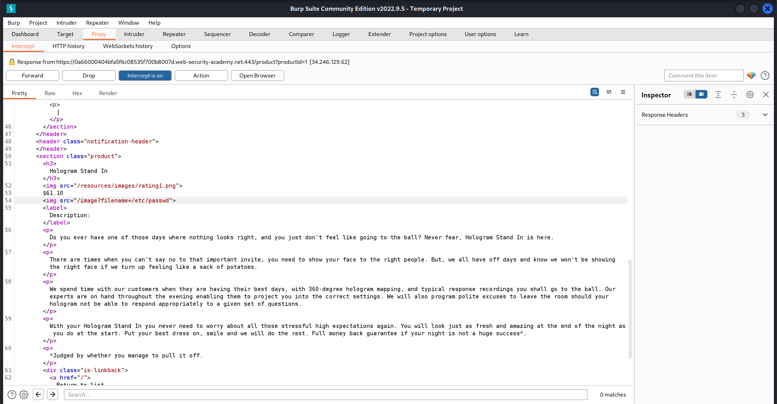

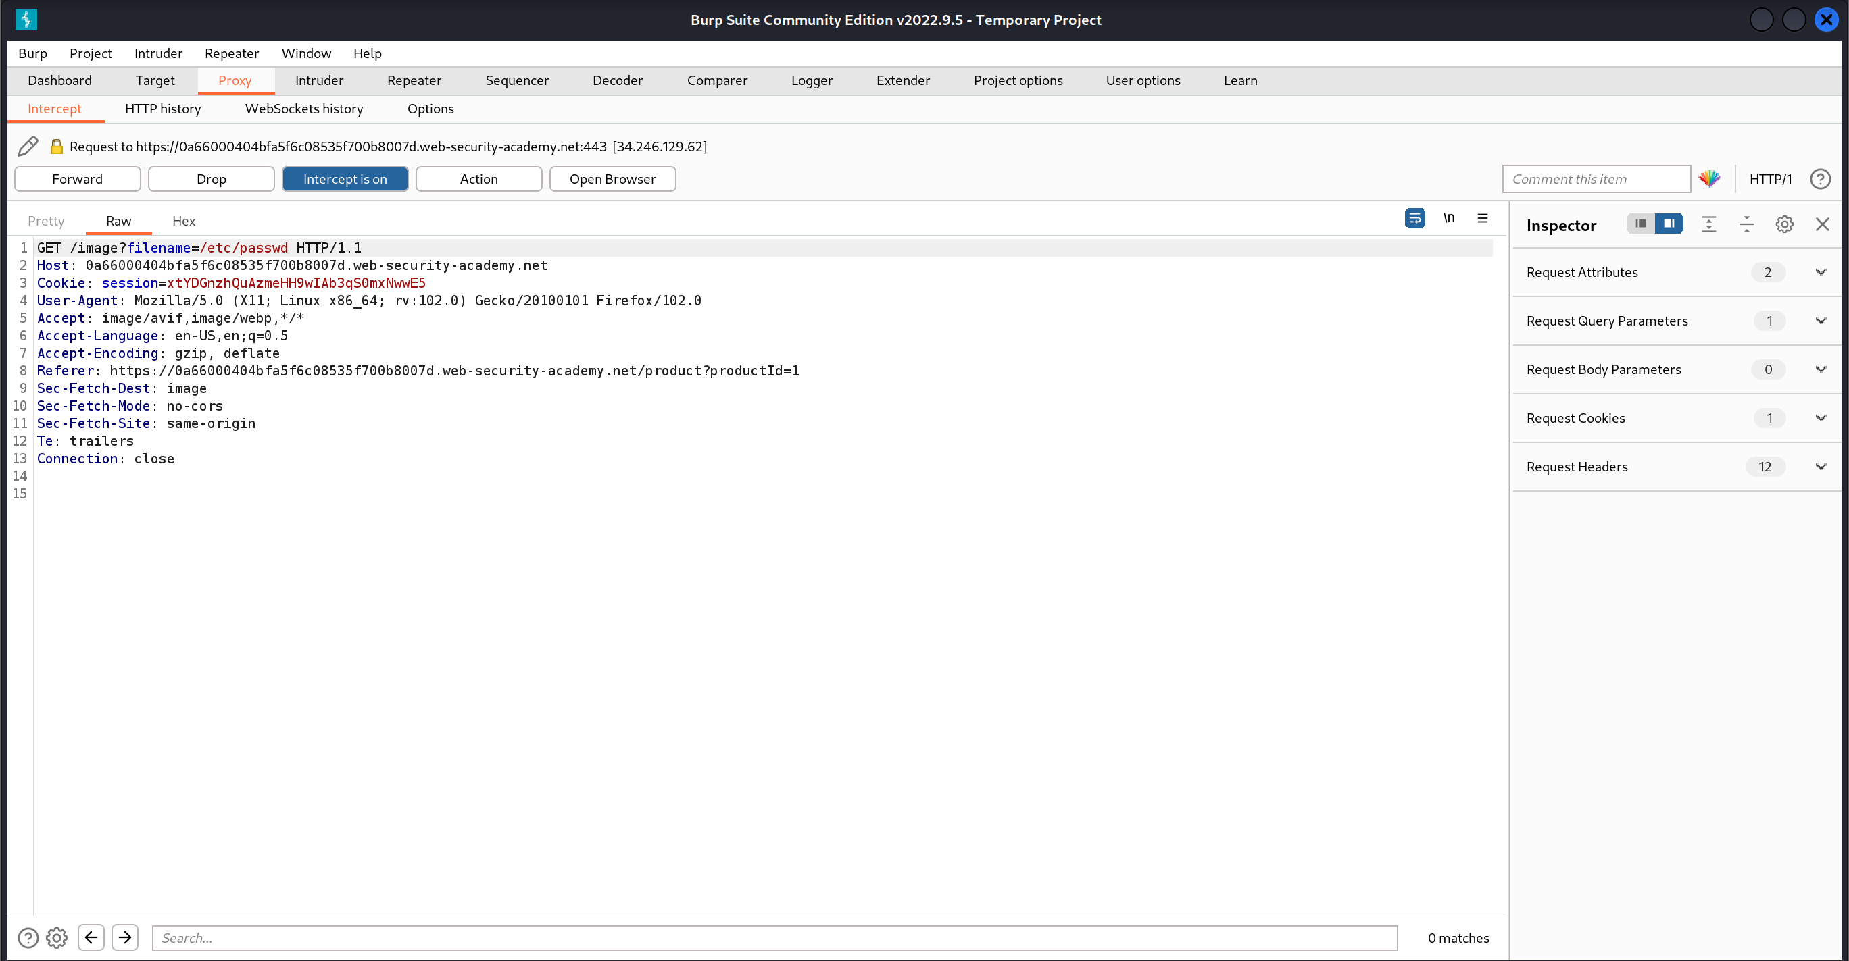

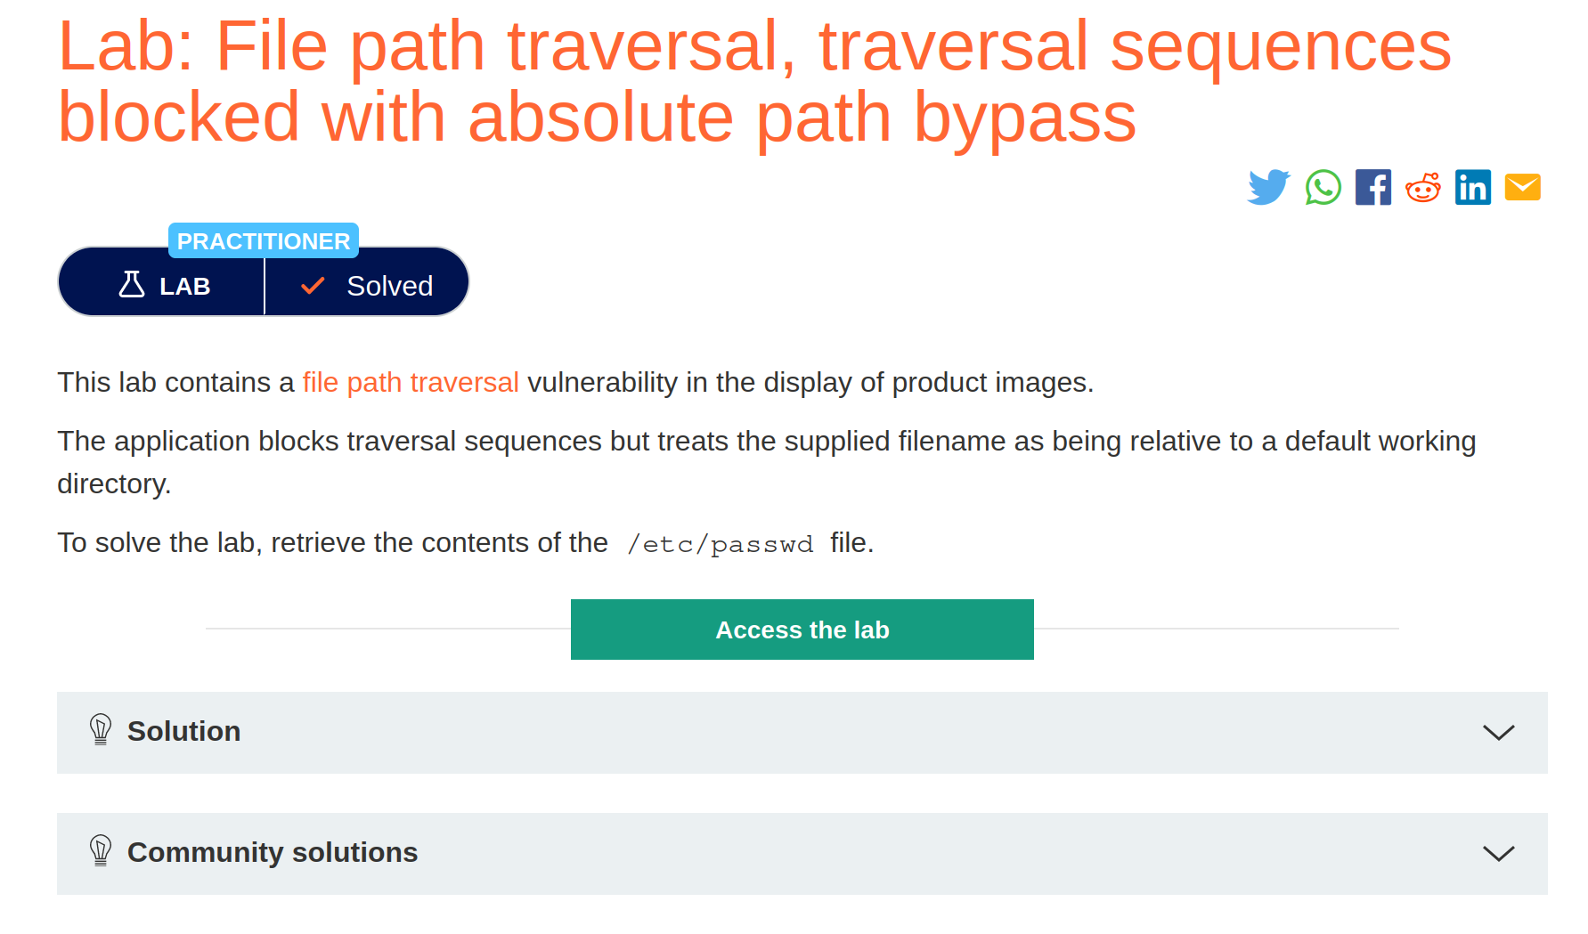

## File path traversal, traversal sequences stripped non-recursively

1. Open the lab

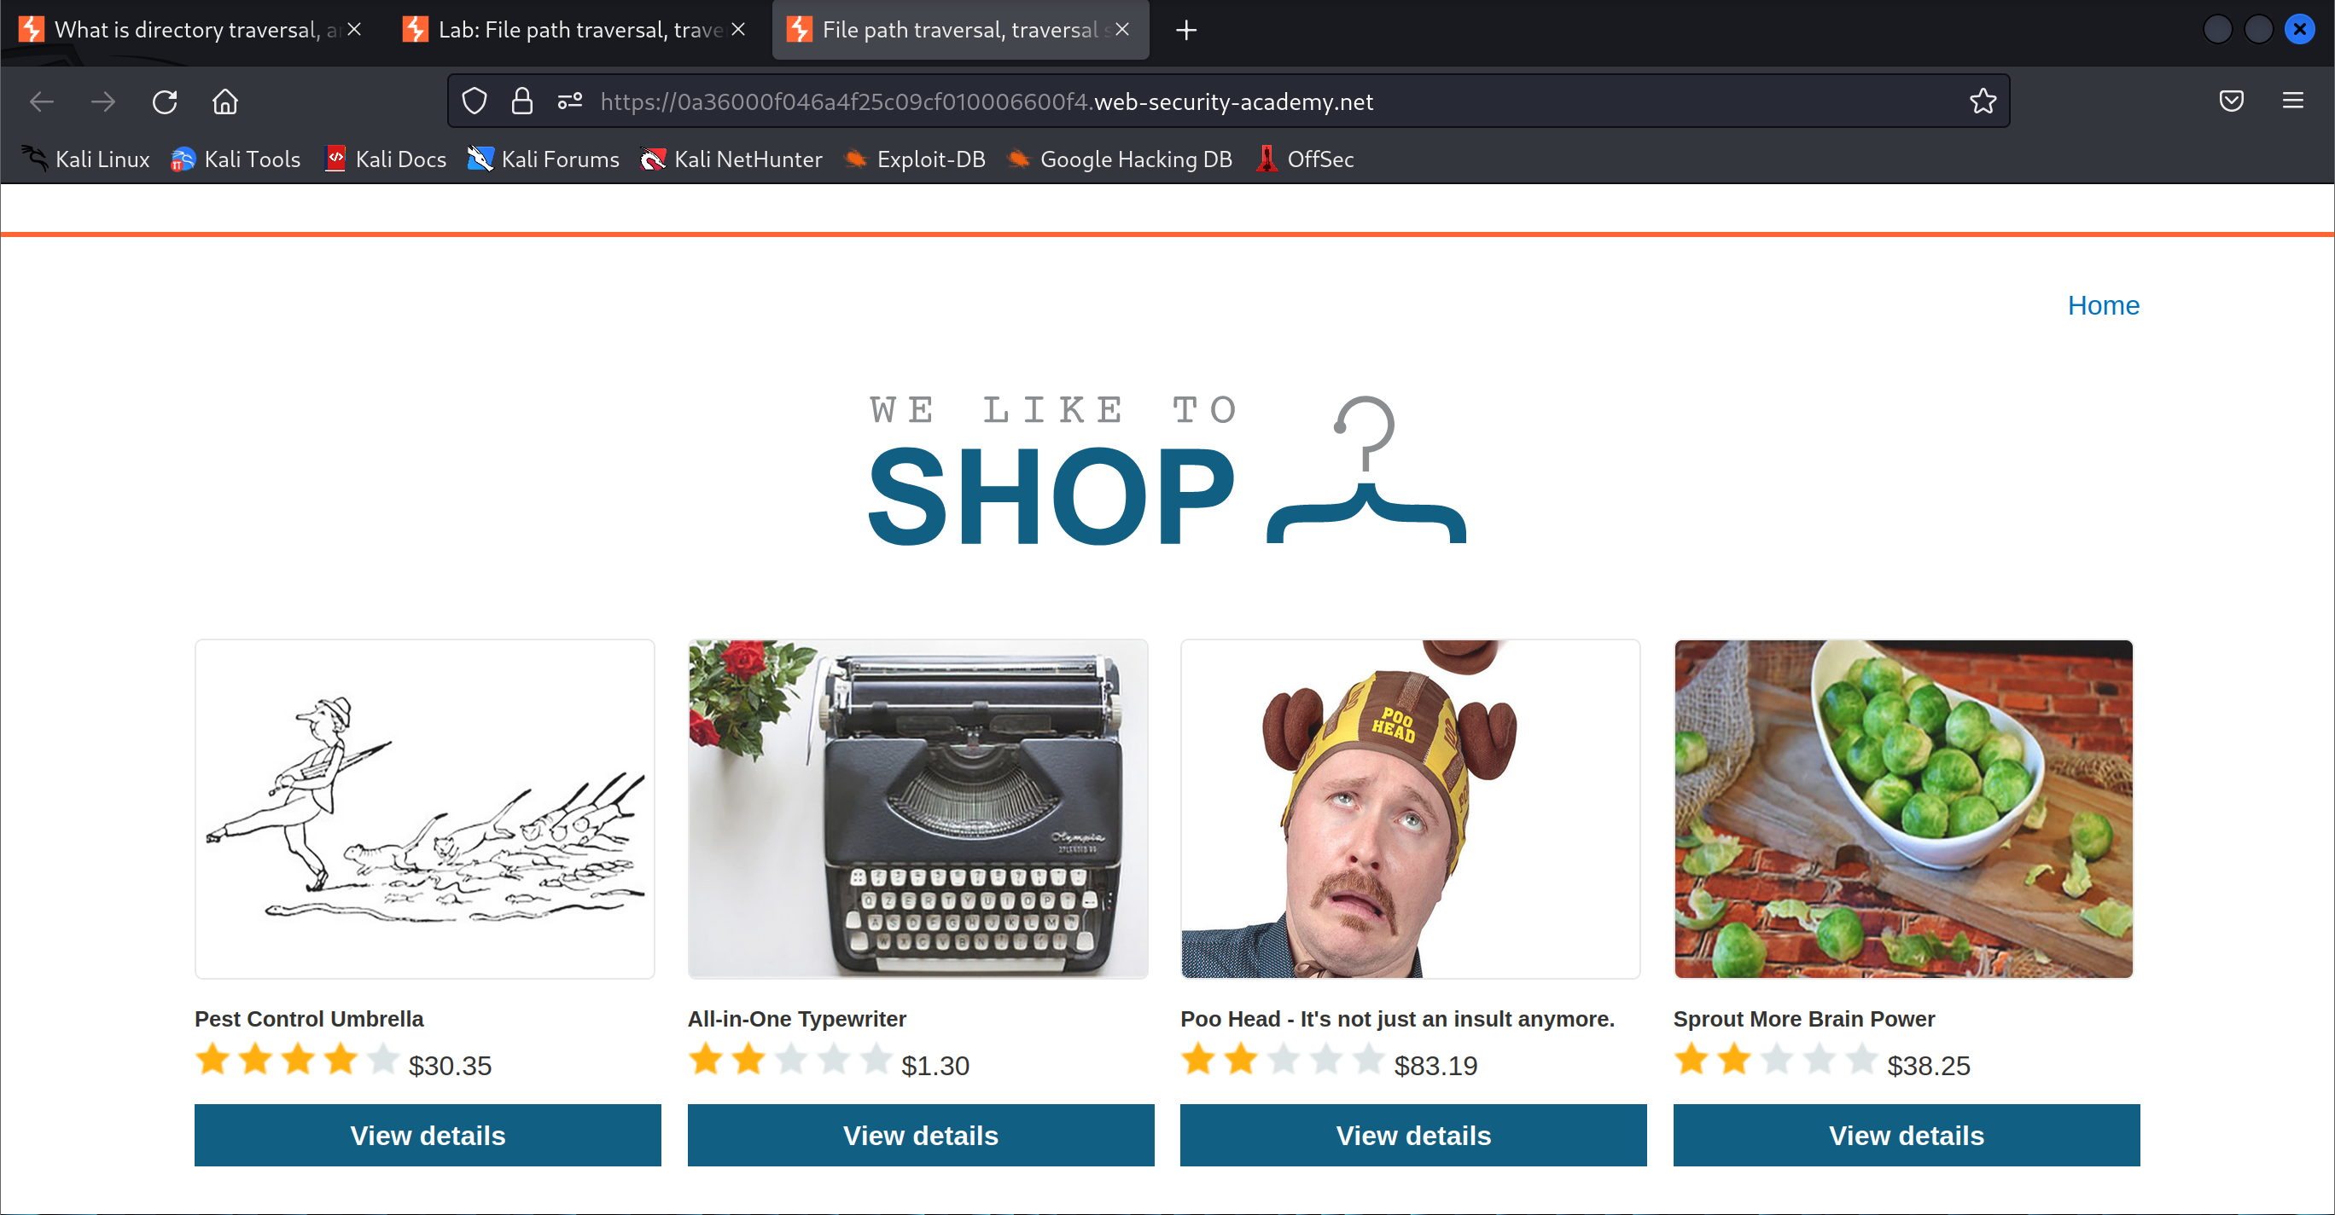

1. Start intercepting the HTTP traffic



1. View the details of the product in the shop

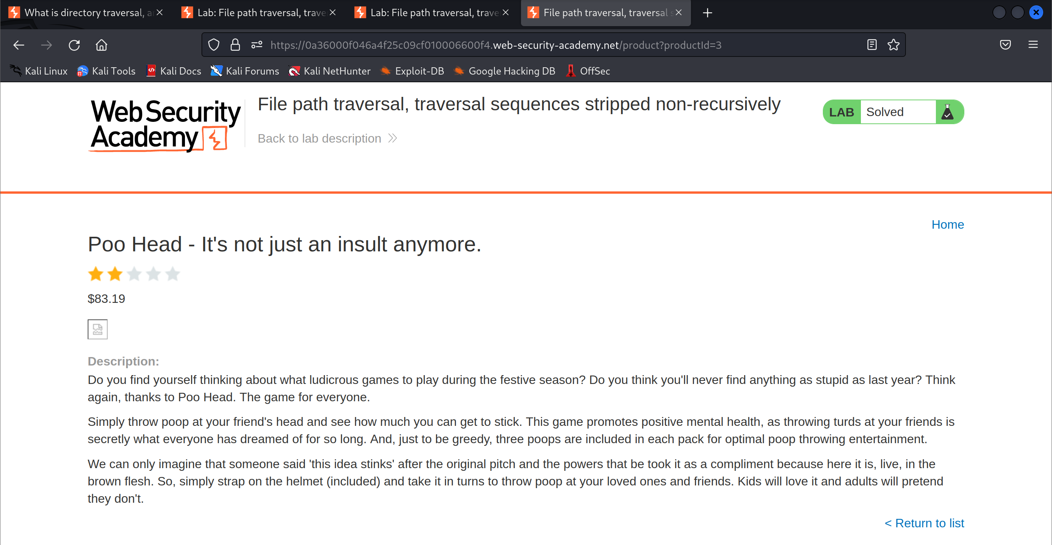

1. Modify the file path request

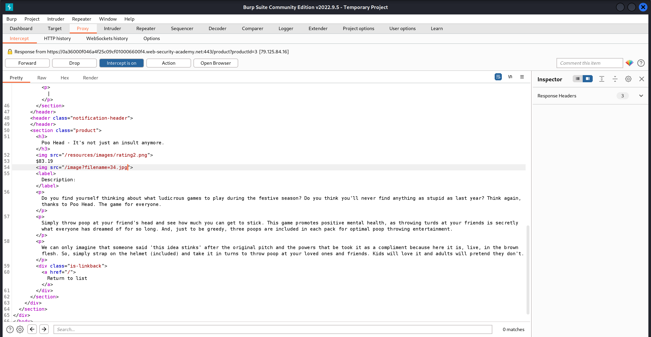

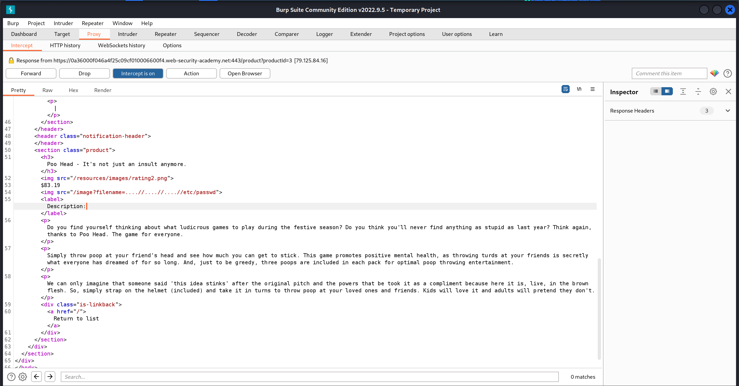

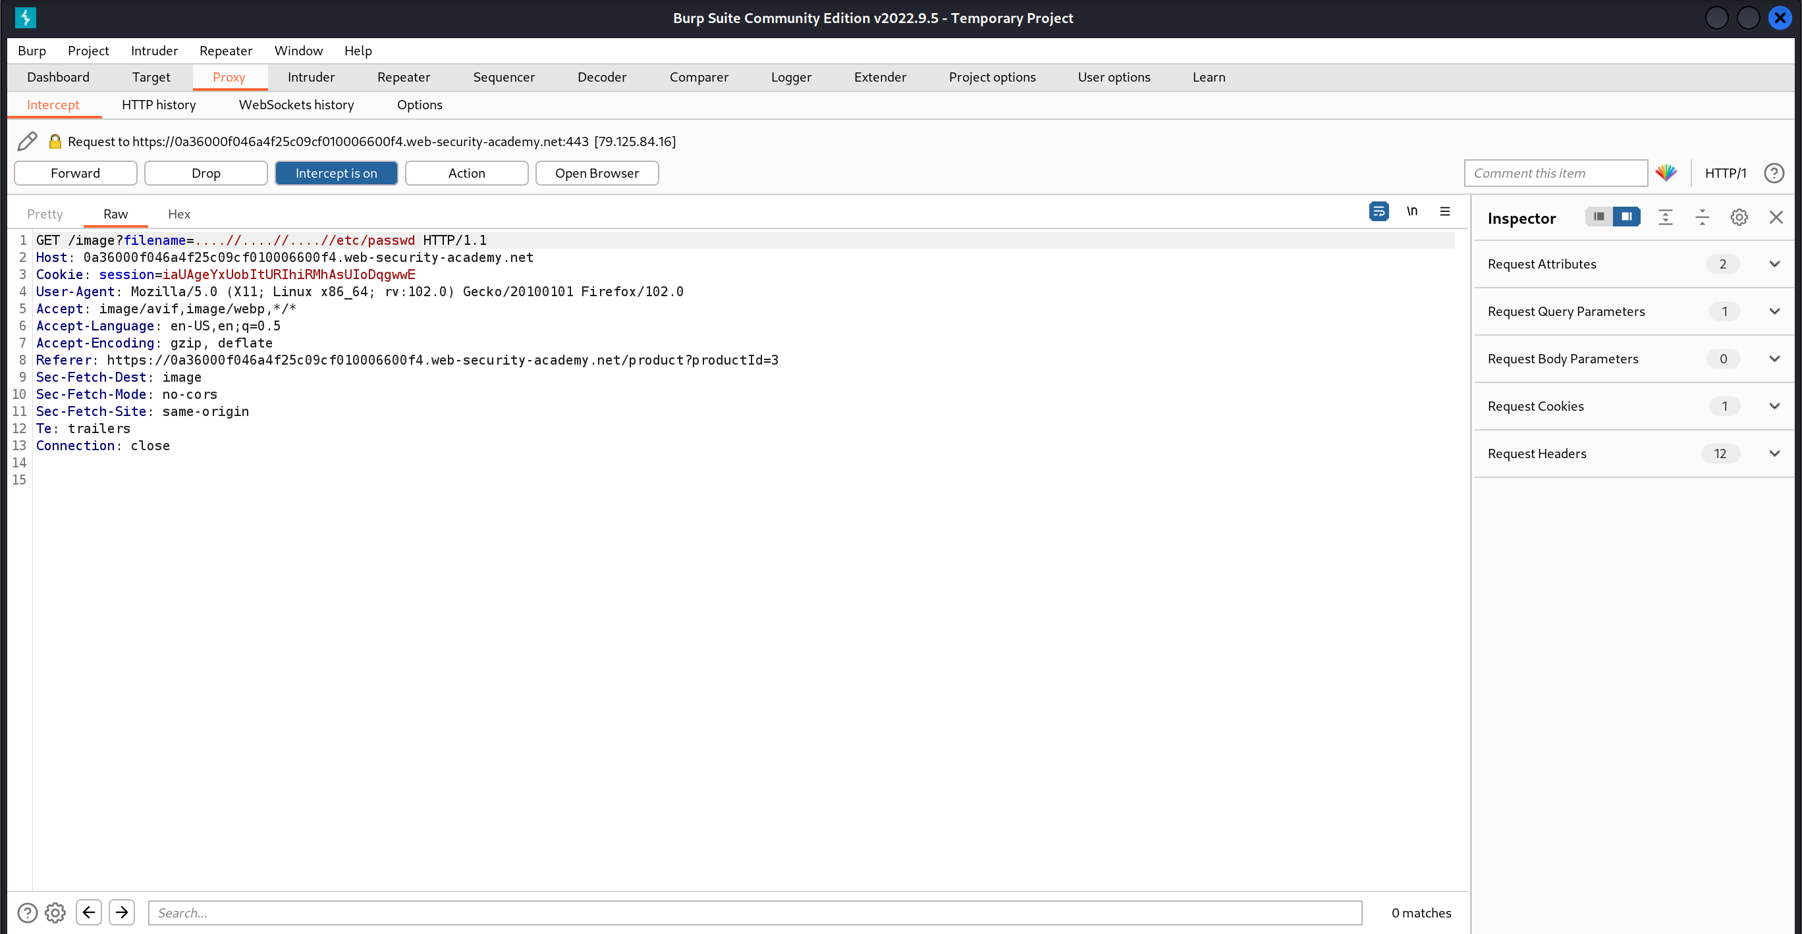

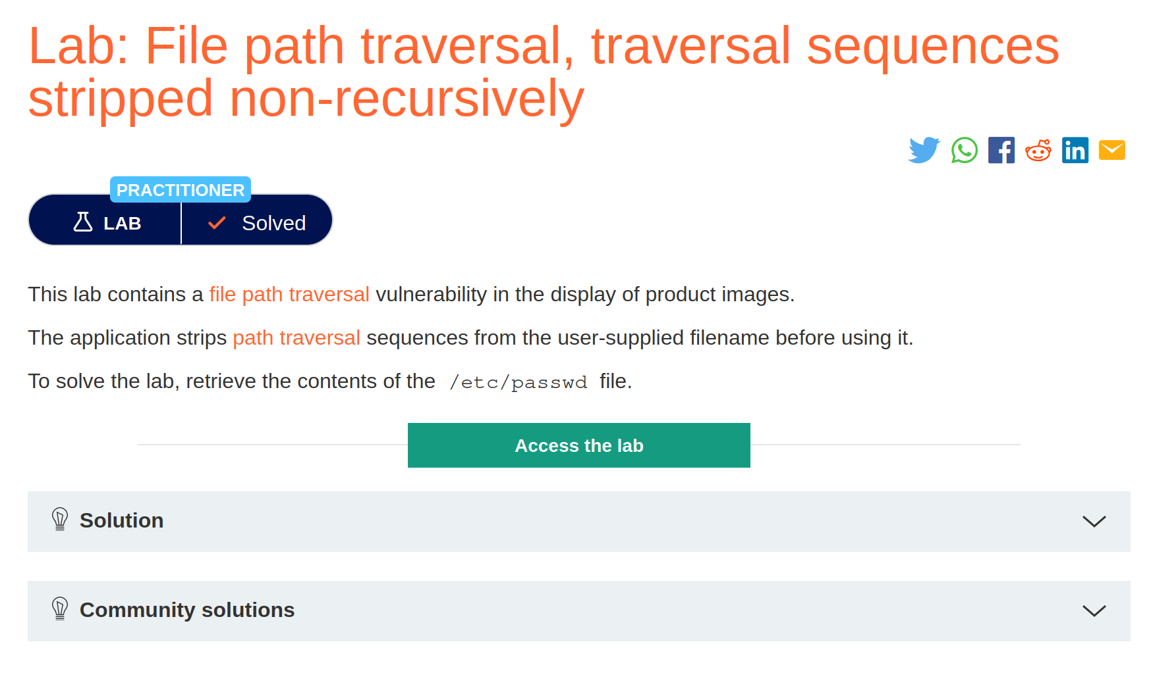

## File path traversal, traversal sequences stripped with superfluous URL-decode

1. Open the lab

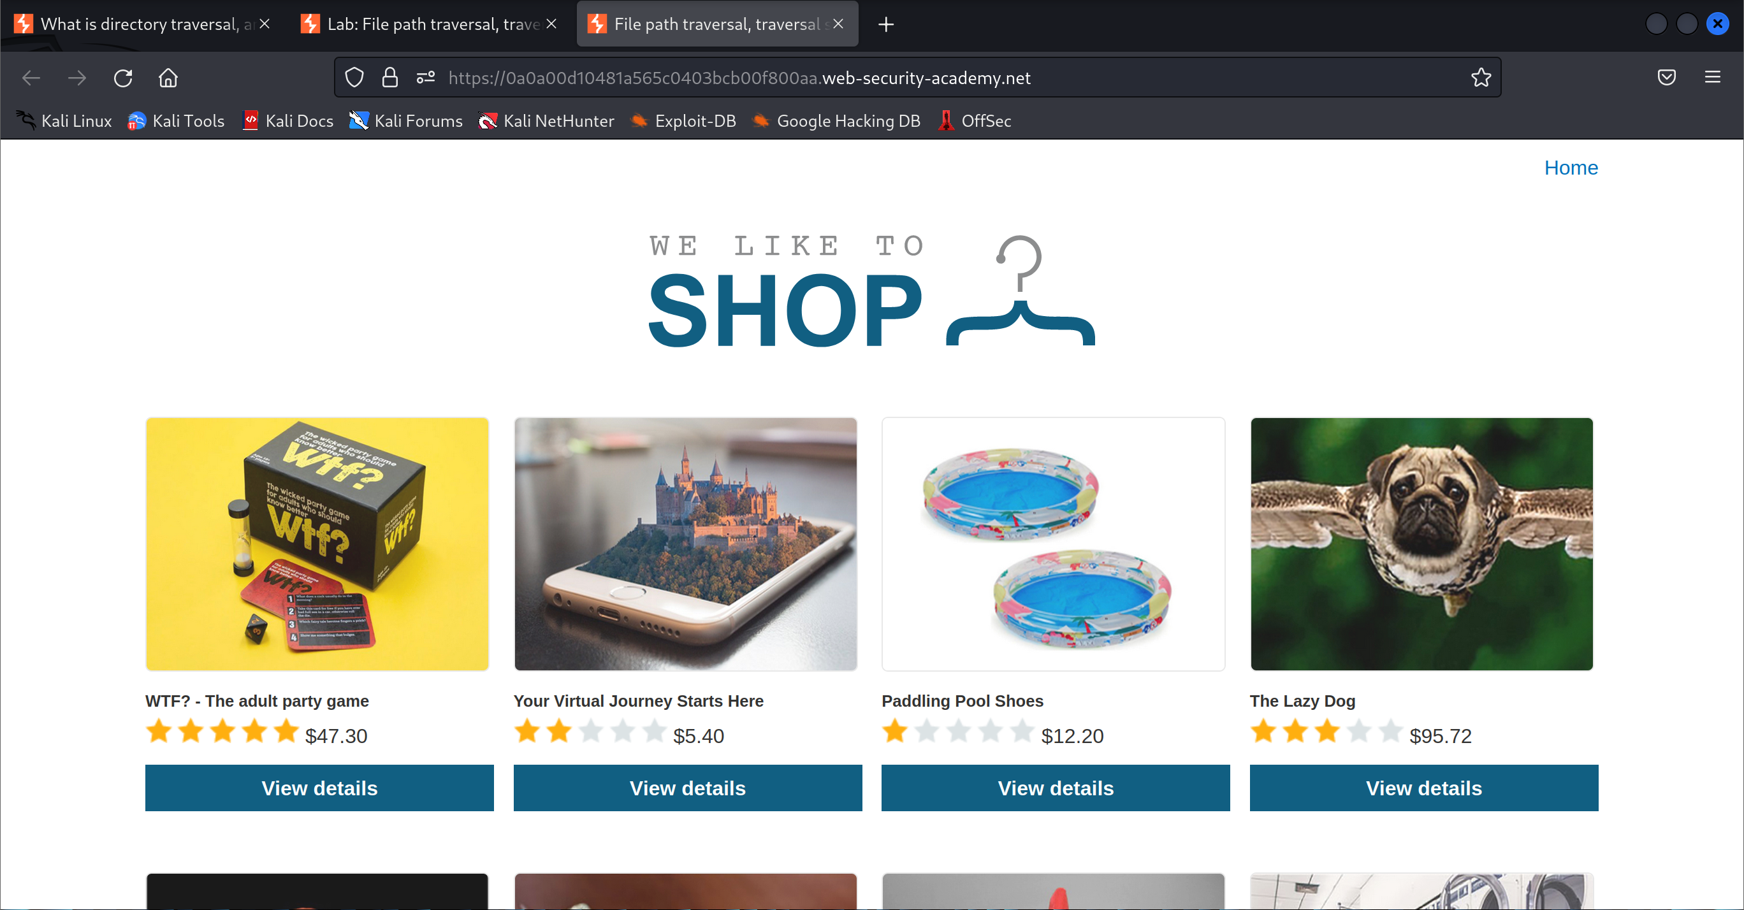

1. Start intercepting the HTTP traffic



1. View the details of the product in the shop

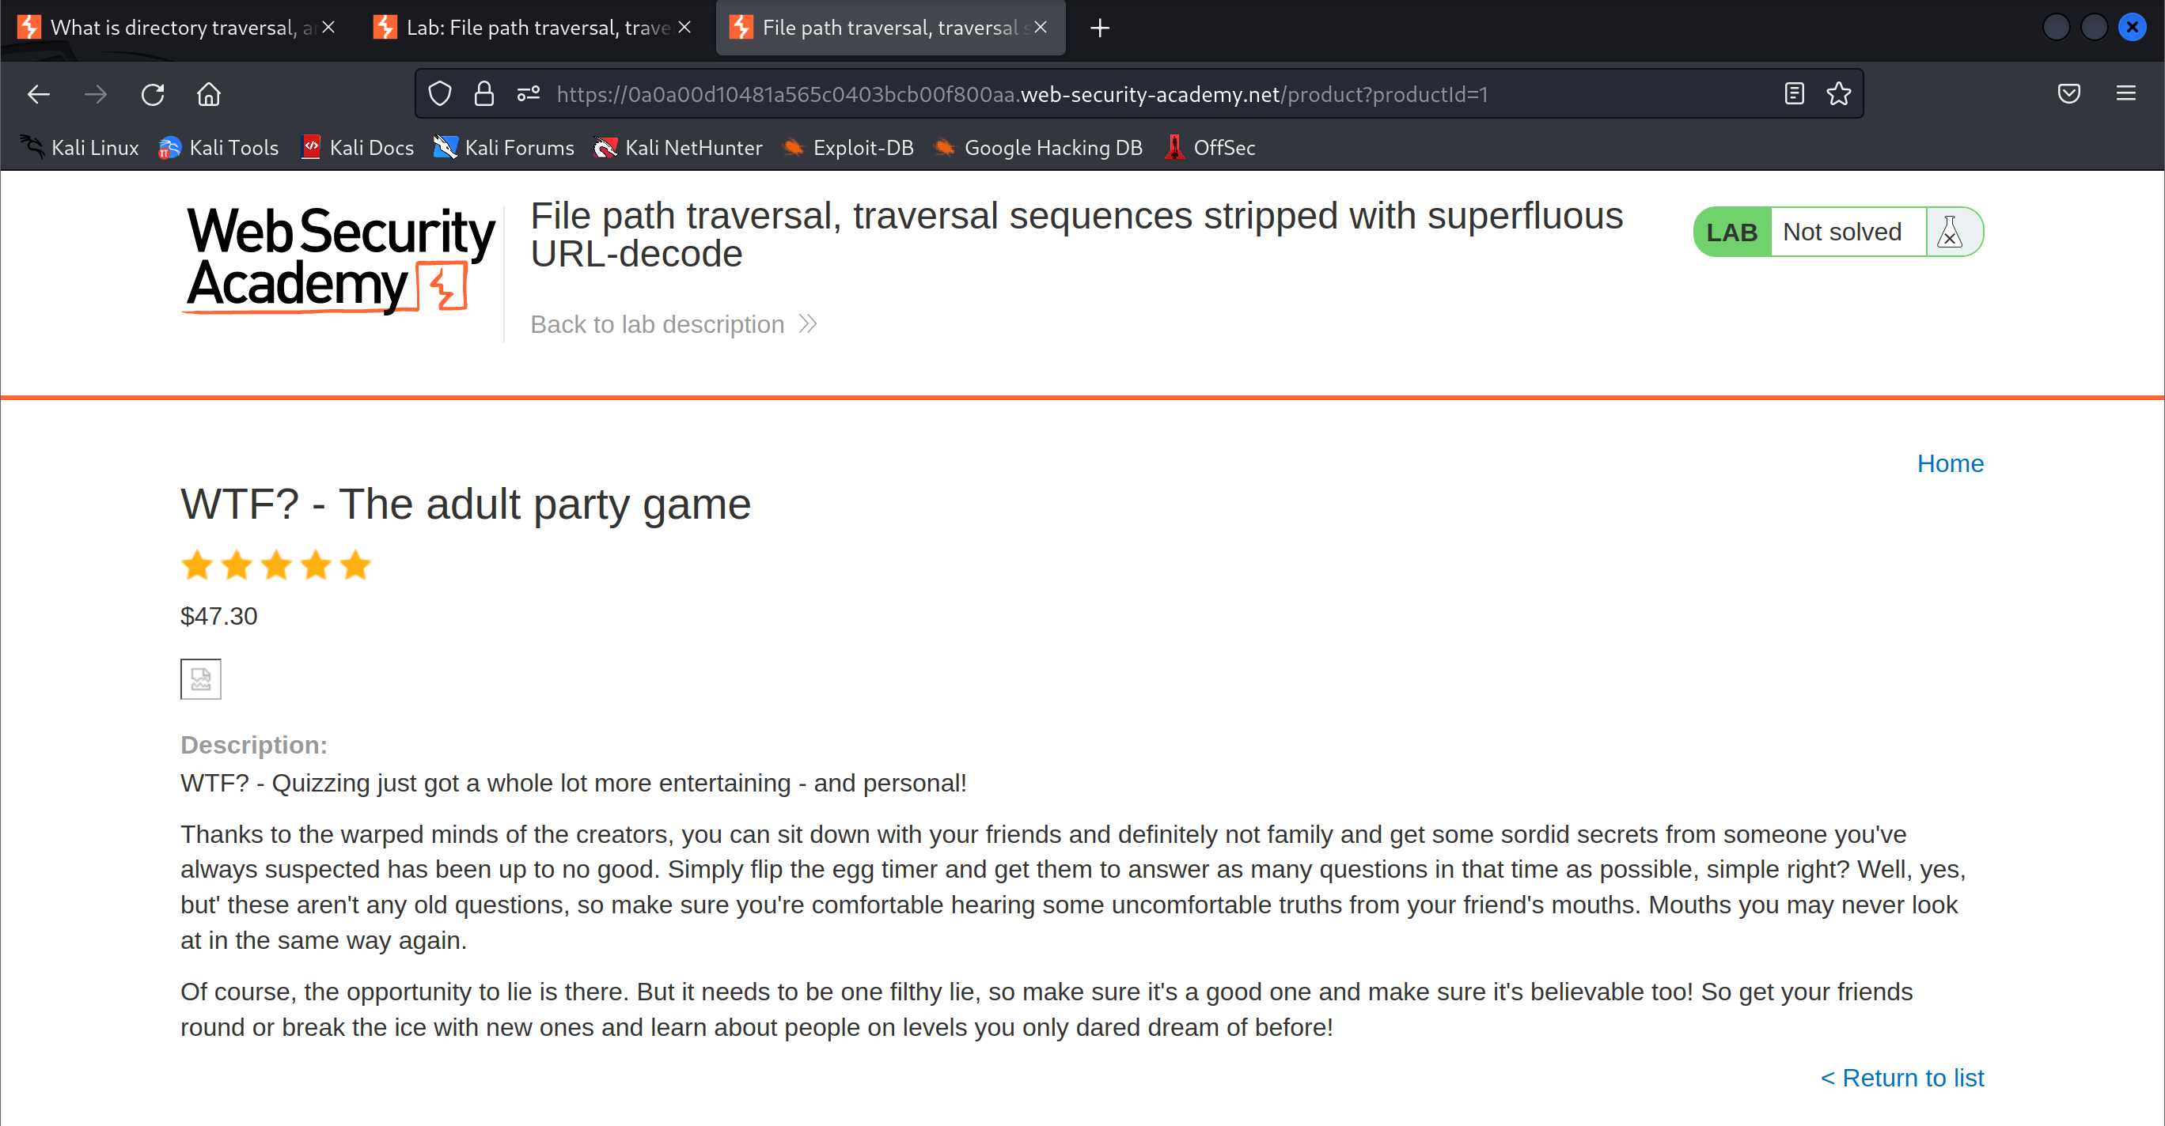

1. Modify the file path request

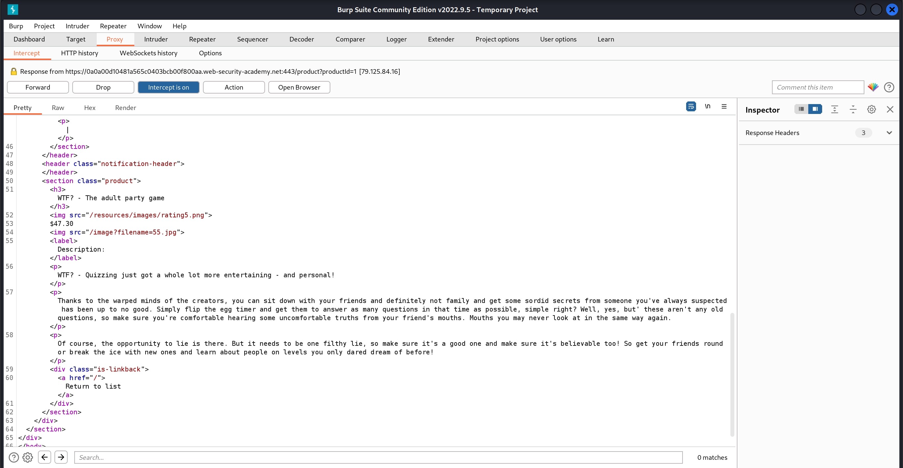

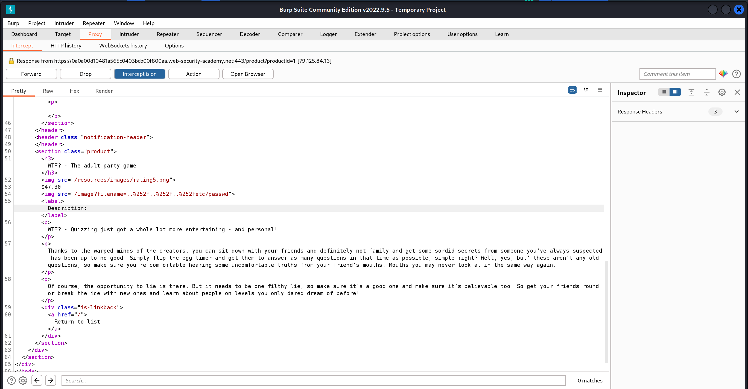

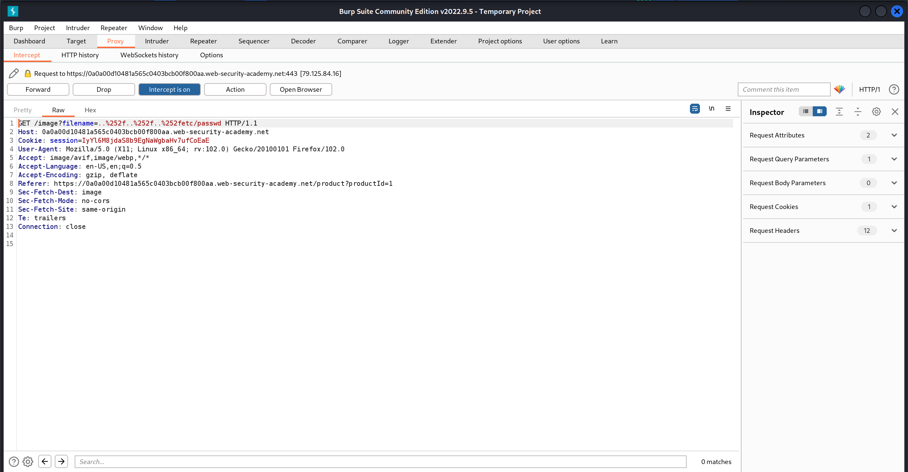

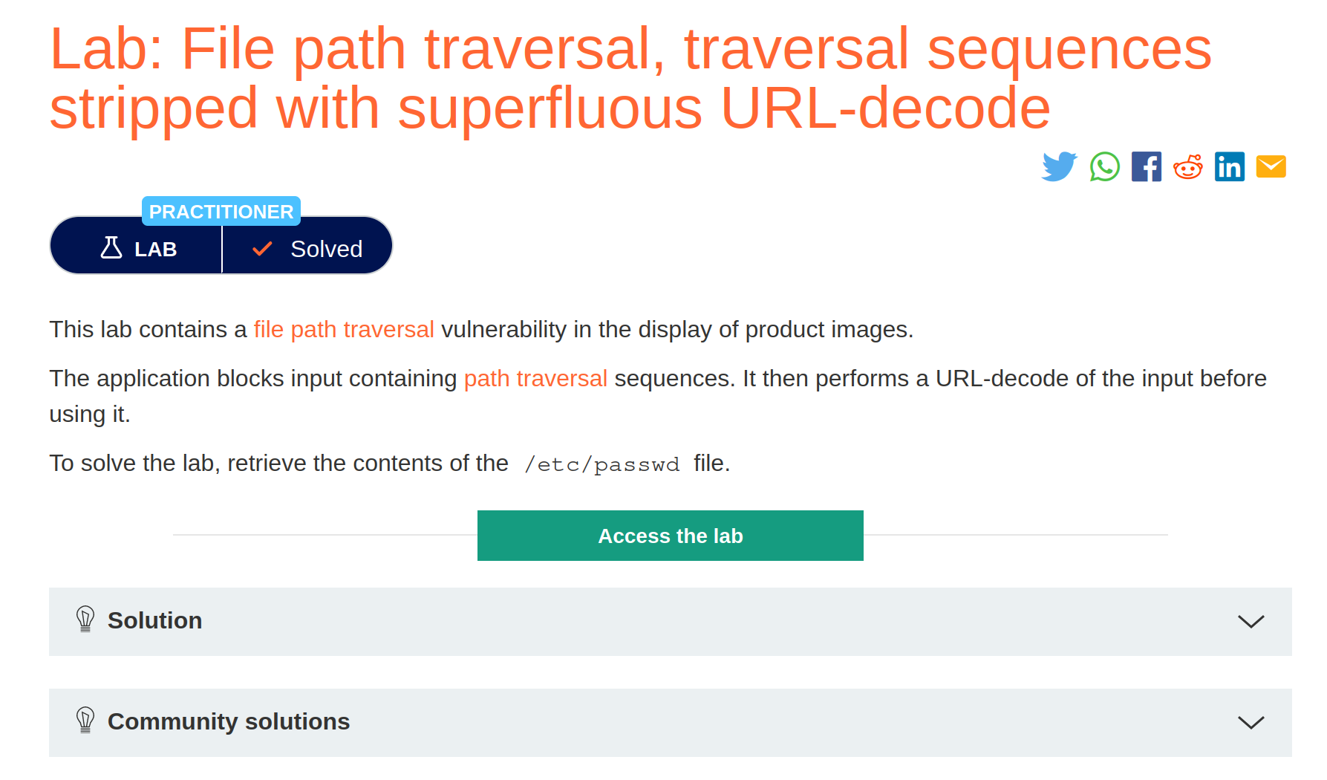

## File path traversal, validation of start of path

1. Open the lab

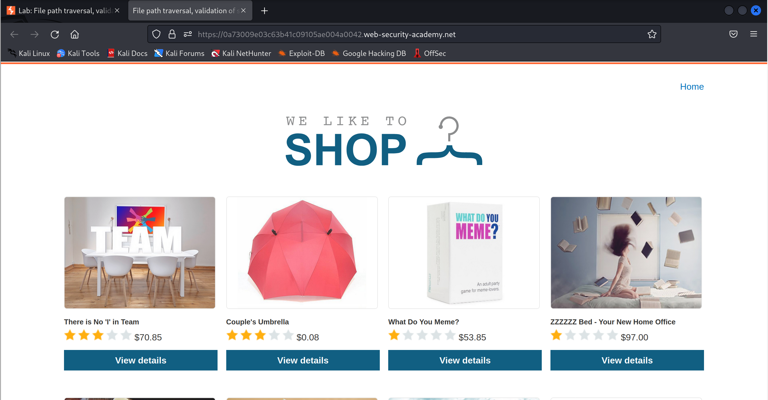

1. Click to view details

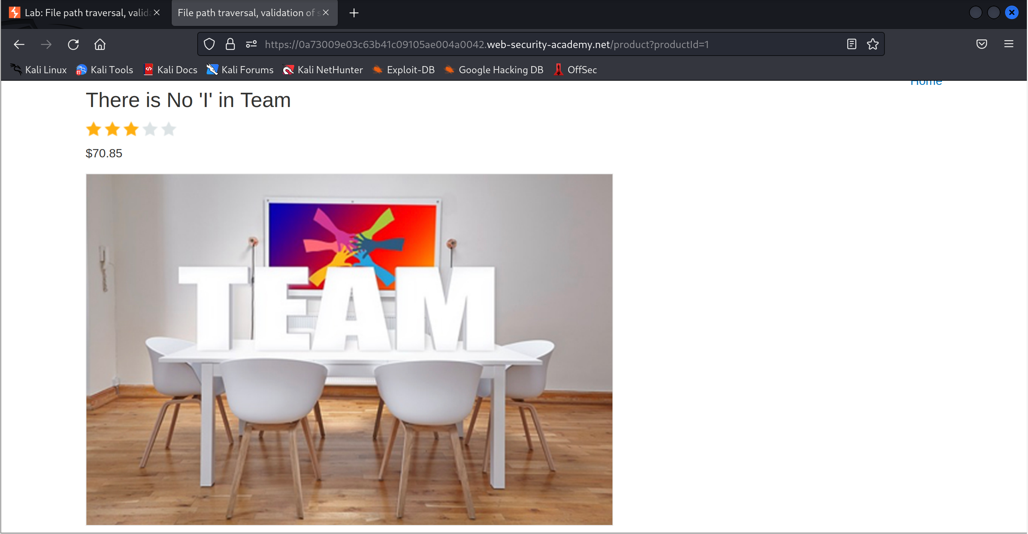

1. Open image in new tab

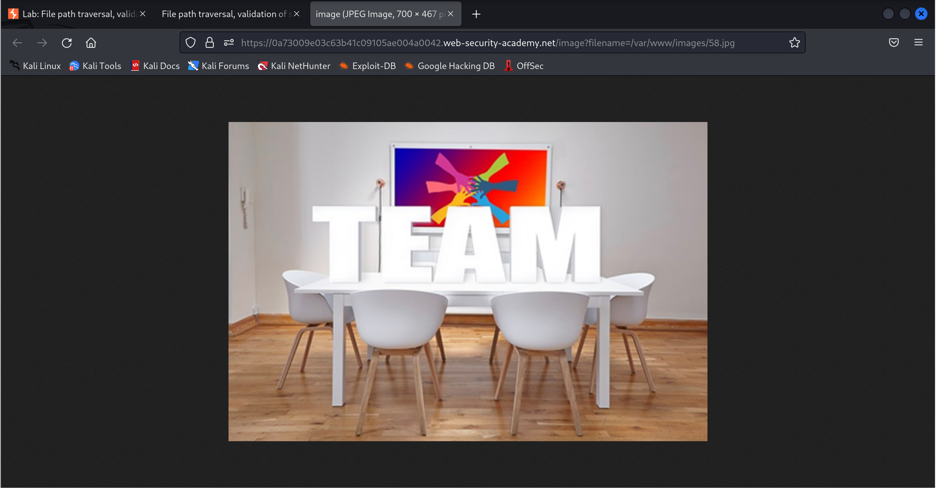

1. Modify the file path to navigate to the /etc/passwd file

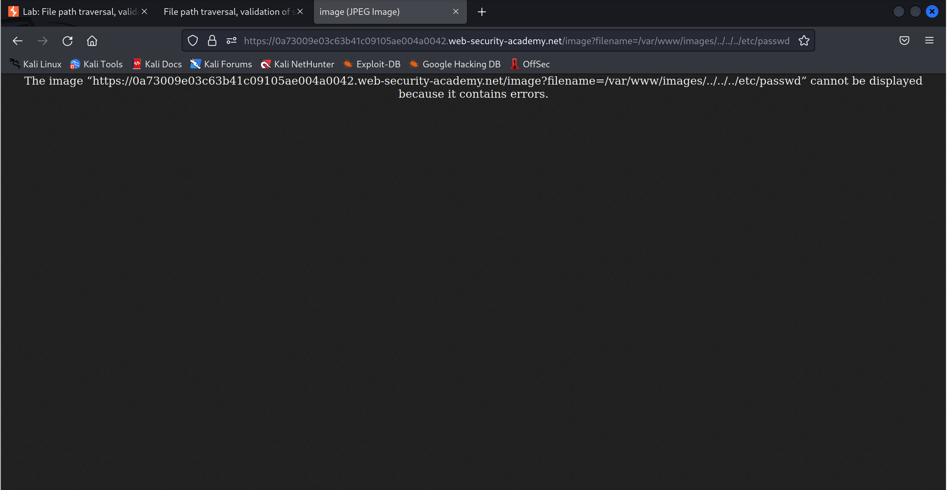

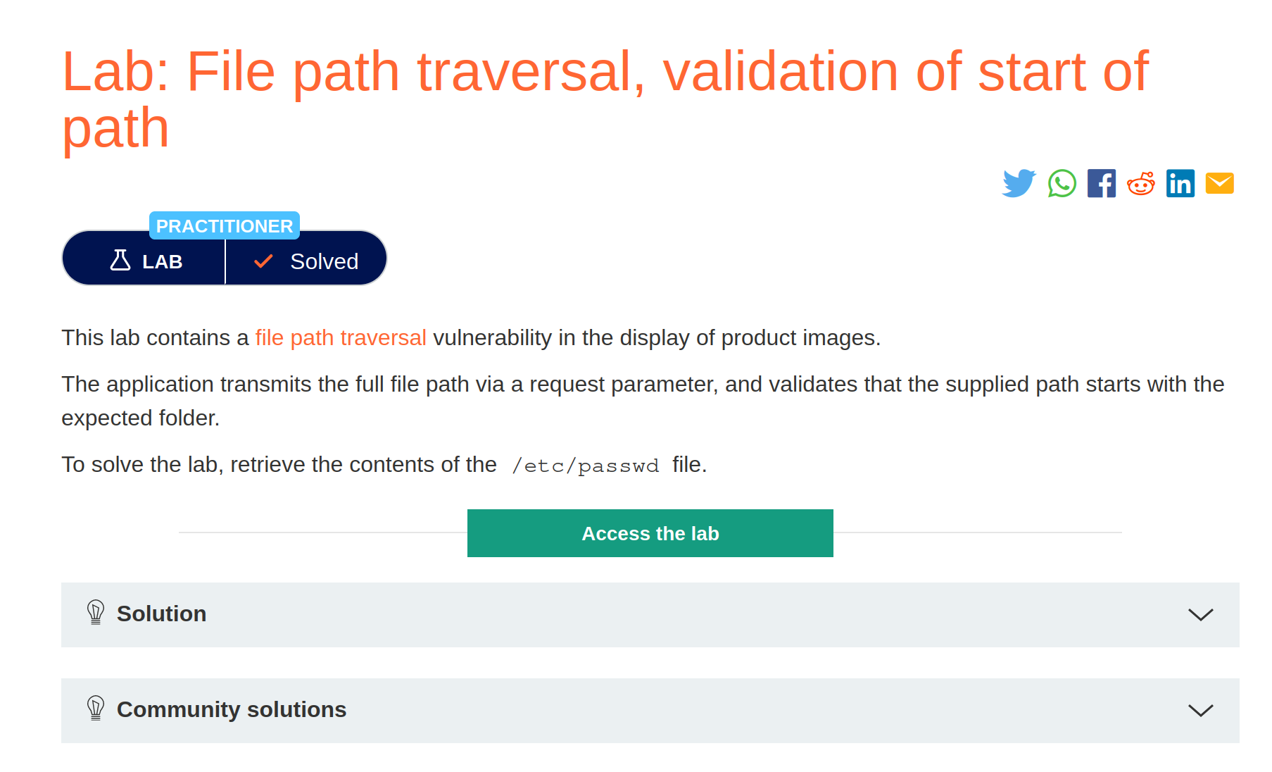

## File path traversal, validation of file extension with null byte bypass

1. Open the lab

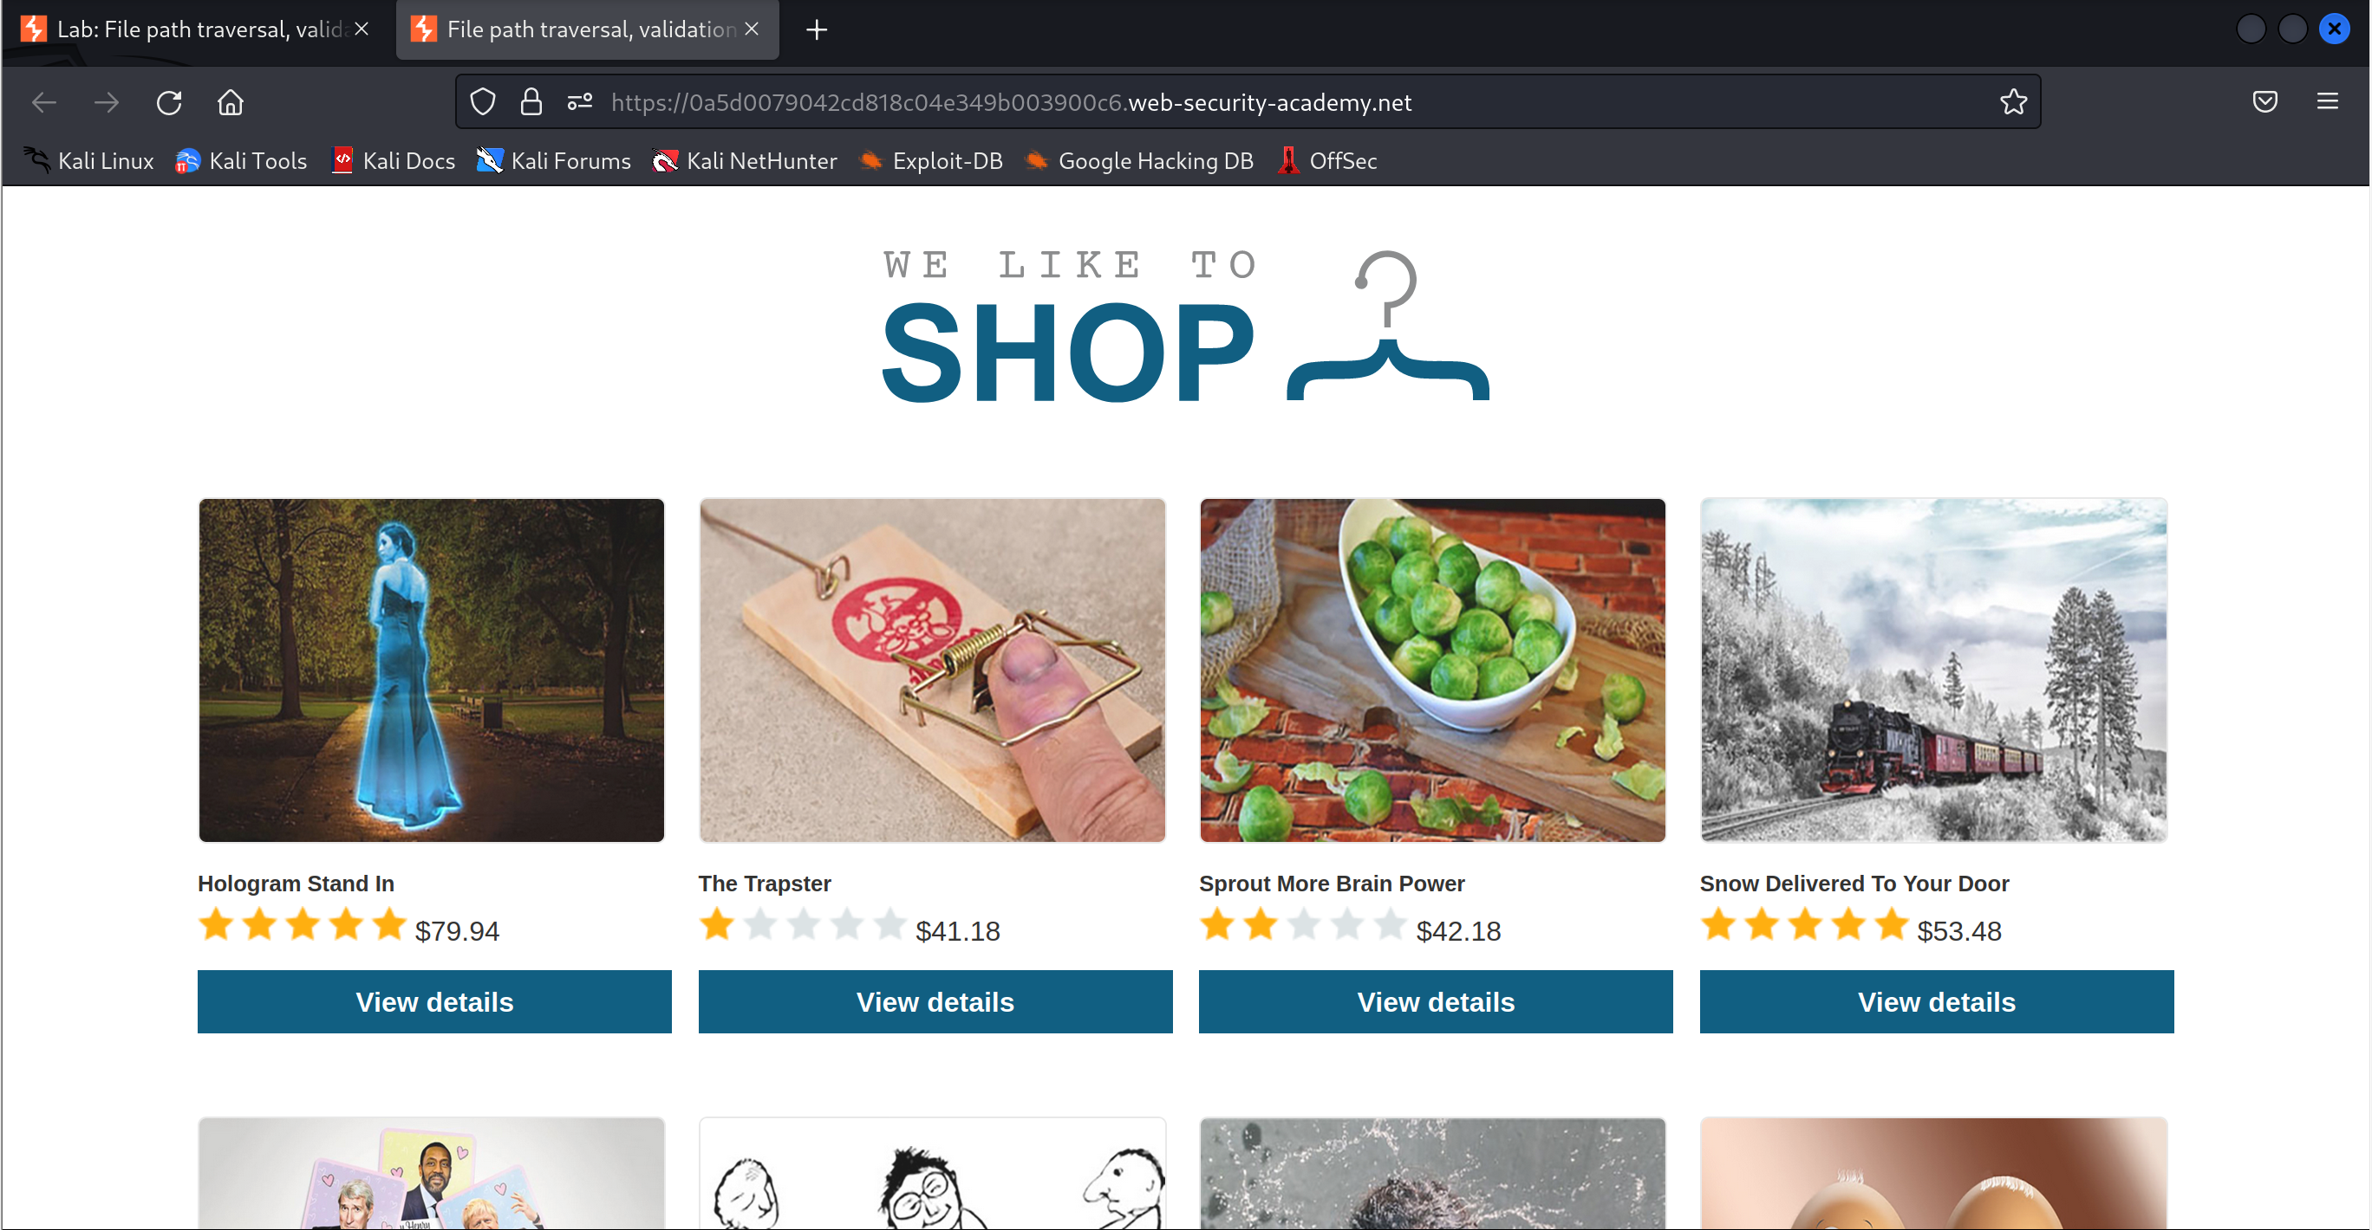

1. Click to view details

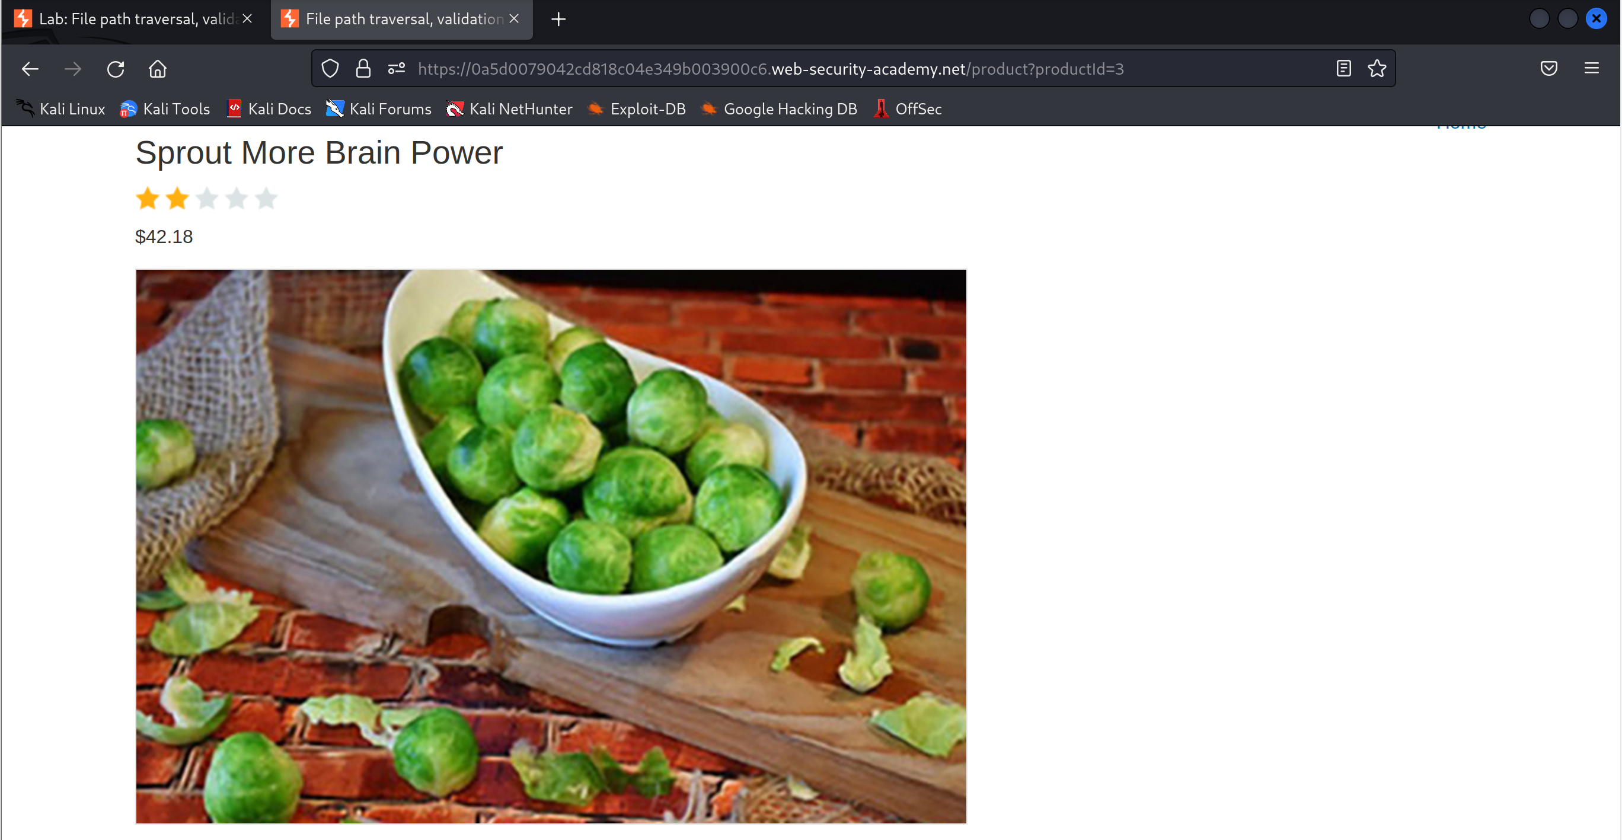

1. Open image in new tab

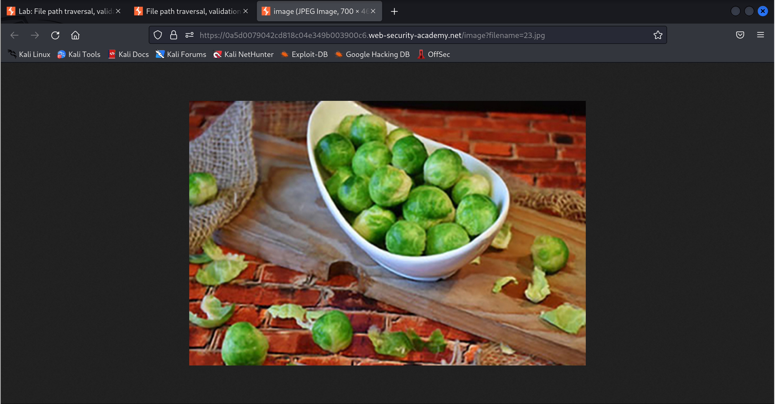

1. Modify the file path to navigate to the /etc/passwd file

